**Big Sky High School  
International Baccalaureate  
Diploma Program**

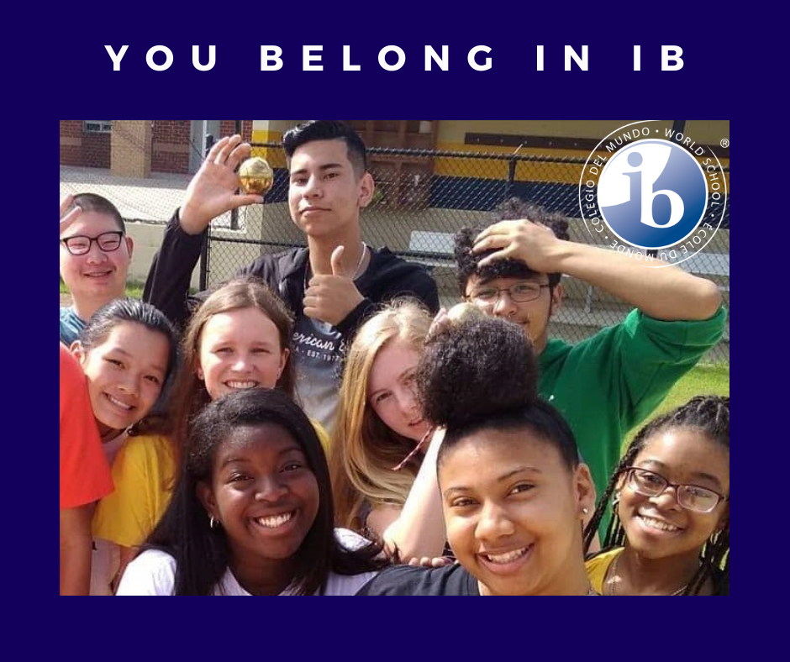

**Student Creativity, Activity, Service (CAS) Guide**

***Big Sky High School***

***3100 South Avenue West***

***Missoula, Montana 59804***

***IB Diploma Program Coordinator***

**Meleina Helmer**

***Revised 5/17/2023***

# Table of Contents

Mission Statement and Learner Profile …………………………………………………………………...………… 3

What is CAS? What it is not? …………………………………………………………………………… 4-5

Student Responsibilities. …………………………………………………………………….……… 6-7

FAQs … What if ……………………………………………………………………....……..7-8

I am a musician, artist, dancer, actor, athlete, horseback rider, etc.

How can these activities meet the Creative area?

What are some guidelines about service?

Are there political or religious limitations?

Appendices

30-Day CAS Project ……………………………………………………………………………… 9

CAS Inventory …………..……………………………………………………....……….… 10

# 

**IB Mission Statement**

*The International Baccalaureate aims to develop inquiring, knowledgeable and caring young people who help to create a better and more peaceful world through intercultural understanding and respect.*

*To this end the organization works with schools, governments and international organizations to develop challenging programs of international education and rigorous assessment.*

*The programs encourage students across the world to become active, compassionate and lifelong learners who understand that other people, with their differences, can also be right. – IBO*

**We strive to be …**

***Inquirers****: We nurture our curiosity, developing our skills for inquiry and research. We know how to learn independently and with others. We learn with enthusiasm and sustain our love of learning throughout life.*

***Knowledgeable****: We develop conceptual understanding, exploring knowledge across a range of disciplines. We engage with issues that have local and global significance.*

***Thinkers****: We use critical and creative thinking skills to analyze and take responsible action on complex problems. We exercise initiative in making reasoned and ethical decisions.*

***Communicators****: We express ourselves confidently and creatively in more than one language and in many ways. We collaborate effectively and listen carefully to the perspective of other individuals and groups.*

***Principled****: We act with integrity and honesty, with a fair sense of justice and justice, and with respect for the rights of people everywhere. We take responsibility for our actions and their consequences.*

***Open-minded****: We critically appreciate our own cultures and our history, as well as the values and traditions of other cultures. We seek and evaluate a range of points of view, and we are willing to grow from the experience.*

***Caring:*** *We show empathy, compassion and respect. We have a commitment to service, and we act to make a difference in the lives of others and in the world around us.*

***Risk Takers****: We approach uncertainty with forethought and determination; we work independently and cooperatively to explore new ideas and innovative strategies. We are resourceful and resilient in the face of challenges and change.*

***Balanced****: We understand the importance of balancing different aspects of our lives – intellectual, physical and emotional – to achieve well-being for ourselves and others. We recognize our independence with other people and with the world in which we live.*

***Reflective****: We thoughtfully consider the world and our own ideas and experience. We work to understand our own strengths and weaknesses in order to support our learning and personal development.*

# What is CAS?

CAS is at the heart of the Diploma Program, being 1 of the 3 essential elements in every student’s experience. CAS provides students with the opportunity to develop characteristics outlined in the **Learner Profile** specifically aiming to develop students who are:

* Reflective thinkers
* Willing to accept new challenges and new roles
* Aware of themselves as members of the community
* Active participants in sustained, collaborative projects
* Balanced

Students develop these characteristics through the **three strands of CAS**, which are part of activities.

* Creativity: exploring and extending ideas leading to an original or interpretive product or performance
* Activity: physical exertion contributing to a healthy lifestyle
* Service: collaborative and reciprocal engagement with the community in response to an authentic need

Participants in CAS are required to demonstrate seven **learning outcomes** from their experiences

* Identify own strengths & develop areas for growth
* Demonstrate that challenges have been undertaken, developing new skills in the process
* Demonstrate how to initiate and plan a CAS experience
* Show commitment to and perseverance in CAS experiences
* Demonstrate the skills and recognize the benefits of working collaboratively
* Demonstrate engagement with issues of global significance
* Recognize and consider the ethics of choices and actions

All seven outcomes must be present over an 18-month period (minimum of August of student’s 11th grade year through March of student’s 12th grade year) for a student to complete the CAS requirement.  **CAS experiences should occur regularly, ideally weekly.**

Students will maintain a CAS portfolio to document their experiences. The portfolio serves as a showcase to document experiences as well as student reflections of these experiences as connected to the learning outcomes described above.

CAS experiences enable students to enhance their development through experiential learning. Big Sky High School aims for its CAS program to be both challenging and enjoyable. Since all students begin their CAS experience with different backgrounds and experiences it is imperative that the following CAS experience criteria be met:

* Real, purposeful activities, with significant outcomes
* Personal challenge – experiences must extend the student
* Thoughtful consideration
* Reflection on outcomes & personal learning

**What CAS is not?**

It is not a resume filler or builder.

It is not any activity associated with an assignment in ANY course of study.

It is not about accumulating and counting hours.

It is not any activity for which you receive payment, compensation or grade.

It is not an activity that is repetitive, tedious work that has no connection to the learning outcomes.

It is not a passive pursuit (i.e. visiting a museum, concerts, vacation, or familial duties that have no connection to the learning outcomes).

It is not an activity that is solely religious devotion of proselytizing.

It is not fundraising with no clearly defined connection to a broader purpose.

It does not work on a political or religious activity that causes division among people.

# Student Responsibilities

Per the International Baccalaureate Diploma Program Creativity, Activity, and Service Guide For Students graduating in 2017 and thereafter:

The relevant section of the IB Program standards and practices document states that students should have opportunities to choose their own CAS activities and to undertake activities in a local and international context as appropriate. This means that, as far as possible, students should “own” their personal CAS experiences. With guidance from their mentors/advisers/coordinator, students should choose activities for themselves, initiating new ones where appropriate.

Students are **required** to:

* + - Approach CAS with a positive attitude
* Develop a clear understanding of CAS expectations and the purpose of CAS
* Explore personal values, attitudes and attributes with reference to the learner profile and the IB mission statement
* Determine personal goals
* Discuss plan/seek approval for CAS experiences with the CAS coordinator
* Understand and apply the CAS stages where appropriate
* Take part in a variety of experiences, some of which are self-initiated, and **at**

**least one CAS project that has a duration of 1 month or more and is collaborative in nature.**

* become more aware of personal interests, skills and talents and observe how these evolve throughout the CAS program
* Maintain a CAS portfolio collection of their experiences and keep records including evidence of achievement of the seven CAS learning outcomes
* Understand the reflection process and identify suitable opportunities to reflect on CAS experiences
* Demonstrate accomplishments within their CAS program
* Communicate with the CAS coordinator in formal and informal meetings
* Ensure a suitable balance between creativity, activity and service
* Behave appropriately and ethically in their choices and behaviors

The aforementioned requirements will be documented by the following actions

* 3 meetings with the CAS advisor; two meetings during a student’s junior year and one meeting during a student’s senior year
* Student will maintain electronic CAS Portfolio and Experiences with artifacts
* Student will complete a minimum of one 30-Day CAS Project (see Appendix A) that integrates two or more of creativity, activity and service and is completed collaboratively.
* Students should attempt to “Think globally, act locally” during their CAS planning

When necessary, the student must apply the 5 CAS Stages:

* 1. **Investigation:** Identification of interests, skills and talents as well as areas for personal growth and development. In case of service, students identify a need they wish to address.
  2. **Preparation:** Clarify roles / responsibilities, develop a plan of action, identify resources and timelines
  3. **Action:** Student implements their idea or plan.
  4. **Reflection:** Students describe what happened, express feelings, generate ideas and raise questions. Reflection can occur at any time during the CAS experience.
  5. **Demonstration:** Students make explicit what and how they learned and what they have accomplished.

# Frequently Asked Questions

## I am a musician, artist, dancer, actor … How can these activities meet the Creative area?

From the Creativity, Activity, Service Guide:

A student may already be engaged in creativity as part of a school group or club, or through some form of sustained creativity. Students may continue in this as part of their creativity; however, students could also be encouraged to further extend and develop their participation if applicable.

## I am an athlete. How can these activities meet the Activity area?

From the Creativity, Activity, Service Guide:

A student may already be engaged in activity as part of a school team or club, or through some form of sustained physical activity. Students may continue in this as part of their activity; however, they should set personal goals in keeping with the principles of CAS. Students can also be encouraged to further extend and develop their participation if appropriate and extend these to service wherever possible. .

## What are some guidelines about Service?

From the Creativity, Activity, Service Guide:

The aim of the “Service” strand is for students to understand their capacity to make a meaningful contribution to their community and society. Through service, students develop and apply personal and social skills in real-life situations involving decision-making, problem solving, initiative, responsibility, and accountability for their actions. Service is often seen as one of the most transforming elements of CAS by promoting students’ self-awareness, offering diverse occasions for interactions and experiences and opportunities for international-mindedness. Use of CAS stages in developing a service experience is recommended for best practice.

Service within CAS benefits all involved: students learn as they identify, and address authentic community needs, and the community benefits through reciprocal collaboration. Service fosters development of abilities, attitudes and values in accordance with the IB mission statement and the IB learner profile. As such, CAS service experiences are unpaid.

## Are there limitations about political and religious experiences?

Big Sky High School honors all students’ political and religious beliefs and their right to practice and participate in these activities. Students’ personal engagement with faith-based, cultural, or political events can add great value to individual CAS programs. Some events, however, may contradict the values of the IB mission and/or the requirements of CAS.  
  
To facilitate mutual agreement between school & student on suitability of a proposed CAS experience, candidates with the CAS coordinator/adviser should consider guiding questions.

* Does the experience meet the guidelines of CAS experience?
* What attributes of the learner profile can be emphasized in the proposed experience? What may be left out? Why?
* Does the event or organization respect the differences of other individuals and groups?
* Will the event or organization increase understanding of language, culture, other perspectives and/or international-mindedness?
* What are the state goals of the organization with which you would be undertaking the experience? How do these goals relate to the mission statement of the IB or the attributes of the IB Learner Profiles?
* Does the event have the potential to impact the environment?
* How have you considered the legal or health and safety implications of your CAS experience?

# Appendix A

# 30 Day CAS Project

Students are expected to complete at least one project involving teamwork (maximum of 4 people per team) that integrates two or more of creativity, activity and service, and is of significant length. Larger scale activities of this sort may provide excellent opportunities for students to engage “with issues of global importance”.

* 30-Day Project must be approved BEFORE you begin. Please wait for approval BEFORE you begin.
* The 30-Day Project must show evidence of 4 of the 7 Learning Outcomes.
* A log of project hours must be maintained and submitted through the electronic journal.
* Digital Photographs and other artifacts of your project are required and should be uploaded to the journal.
* A project of this size deserves a thoughtful reflection. Your reflection should consist of at least 500 words and reference the 4 Learning Outcomes met through the experience.
* Deadline for the 30-day project is September of Year One TOK.

**CAS EXPERIENCE FORM**

**Name:** __________________________________ **Graduation Year:** ____________

**What strand(s) will this CAS experience be under? (circle all that apply)**

Creativity Activity Service

**Does this CAS experience: (All must apply)**

_____ Fit within one or more of the CAS strands  
_____ be based on a personal interest, skill, talent or opportunity for growth  
_____ provide opportunities to develop the attributes of the IB learner profile  
_____ not be used or included in the student’s Diploma course requirements

**What IB learner outcomes are you hoping to develop?**

_____ Identify own strengths and develop areas for growth   
_____ Demonstrate that challenges have been undertaken, developing new skills in the process   
_____ Demonstrate how to initiate and plan a CAS experience   
_____ Show commitment to and perseverance in CAS experiences   
_____ Demonstrate the skills and recognize the benefits of working collaboratively   
_____ Demonstrate engagement with issues of global significance   
_____ Recognize and consider the ethics of choices and actions

**Does this CAS experience help you develop the attributes of the IB learner profile?**

* Inquirers
* Knowledgeable
* Thinkers
* Communicators
* Principled
* Open-minded
* Caring
* Risk-Takers
* Balanced
* Reflecti

**IB Candidate and Parent Commitment**

**I, __________________________________________, Candidate for the International Baccalaureate Diploma through the BSHS IB Diploma Program, do hereby acknowledge my responsibility for developing myself as a global citizen. I understand that to be an IB candidate I must complete at least one 18 month-long sustained experience that develops me in one or more of the IB strands and fulfills the learner outcomes, and I must participate in at least 1 one-month long collaborative experience that meets the strands and fulfills at least 3 of the learner outcomes. It also means I understand, recognize and accept the challenge in front of me to reach beyond myself, to reach out to others, and to reach for those goals that show I am an inquirer seeking knowledge and perspective on the world outside of myself. I accept the challenge to think about ways I can be a communicator, showing at all times I am principled, open-minded and caring. My goal is to be a more compassionate citizen, and I know that this will only happen if I am balanced in all things, always seeking to find my best through reflection on who I am.**

**_______________________________________________________________________**

**IB Diploma Program Candidate Date**

**I, __________________________________________, parent/guardian of the above-signed candidate, do hereby acknowledge that my child understands and accepts the responsibility that comes with seeking the IB Diploma. I acknowledge that my child will seek to be a global citizen through outreach and inquiry. I accept the challenge to encourage and support my child in his/her pursuit of the IB Diploma and in his/her pursuit of globally sensitive, compassionate and caring citizenship. My child will commit to fulfilling the commitment for achieving the IB Diploma by committing to an 18 month sustained service experience that includes at least 1 of the strands (Creative, active and service) and fulfills the learner outcomes. I also will commit to fulfill, undertake, investigate, plan, organize and execute at least 1 one month long collaborative experience of his/her choosing that meets the strands and fulfills at 3 or more of the learner outcomes.**

**IB Parent Signature Date**