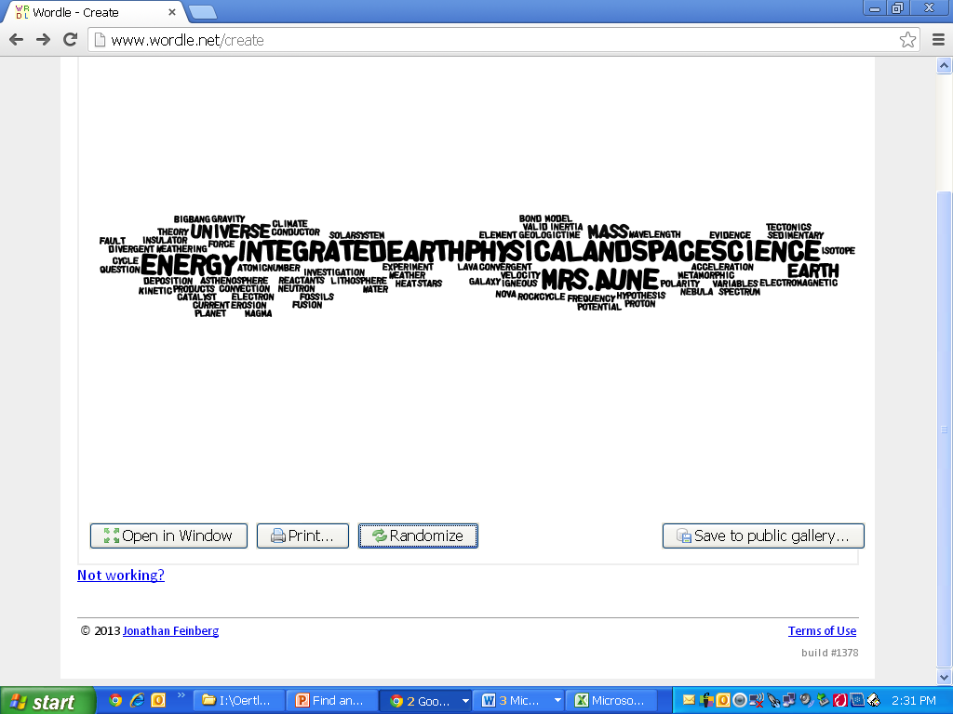  
**Room 165**

[**kpaune@mcps.k12.mt.us**](mailto:kpaune@mcps.k12.mt.us)

**728-2400 x7067**

**Expectations and Policies**

* RESPECT – your classroom, your materials, your teachers, your peers, and yourself. This one rule will make for a enjoyable school year if followed in all your classes.
* No electronics (MP3, cell phone, laptop, etc.) unless teacher approved.
* No food in class. Drinks are okay as long as they have a screw top lid.
* Be in your desk and prepared to begin our day together when the bell rings. You will need a notebook, folder, pencil and a pen, calculator, book and any assigned homework. If you aren’t in your seat and ready to go, you will be marked tardy!
* You will have a seating assignment; I will rearrange the seats every midterm. I will also select your lab groups.
* Every action positive or negative has a consequence.

*\*Sentinel High School and Missoula County Public School policies also apply in the classrooms – please see the handbook for further guidelines and information.*

**Homework**

* Expect to homework
* Assignment information and links to handouts can also be found online on my website.
  + To find my website, go to the Sentinel website, click on Staff and then on my name

**Absences**

* If you are absent, **it is YOUR responsibility to find out what you missed and make up the work**.
* Do not interrupt class to ask what you missed the previous class period come in before or after school.
* Do what you can to be here every single day – **you must be present to learn!**

**Passes**

* Please take care of any/all personal care before class begins. During 50 minute classes, you **will NOT leave the room** for anything other than an emergency.
* Passes to the restroom will be allowed during 90 minute classes IF it is a good time to take a break (work time, reading time). Students are expected to stay in class during the first and final 20 minutes.

**Assignments/Grading**

* You will have **daily work and homework, quizzes, tests, labs** and **project assignments**. The point value for each assignment will depend on the difficulty and importance.
  + You will have a cumulative semester exam that will be worth a considerable number of points.
  + If an assignment is late, you will receive half credit.
  + Late work will be accepted for up to one week.

Grading Scale

90%-100% = A

80%-89% = B

70%-79% = C

60%-69% = D

59% and below = F

Please remember that **you are responsible for your grade**. We will not seek you out to find a missing assignment or schedule a quiz/test makeup. That is your job as a student!

**Plagiarism/Cheating**

Per the student handbook, plagiarism (copying or using another’s work without acknowledging it) is a serious offense and will be treated as such.

The first instance of plagiarism or cheating (in or out of class) will result in a zero on the assignment, a call home, and a discipline referral.

The second offence will result in an ‘F’ for the semester.

**Lab Safety**

* Special rules and guidelines are in place for us to work safely in the lab. Please read through these guidelines found on pages 868-869 in your text.

**Parent(s) and Student please read and sign:**

**I have read and agree to the above coarse description, rules, policies and laboratory safety guidelines.**

**Student Name-**

**Student Signature-**

**Parent Signature-**

**Preferred contact method-**