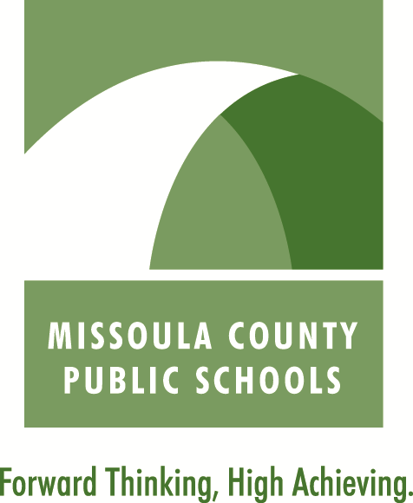
Acceptable Use of Technology Agreement
Grades K-5

Parents and Students:

Please read together, sign and return this document to the school. This document, identified in Policy 3612 “District Provided Access to Electronic Information Services and Networks,” is also available online at www.mcpsmt.org.

This form must be returned by Friday, September 25, 2015 in order for your student’s network account to remain active. Any student who does not return this form will have their network account deactivated until the completed form is submitted to the school.

Statement of Purpose:

Missoula County Public Schools believes that all students should have access to technology when they act in a responsible, efficient, courteous and legal manner. Internet access and other online services, available to student and teachers, offer a multitude of global resources. Our goal in providing these services is to enhance the educational development of our students.

Acceptable uses of technology are devoted to activities that support teaching and learning. The following are our agreements about the use of technology in MCPS schools:

Terms of Agreement

Using the computer correctly and responsibly is very important. I promise to follow these rules:

- I promise to use all computer equipment carefully and not damage, change or tamper with the hardware, software, settings or the network.
- I promise never to use any form of electronic communication¹ to harass, frighten or bully anyone.
- I promise to use the computer and the Internet for schoolwork only. I will use the programs and websites that my teacher has approved.
- I promise not to share my passwords.
- I will not view, send or display inappropriate messages or pictures.
- I promise to tell an adult if I read or see something in the computer that is inappropriate.
- I promise to obey copyright laws.
- I will not use my personal email account or any personal electronic device at school except with the permission of a staff member.
- I promise to print only when my teacher tells me to.
- I promise to use my own file or my own folder on the student server.
11. I understand that if I break any of my promises, I might not be able to use the computers.

¹ “Electronic communication” means a communication transmitted by means of an electronic device, including but not limited to, a telephone, cellular phone, computer, pager, iPod, or other mp3 or audio-video players and cameras.

Missoula County Public Schools
Acceptable Use of Technology Agreement
Grades K-5

Use of New Web Tools

As part of 21st century learning, teachers and students will be using new web tools such as blogs, wikis, podcasts and video-casts. These technologies improve students’ communication and collaboration skills, provide a real audience and extend learning beyond the classroom walls while building digital citizenship skills.

- I will act safely by keeping personal information out of my web projects. I will not give out my family name, email address, home address, school name, city country or other information that could help someone locate or contact me in person. I understand that I am not prevented from providing this information only as necessary to gain authorization for use of the web tool. I will not post identifying photos or videos.
- I will treat blog and wiki spaces as I would a classroom space, and I will use appropriate and respectful language. I will only post on school-appropriate subjects. If I include pictures on my blog, podcast, videocast or wiki, they will be appropriate.
- If I post a link in a blog, podcast, videocast or wiki, I will have read that information carefully to be certain that it is appropriate for the school community.
- I understand that if I fail to follow these guidelines, I may lose the opportunity to take part in the project.

I will sign my name to show that I will follow these rules.

Student Name (print) ________________________________________________

Student Signature ___________________________________________________

Homeroom Teacher _________________________________________________

Grade __________ Date Signed _________________________________

I have read this Acceptable Use Agreement and have discussed it with my child:

Parent/Guardian Name (print) _________________________________________

Parent/Guardian Signature ____________________________________________

Date Signed __________________________________

8/2015

