MCPS PRINT SHOP

As a new hire with MCPS we are an intricate part to your job. The print shop needs you to use the following guidelines when requesting printing:

DO’S DON’TS

Copies must be print ready No tape, No glue, No staples

Use “Print Request” for your order No Ragged edges

Standard paper size 8.5x11 or 8.5x14 large jobs with short time

Dated needed (allow enough time) check for “Copyright”

Original Books will have their spine CUT OFF. No due dates that says “ASAP”

Color ink copies need a code and principal permission

For more detailed information of our guidelines go to the MCPSMT.ORG website. 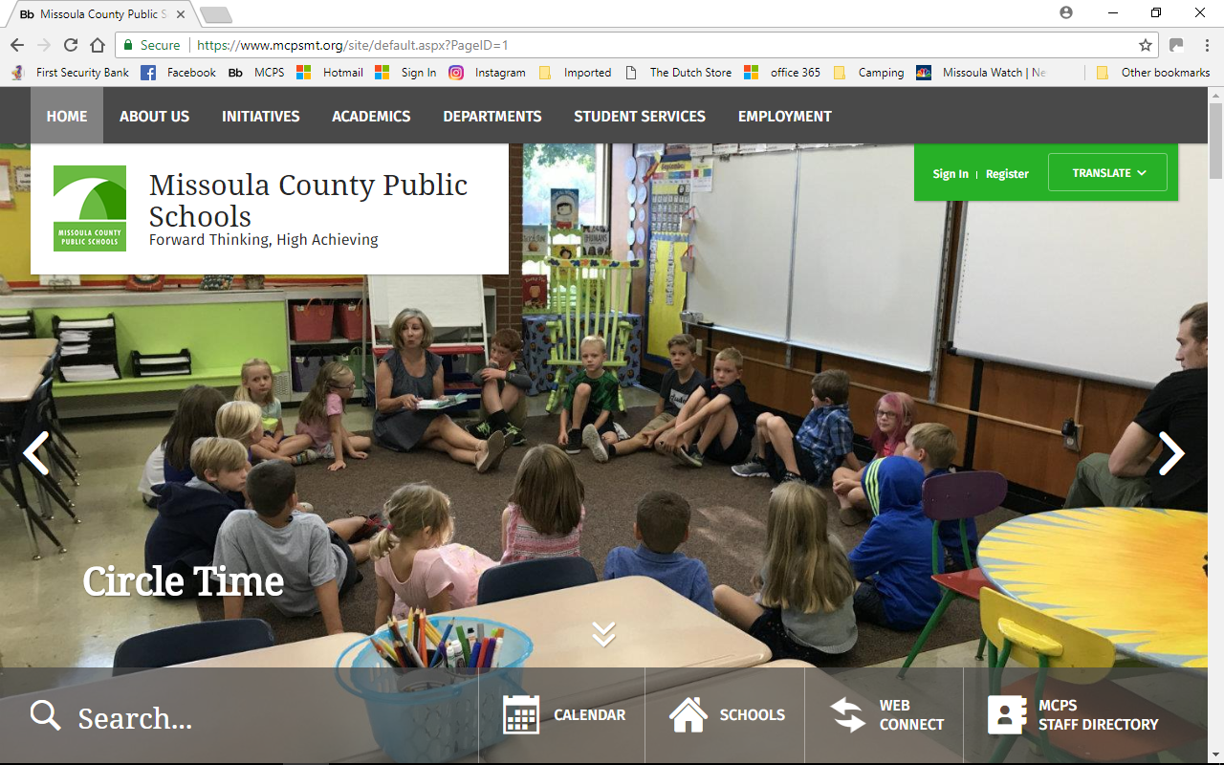 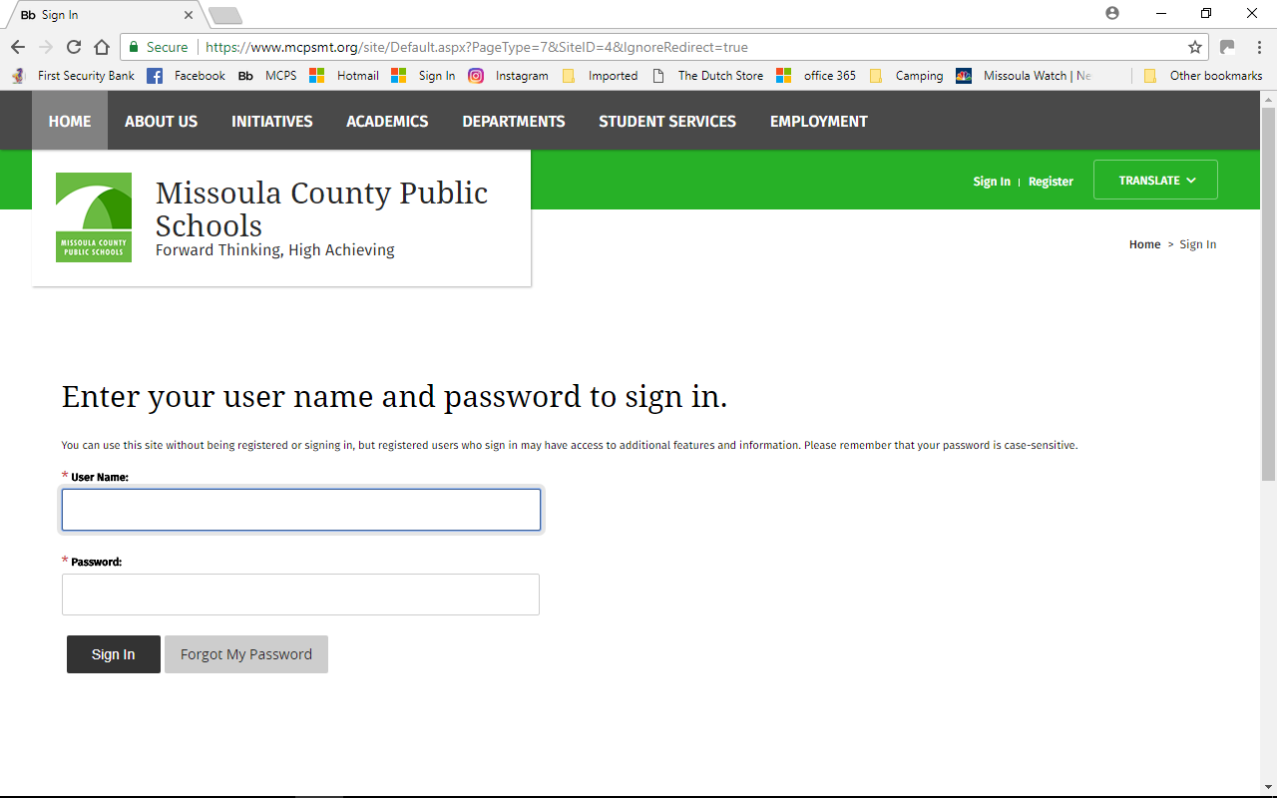

SIGN IN FIRST PART OF EMAIL ADDRESS AND PASSWORD

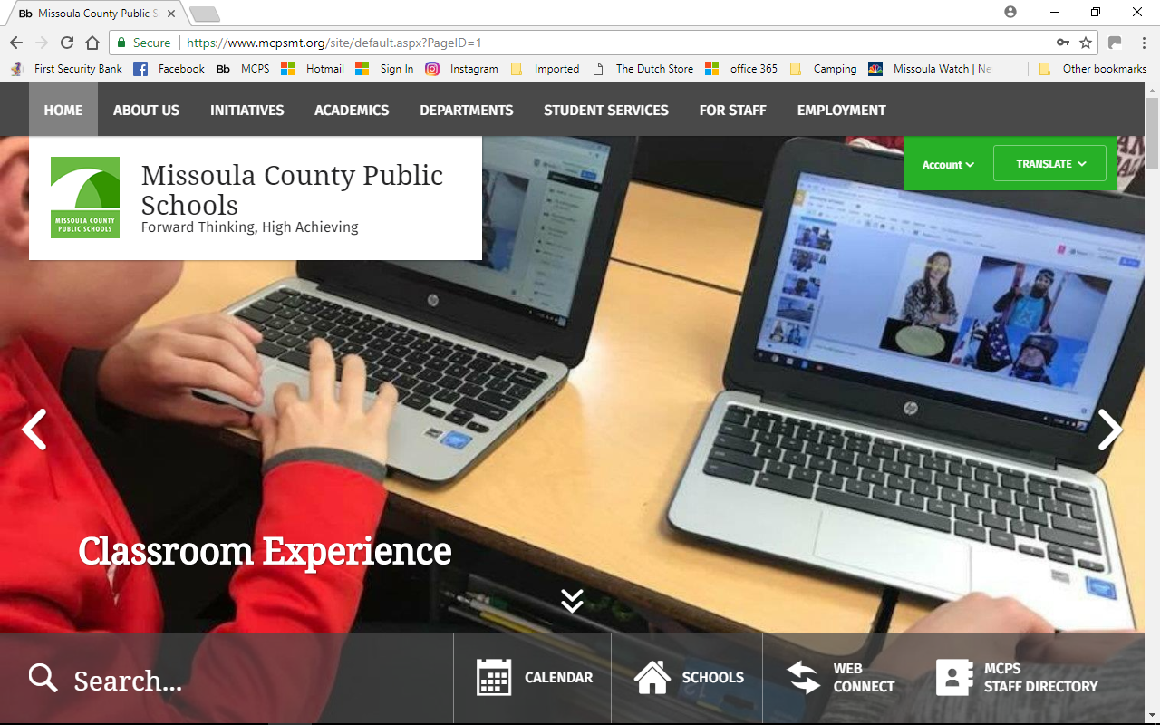 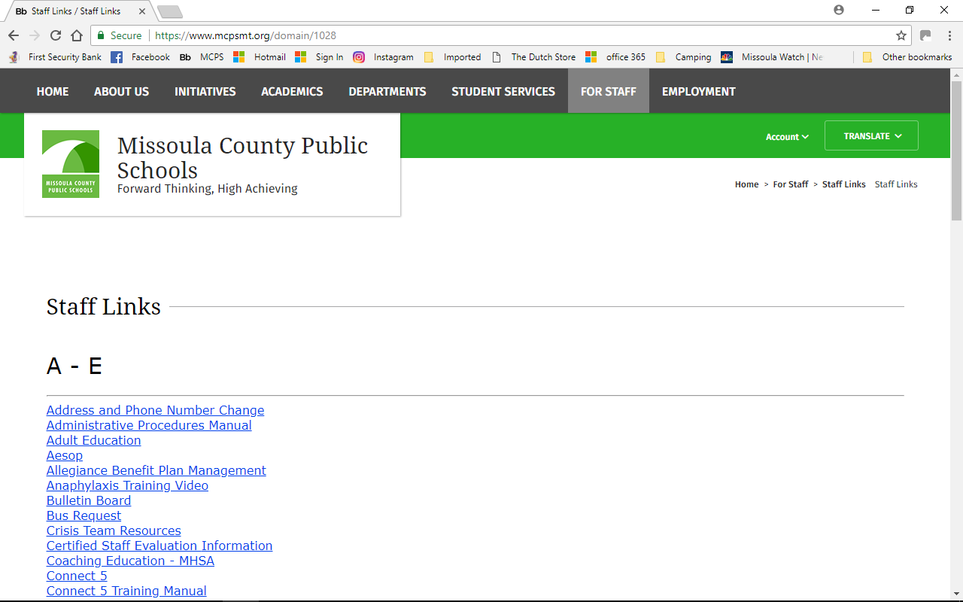

FOR STAFF STAFF LINK, GO TO K-P FOLLOW DOWN TO “Print shop Information” THERE YOU WILL FIND THE ELECTRONIC “PRINT REQUEST” AND FULL DETAILS OF REQUIRMENTS.

For more information, please contact us at extension 1069 or 1033. No question too big or too small.

Patti: Chief Charlo, Lowell, Paxson, Lewis and Clark, Meadow Hill, Hellgate, Willard, Administration building

Ramona: Russell, Cold Springs, Rattlesnake, C.S Porter, Sentinel, Seeley, Business Building

Sky: Franklin, Hawthorne, Washington, Big Sky