Introduction to Art
Modifications to the Curriculum in Pursuit of Differentiated Instruction In a homebound setting
Dustin Hoon M. Ed Curriculum and Instruction

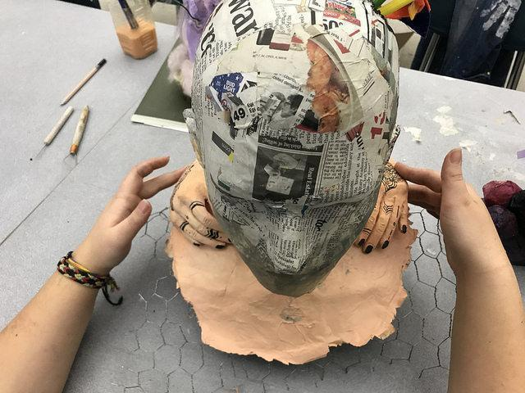
Collaborative Sculptural Piece: Introduction to Art
2018 Artists: Amelia Kim, Emilee Pollock

Making Stuff with Mr. Hoon is Fun, Challenging, Meaningful and for Everyone. Let’s get started!
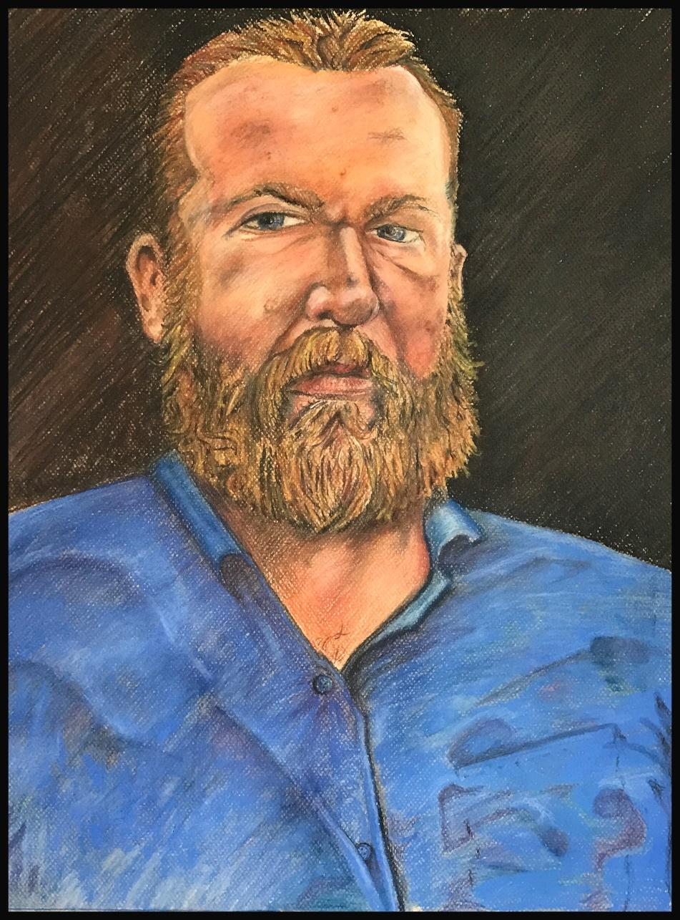

Table of Contents Note: page numbers are continually changing, as this is a workable document by Dustin Hoon
Scope and Sequence.
Color Theory.
Illuminated Manuscript.
Colored Pencil Technique.
Creature Collage.
Drawing Values.
Mixed Media Portrait.
Watercolor.
Symbols.
Linear Perspective.
Color Theory & Portraiture.
Color, Design and Scratch-Techniques.
Sequential Art.
Puppetry.

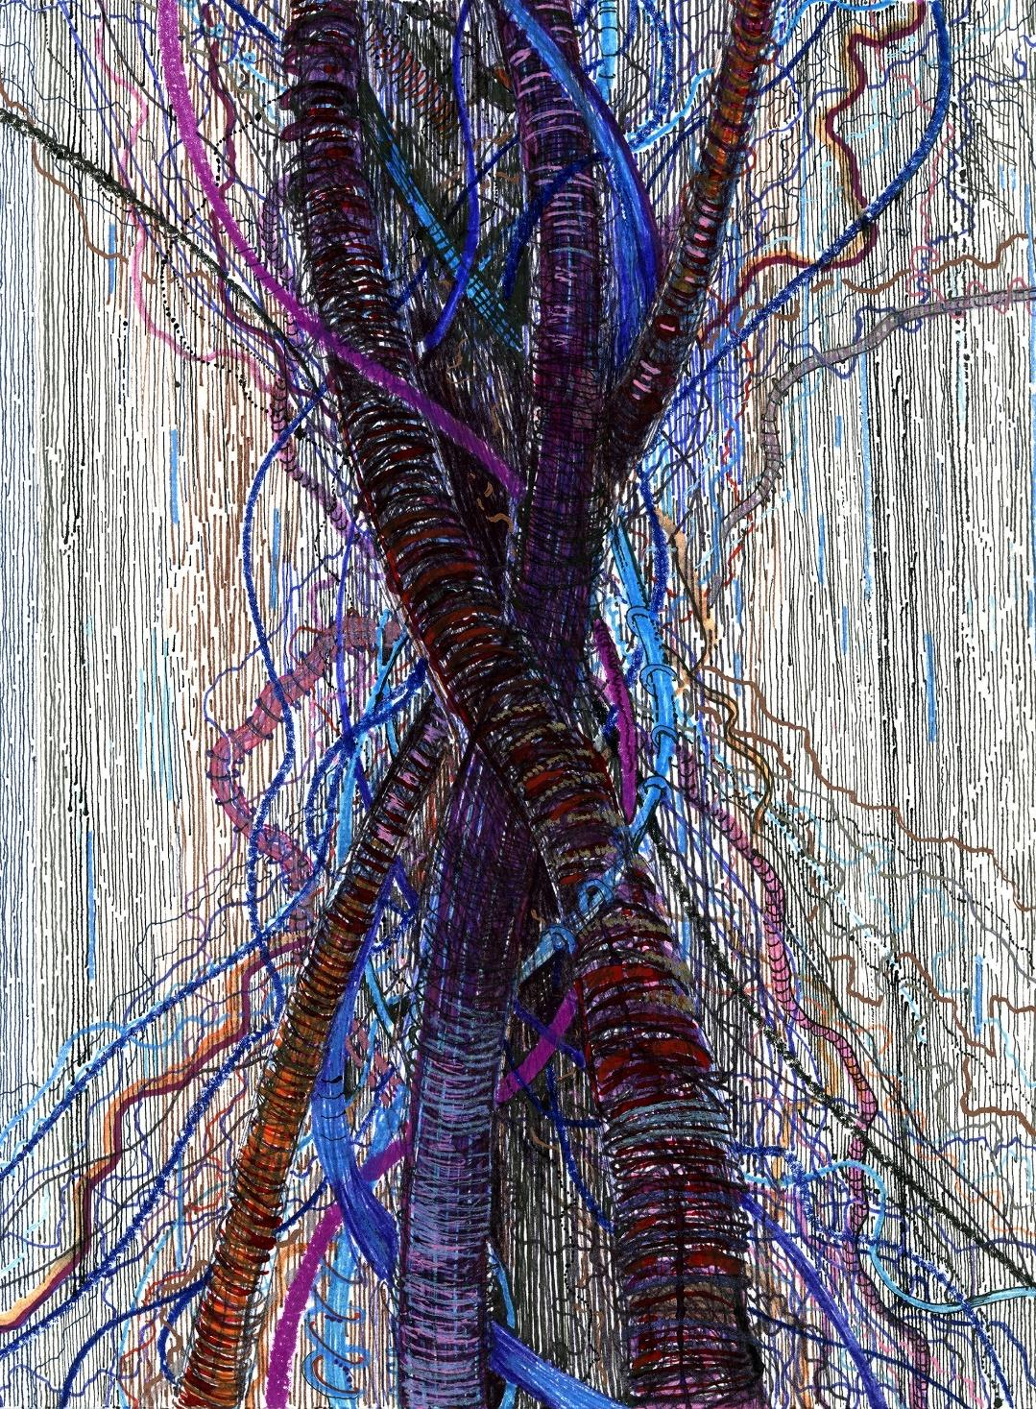
‘School Tension’ : Dustin Hoon Artist, Mixed Media on Hot-Pressed Paper
Modified Instruction Concerning Introduction to Art
- Mission:
The visual art studio embraces inclusion and collaboration for public school students of all aptitudes and abilities; however, there are special circumstances that demand schooling outside of the classroom environment. In that event, it is the obligation of the instructor to modify instruction in pursuit of equity and relative parity between all students enrolled in the class. This goal presents a formidable challenge for: teacher, student and family alike. With planning and teamwork, all parties involved can realize a meaningful experience in keeping with the national standards for visual art.
- Methodology:
Students qualifying for homebound instruction, 504 designation in the classroom or outside of the classroom and those with specific Individualized Education Plans may use the following specialized curriculum in order to thrive. This home-bound instruction is fully realized and best used with internet access, as web-links are coupled with book references for tutorial purposes.

Inclusion and Collaboration

Inclusion is an integral part of a dynamic art studio embracing diversity, reality and socio-economic and cultural plurality.

When students follow art lessons outside of the classroom or studio environment, collaboration must shift from the valuable learning among classroom peers to parents and students. To ignore the critical importance of the classroom environment is wrong-headed and unhelpful; however, it behooves the educational professional to develop alternatives to enhance the home-art experience in light of this truism. This is in the interest of all learning parties, as federal law requires that public school offers the student a least restrictive environment.

Consider the Following Standards, Images, Rubrics and Tutorials.
- All two-dimensional artwork may be done in a sketchbook, with the exception of painting projects that require specific paper. Please consider the national standards below and the applicable Summative Assessment tool regarding creation and performance. The tutor, parent or teacher may use Summative Assessment evaluation tools listed after the standards for each project generally, whereas, the Formative assessments are project specific. Formative assessment i.e. practice, exercises, and on-going critique are found within each project. Students, Families and Tutors may use the Creating Summative Assessment Tool as a guide for ‘grading’ any of the following lessons’ products
National Art Standards.
https://www.nationalartsstandards.org/sites/default/files/Visual%20Arts%20at%20a%20Glance%20-%20new%20copyright%20info.pdf

Missoula County Public Schools Curriculum for the Visual Arts
https://www.mcpsmt.org/cms/lib/MT01001940/Centricity/Domain/959/Visual%20Arts%20Curriculum%202017.pdf

The Creating Standard is the Most Ubiquitous Anchor Standard, as it is used throughout the entirety of Introduction to Art. Teachers may find the M.C.P.S. Curriculum for Visual Arts in the reference page of this Document.
The Creating: Anchor Standard is implicit to all of the following lessons; However, each lesson has an additional Anchor Standard that informs the lesson.

CREATING:
Anchor Standard 1: Generate and conceptualize artistic ideas and work.

- Enduring Understanding: Creativity and innovative thinking are essential life skills that can be developed.
- Essential Question(s): What conditions, attitudes, and behaviors support creativity and innovative thinking? What factors prevent or encourage people to take creative risks? How does collaboration expand the creative process?
Anchor Standard 8: Interpret intent and meaning in artistic work.
• Enduring Understanding: People gain insights into meanings of artworks by engaging in
the process of art criticism.
• Essential Question: What is the value of engaging in the process of art criticism? How can
the viewer “read” a work of art as text? How does knowing and using visual art
do vocabulary help us understand and interpret works of art?

The Following Rubric serves as a summative assessment in looking at a piece of art. It should be noted that in conjunction with critique this tool affords teacher and student alike formative and summative assessment. Critique is critical to the visual arts. In process and result it adds meaning to a subjective artistic experience. In critique student and teacher aspire for:
- Observation of various cultural understanding of Artistic Meaning and Aesthetics
- Articulation of Elements of Art and Principles of Design that may exist in artistic examples
- Expression of feeling and appreciation for the judgment of aesthetic sensibilities
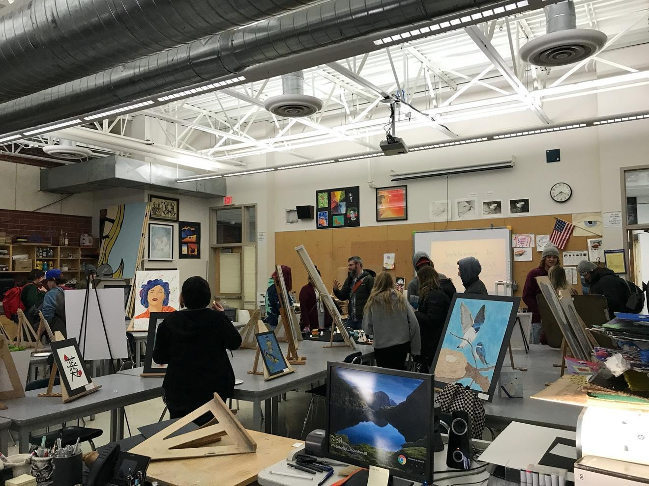
Students and Educators Discuss Art at a December Art Show in Mr. Hoon’s Classroom Big Sky Highschool
Generic Standards Based Summative Evaluation Tool

Score of 4
Sharing and Explaining personal art and other artworks
Observing, listening, recognizing and explaining artistic themes in contemporary and historical artwork
Making connections between historical and contemporary artwork, while ascribing meaning
Articulating judgments about aesthetic sensibilities with confidence
Score 3.5
In addition to Score 3.0 performance the student conceptually connects the cultural and external sources of art with their own work through explanation, creation and critique.
Score 3 = Proficiency
VA: Re9.1. IIa Determine the relevance of criteria used by others to evaluate a work of art or collection of works. Articulate what is seen in artwork. Recall descriptive elements of art while observing artwork.
- I can share, explain, and interpret visual art using elements of art and principles of design.
- I can make connections between my own personal work and historical or contemporary artwork.
Score 2
The student:
- Recognizes or recalls specific terminology, such as while describing what they see in the artwork:
  - Elements of art and Principles of Design
Score 1.5
With help the student articulates understanding and sharing simple details involving art and critique.
Score 1.
The student makes few connections within the artwork and what they see in the artwork.
General Art Creating & Refinement Rubric
Anchor Standard 3: Refine and complete artistic work.

• Enduring Understanding: Artists and designers develop excellence through practice and constructive critique, reflecting on, revising, and refining work over time.

• Essential Question: What role does persistence play in revising, refining, and developing work? How do artists grow and become accomplished in art forms? How does collaboratively reflecting on a work help us experience it more completely?

VA:Cr3.1.IIIa Reflect on, rengage, revise, and refine works of art (or design) considering relevant traditional and contemporary criteria as well as personal artistic vision.

I can work within a studio environment ensuring the safety of myself and others.

I can use aesthetics to describe and produce artworks.

I use my studio-time wisely by questioning, collaborating, and making works of art.

I can use constructive criticism in order to articulate my aesthetic sensibilities and revise my work.

Grading Rubric

(Visual Arts)
M.C.P.S Curriculum for the Fine Arts (Introduction to Art) Summative Evaluation
Aligned with National Standards
CREATING:
Anchor Standard 1: Generate and conceptualize artistic ideas and work.

● Enduring Understanding: Creativity and innovative thinking are essential life skills that can be developed.
● Essential Question(s): What conditions, attitudes, and behaviors support creativity and innovative thinking? What factors prevent or encourage people to take creative risks? How does collaboration expand the creative process?

core 4.0 | The work leads by example, inspires interest and inquiry. The work shows a highly resolved surface with clear understanding of the Elements of Art, Color Theory & the Principles of Design. When pressed, the artist would have no trouble relating to their work and communicating its meaning, construction, completion and desired outcome.
Score 3.0  Proficient  90% | VA:Cr1.1.Ia Use multiple approaches to begin creative endeavors.  ● I can demonstrate an understanding of the Elements of Art and the Principles of Design.  ● I can brainstorm an idea for a project and either develop a plan to complete it or ask for help in developing a plan.  ● I can make a visual product. (Meeting the teacher’s learning targets)  ● I can collaborate with others in the creative process.
Score 2.0 | Media application shows thought and effort in most cases throughout the picture plane. Image space exhibits application appropriate for the desired result-even if abstract and expressive. If abstract and expressive, a thoughtful distribution of: line, shape, color, value, form, texture and space is evident; however, the piece shows differences in effort through inconsistent application of media, some areas highly resolved, others not so.
Score 1.5 | Evidence of few Elements of Art are present in the ‘example’ submitted and may or may not represent an effort of time, thought and production on the part of the artist. With focus, effort and attention to the rubric and instructor’s defined learning targets the student will have more to share at a future time. | Bottom Line: (The work exists, yet lacks time, significant thought for composition and effort). The overall work is incomplete and not consistent with the learning targets of the assignment.
Score 1.0 | Materials and marks may exist but work in progress is not clear in any recognizable way. There is no intention on the part of the artist to explain the example given.

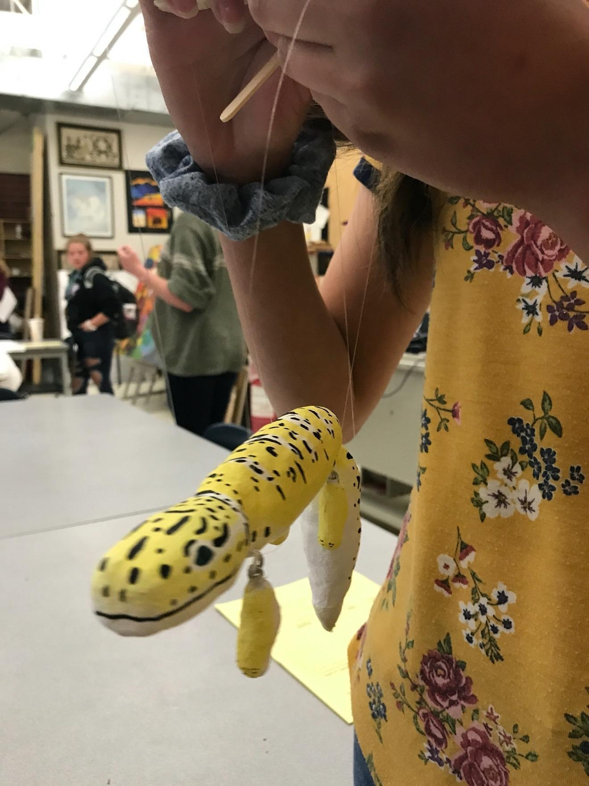
Students critique marionette

Scope and Sequence of this Homebound Curriculum Document: A Note from the Author

Savvy art teachers and teachers in general are well-versed in drawing from a variety of source material in order to deliver quality instruction and augment existing district-approved curriculum i.e. technical manuals, textbooks, YouTube tutorials, guest presenters etc. The scope and sequence are purposefully flexible in this case, to allow for change by the user. Unlike a textbook or rigid curriculum document, this curriculum supplies objectives, formative and summative assessment tools coupled with methodology supported largely by digital hyperlinks to YouTube tutorials, pictures of student and teacher artwork and a bibliography of text that has proven invaluable to my instruction.

Think of this document as a friend suggesting ideas for the homebound tutor, student, family or teacher. A series of lessons are provided without the confines of units or timelines. This arrangement allows the instructor or facilitator to pick and choose the order of lesson instruction. This flexibility is the first and most important gift to the instructor. Freedom of instructional movement helps students with individualized education plans, exceptionalities or other special circumstances cater their educational plan regarding the constraints of time and other needs. Conversely, an instructor and student may choose to follow the document’s recommendations and order to the letter. Ultimately this is a plastic document, meant to change over time and in response to educational demands. I would like to stress that this curriculum document is a guide that is designed with a homebound scenario in mind but is equally useful in the classroom. Afterall, the public-school classroom is the ultimate avenue for success provided adequate supplies and effective pedagogy.
Dustin Hoon

Color Theory and Application
Creating
Anchor Standard 1: Generate and conceptualize artistic ideas and work.
• Enduring Understanding: Creativity and innovative thinking are essential life skills that
can be developed.
• Essential Question(s): What conditions, attitudes, and behaviors support creativity and
innovative thinking? What factors prevent or encourage people to take creative risks?
How does collaboration expand the creative process?
It should be noted that color and its three properties of value, hue, and intensity feature prominently in the visual arts. Beginning a year of Introduction to art with fundamental concepts like the Elements of Art, Principles of Design, color theory and drawing fundamentals is one approach. Much like other disciplines, fundamentals, are just that, fundamental. It is important that students and teachers realize that fundamentals are always present as concepts, techniques and applications evolve and mature.
https://www.colormatters.com/color-and-design/basic-color-theory
https://www.tigercolor.com/color-lab/color-theory/color-theory-intro.htm

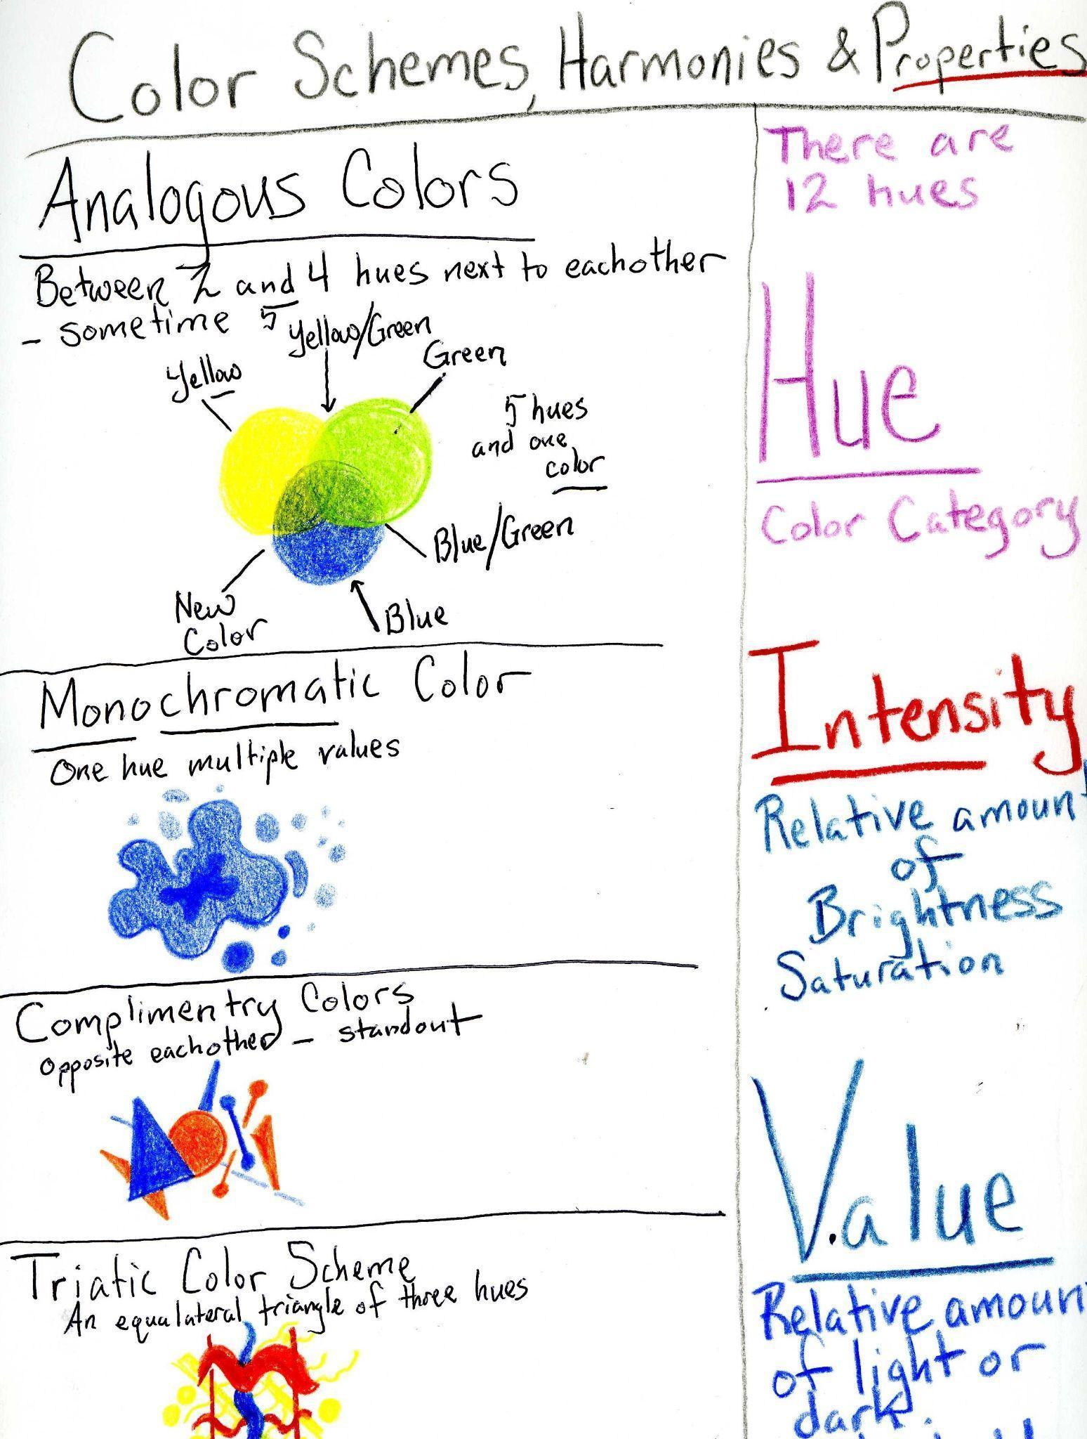

Understanding color relationships early allows the student to mature artistically over time.

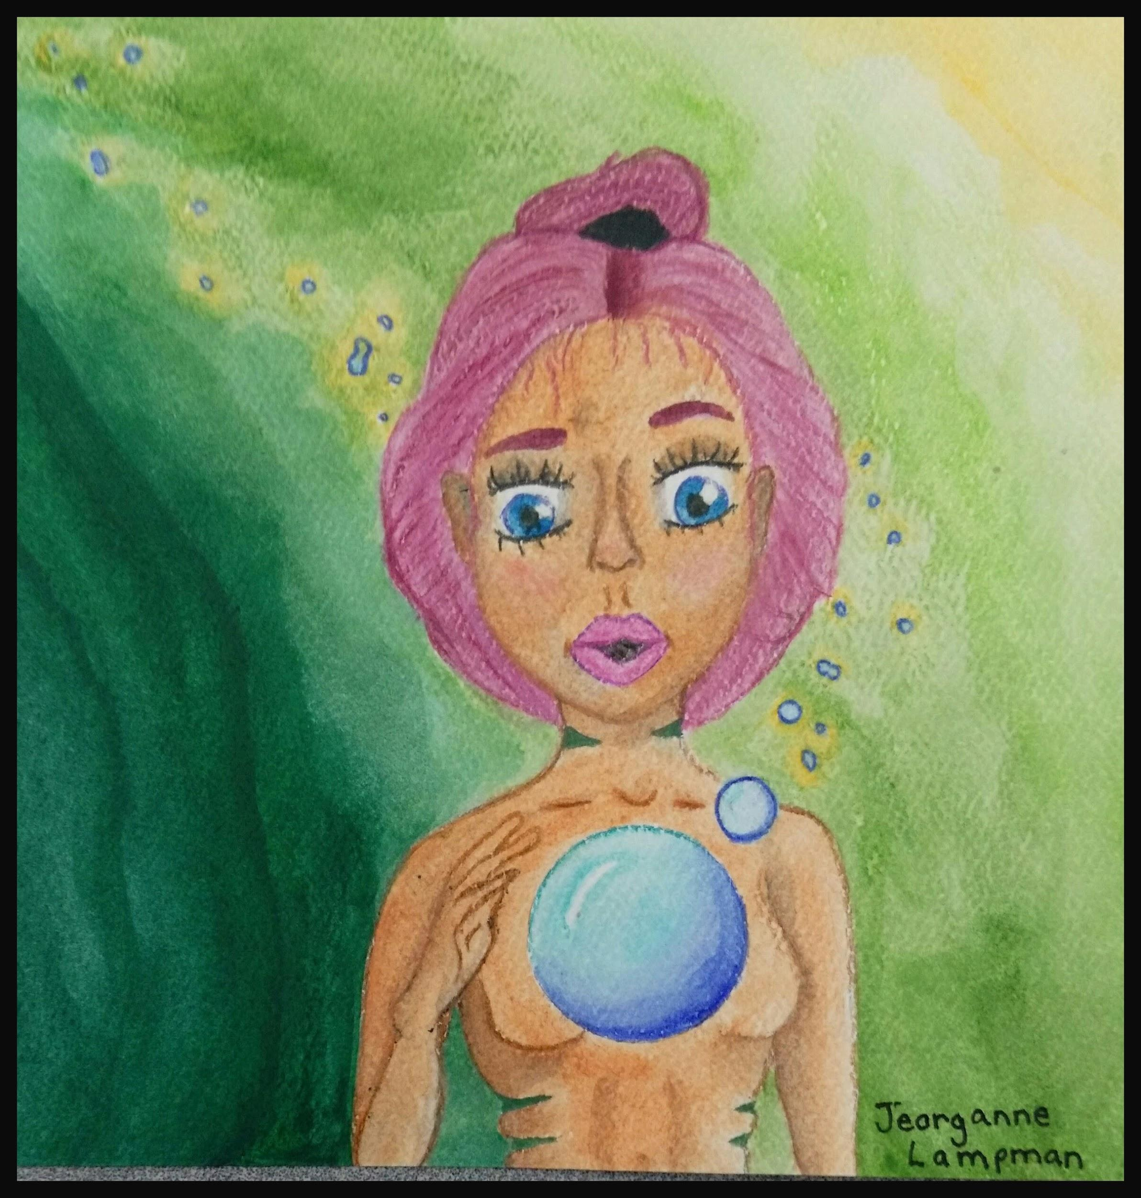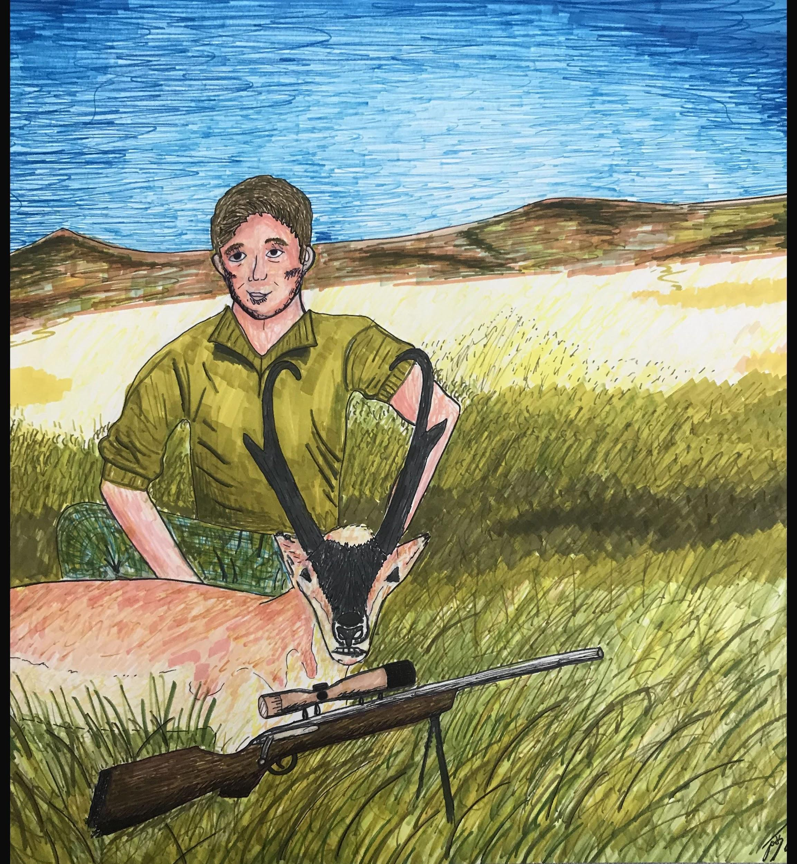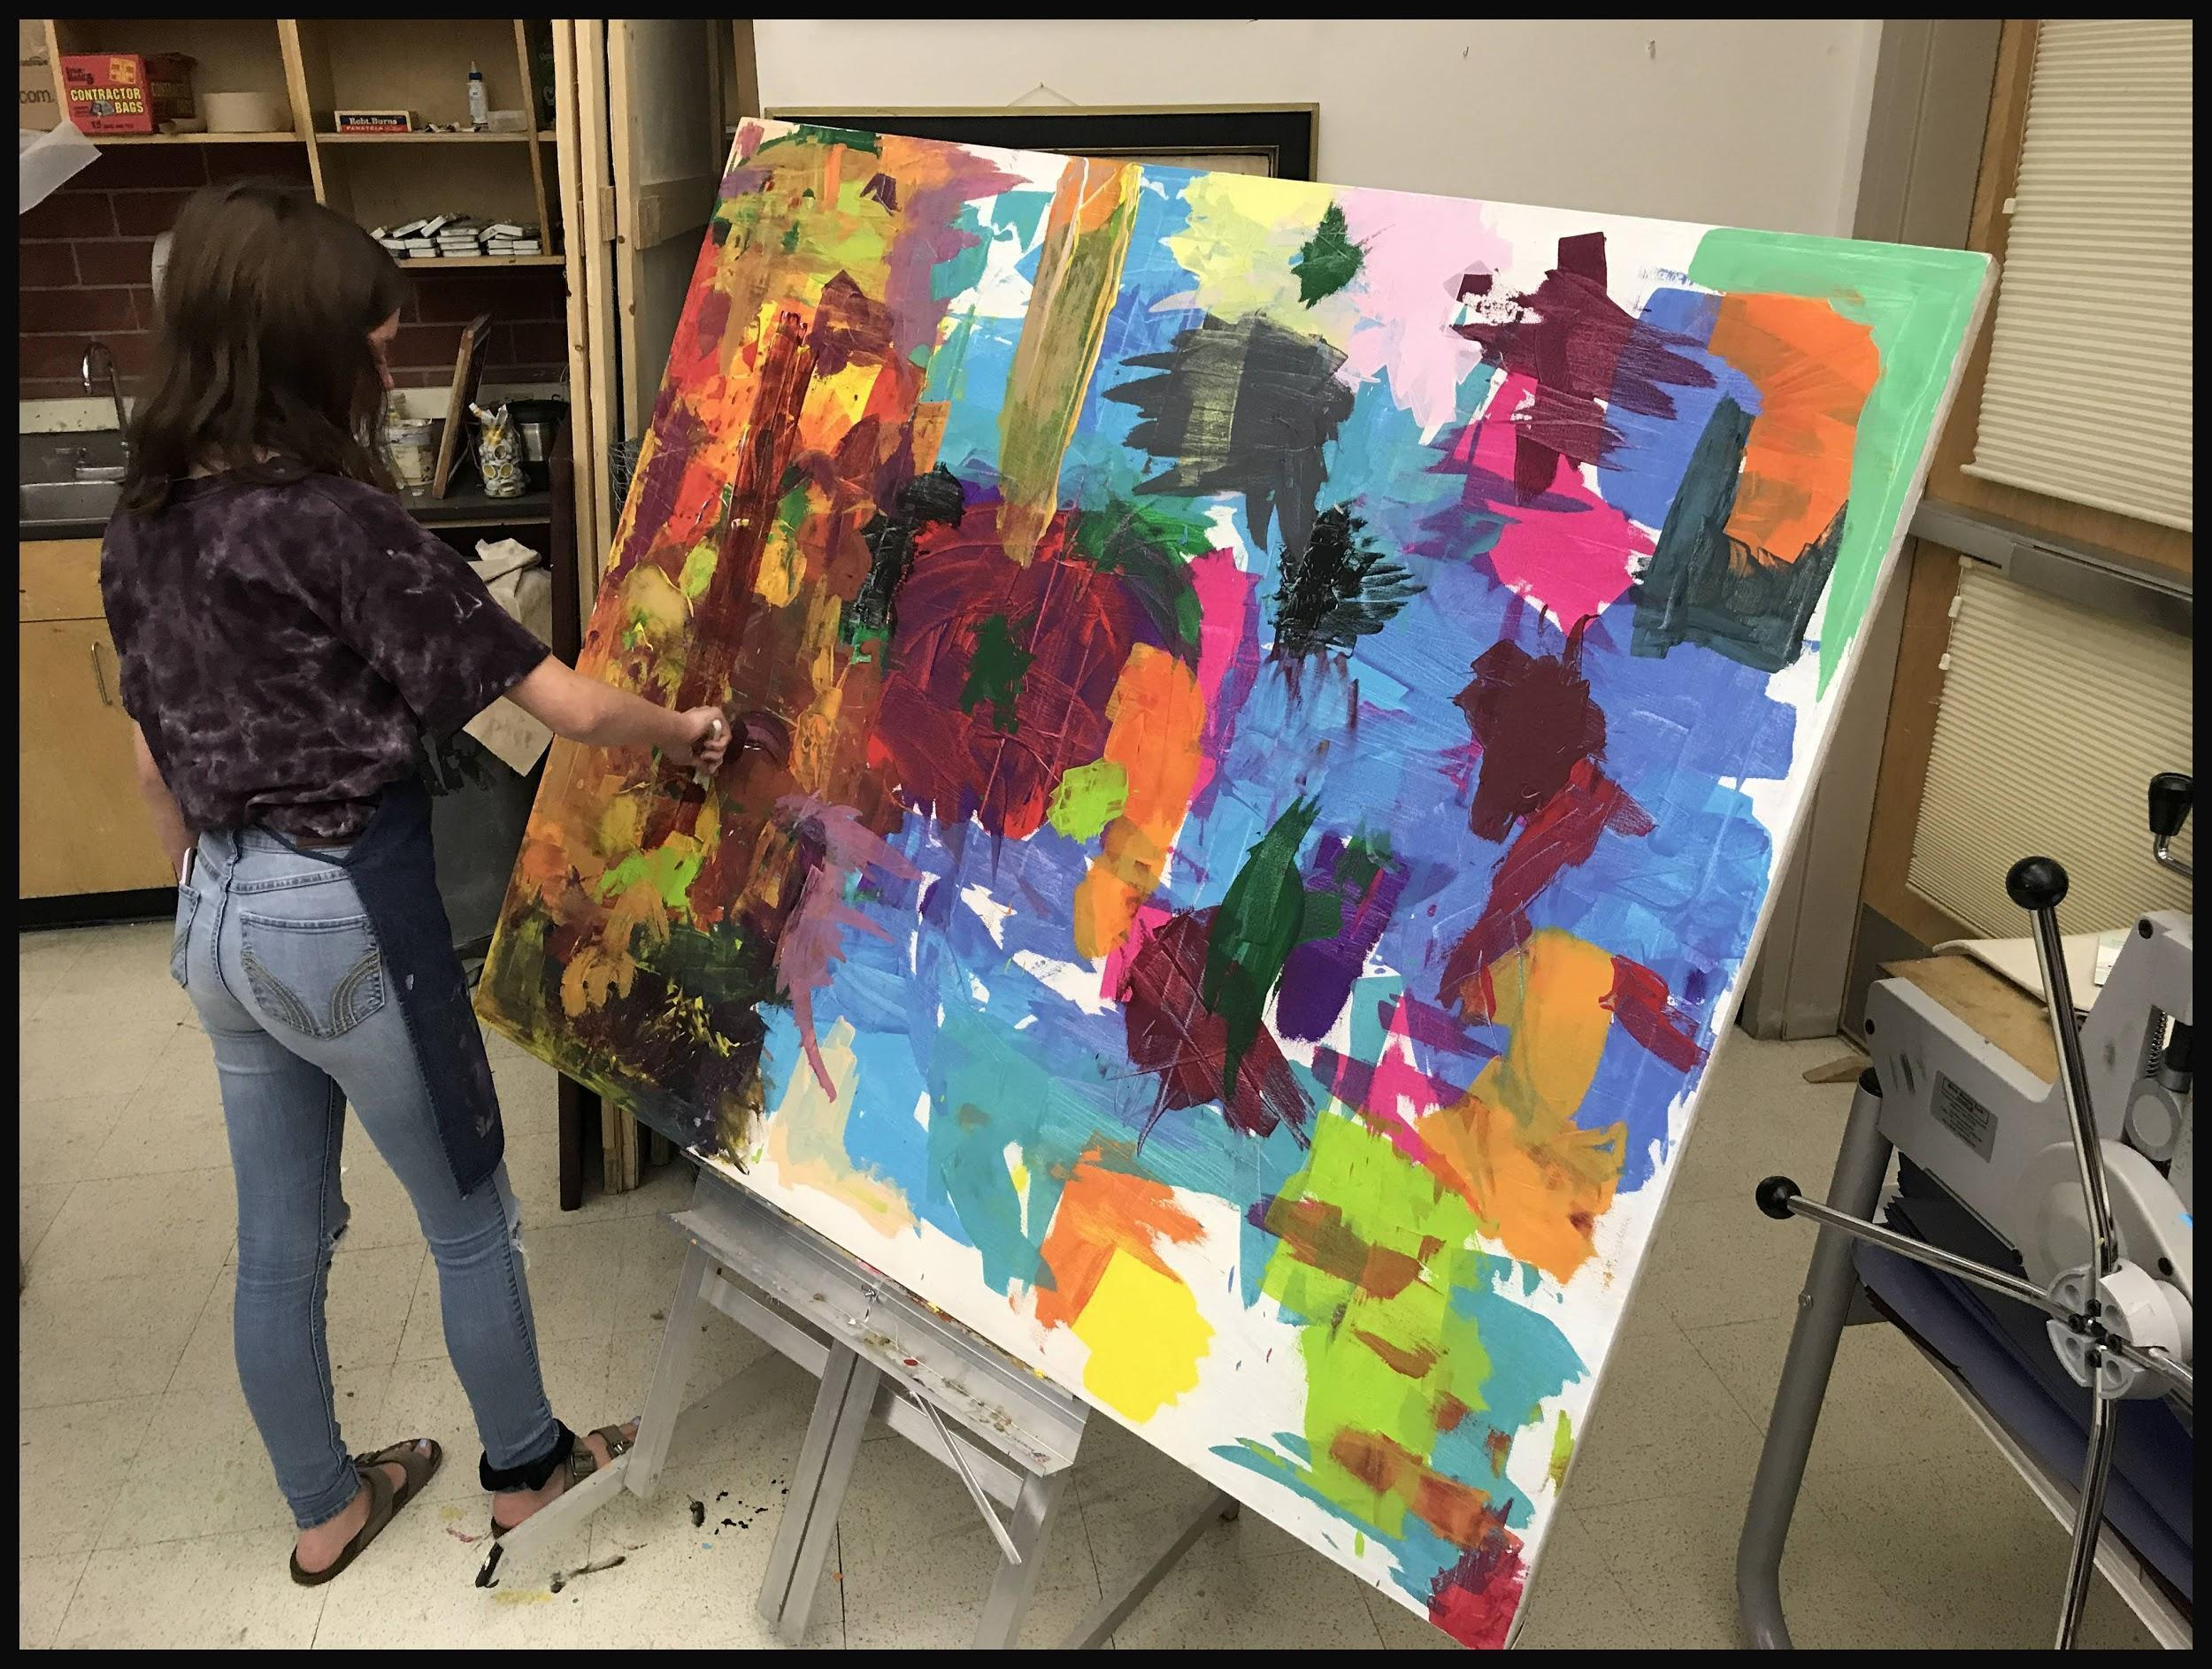
Artist: Jeorganne Lampman Artist: Josh Smalley Artist: Alissa Sampson

Exploring Pattern, Mosaic, and Color Theory through the Construction of a Wax Mandala
Objective:
The student begins the journey to appreciating color through the construction of a mandala. The student may choose to create the mandala with collage, paint or with the following wax mosaic.
What is a Mandala?
a schematized representation of the cosmos, chiefly characterized by a concentric configuration of geometric shapes, each of which contains an image of a deity or an attribute of a deity.

Click the weblink below:

https://youtu.be/GA3su0ECdPc

What is a mosaic?

a picture or decoration made of small, usually colored pieces of inlaid stone, glass, etc.

Artistic Objective: 1. to consider the composition of a mandala
2. to organize small pieces of colored wax, cut from crayons, into a composition inspired by the observation of mandalas 3. to compose a visual work of art that shows Warm vs. Cool color arrangements. 4. to recognize that cool colors are “recessive” and warm colors are “salient”

Consider the following questions:

What does salient mean when considering color?
sa·li·ent
adjective
1.
prominent or conspicuous: salient traits.
2.
projecting or pointing outward: a salient angle.
3.
leaping or jumping: a salient animal.
4.
Heraldry . (of a beast) represented as leaping: a lion salient.

What does recessive mean when relative to color?
Recessive
Adjective
1.Tending to move to the background

Assessment of Art:
I have cut pieces of crayon into small pieces.

I have glued those pieces onto a support (board or paper) in order to construct a mandala design.

I have used mosaic technique in order to construct my piece.

I can glue with care.

I have arranged the composition into cool and warm colors.

I have established recessive shapes.

I have established salient shapes.

I have melted the wax together

I have completed the project
No negative space is without color

Illuminated Manuscript Using Calligraphy and Mixed Media
Incorporating a Historic Calligraphy Style in the students’ Visual Composition
Objectives: By fusing the methods of the masters with their own imagination and visual voice, students will create a unique illuminated manuscript page
Students will:
View examples of Historic Calligraphy in an attempt to synthesize pre-existing styles with students own imagery.
Write down and discuss vocabulary, specific artists, and relative concepts involving the techniques and styles of historic artists and their methods.
Review and apply specific elements of art to their own illuminated manuscript.
SOME RESOURCES: Art History Calligraphy Images, accessed 1-7-13, Bing search engine; http://www.bl.uk/catalogues/illuminatedmanuscripts/ILLUMIN.ASP?Size=mid&IllID=22878
Assessment Grading:
Part I. Using visual aids, and texts, students will view instructional information, define vocabulary, identify an artist and their work, and complete the following tasks in their sketchbook (worth 30 possible points):
- Name three artists and the culture and time period that they worked.
- Replicate 3 styles of calligraphy from various times, in alphabet form, in their sketchbook (including foundational).
- Identify elements and principles of art that are specific to a form of Calligraphy that the student finds appealing
Part II. (Worth 200 possible points) Part III. (Instructor will evaluate work:100 pts.)
- Students will use vellum or rice paper as a support for their calligraphy and imagery. Using their references, pen handles, brushes, nibs, etc. students will lay out their composition.
- Through demonstration and references given by the instructor, students will apply knowledge and synthesize this knowledge into an illuminated manuscript using a favorite form of calligraphy, (a piece of visual art).
- Students will display their work, while verbally, and in writing, educate their peers as to the elements present in the work, along with the compositional components of their piece of art. Their notes may inform their critique.

Illuminated Manuscripts

Anchor Standard 8: Interpret intent and meaning in artistic work.
• Enduring Understanding: People gain insights into meanings of artworks by engaging in
the process of art criticism.
• Essential Question: What is the value of engaging in the process of art criticism? How can the viewer “read” a work of art as text? How does knowing and using visual art
vocabularies help us understand and interpret works of art?

Objective:
Students will explore the history of illuminated manuscripts, compare and contrast with other examples of calligraphy from different regions of the world. Students will experiment with pen and ink techniques using a traditional European calligraphy pen. Students will fill one three pages of sketchbook with pen and ink exercises: strokes and line work, spacing, and various scripts. Students will define and know terminology associated with calligraphy and calligraphy techniques. Students will use successes and failures learned in practice in order to create their own Illuminated Manuscript combining drawing, color and the written word.
Watch: Illuminated Manuscripts BBC Documentary with the following click-link:
https://youtu.be/HVM9qvUohO0

Consider these questions:
- What Elements of Art or Principles of Design Apply to Calligraphy & Illuminated Manuscripts?
- How does drawing, writing and design merge in Illuminated manuscripts?
- How does culture influence art and writing?

Exploring European Calligraphy Techniques
Watch the following internet links for tutorials on Calligraphy Techniques:
https://youtu.be/sBoVGqiSzr4
https://youtu.be/Rql8Qq3DMlk

Consider the following terms and attempt to define them in your sketchbook and on this rubric: 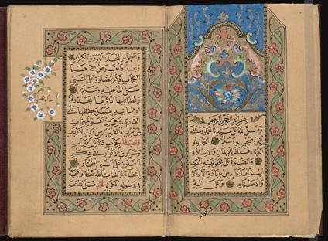
Illuminated Manuscript
Calligraphy
Majuscule
Minuscule
Nib
Serif
Versals
Pen angle

I can space my calligraphy in a presentable way
My work fills the entire page

I can use the proper paper for the medium  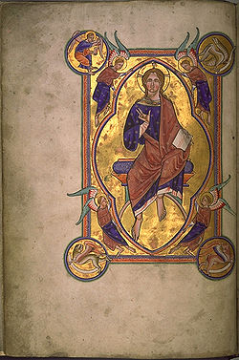 | I have shown extreme detail in either positive or negative space
I have included patterns and designs supporting my imagery. | I have created a complete piece of art based on the materials and the knowledge given
I have presented my work for critique.
I can write in an that is evenly spaced.
My drawing is fully colored with values | I have filled the page leaving little to no white paper behind.

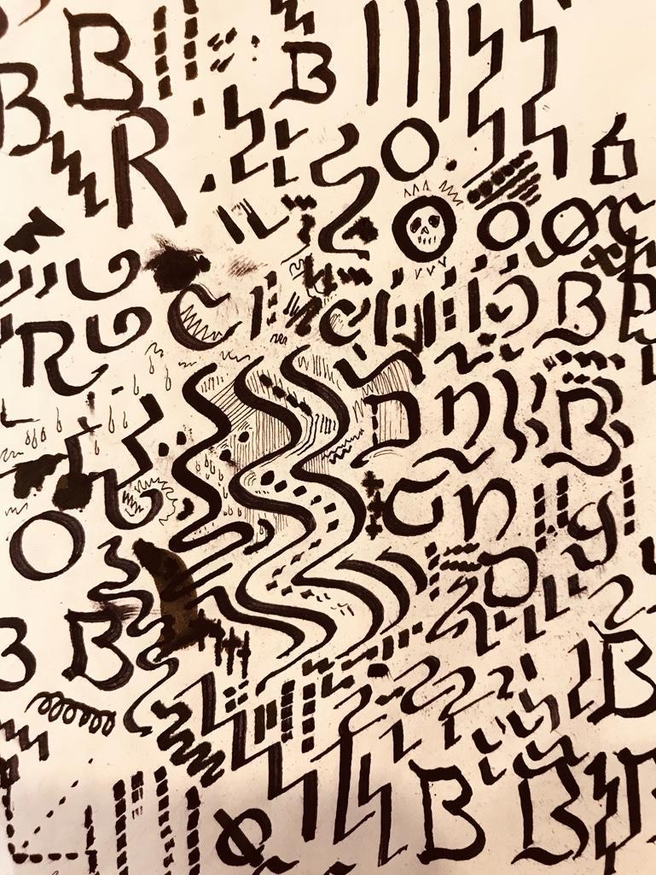 Practice Strokes One Full Page of Sketchbook
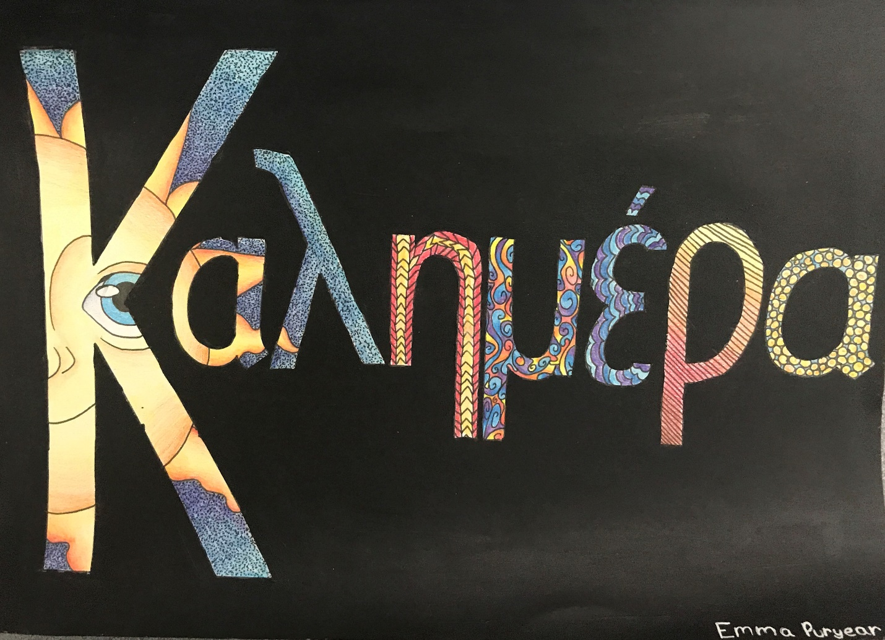
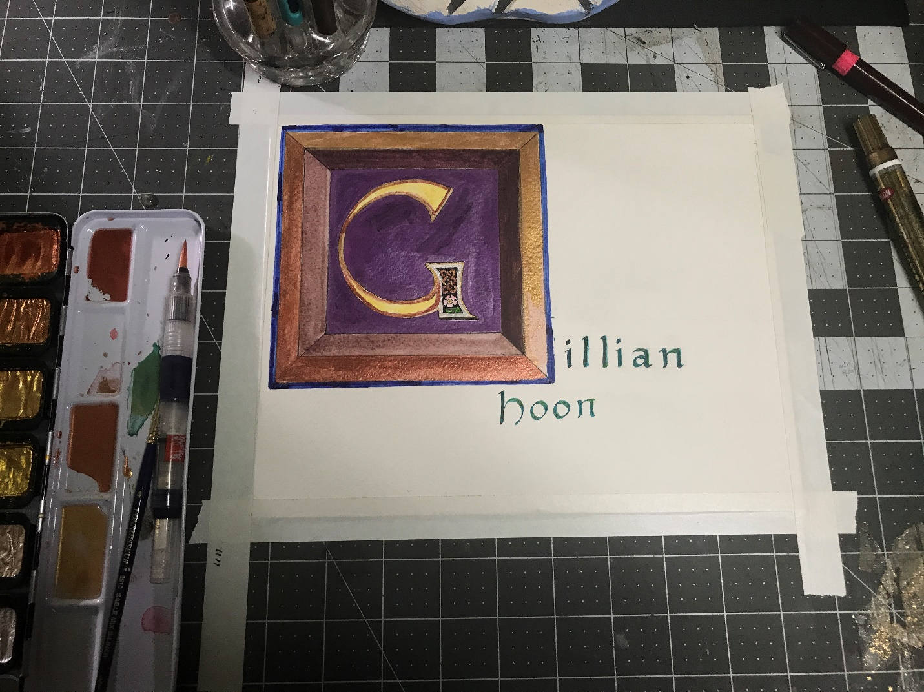
Process
Experimenting with Colored Pencil
Anchor Standard 1: Generate and conceptualize artistic ideas and work.
Objective:
Students will create a series of color combinations using colored pencil as a medium. Students will layer pencil using light pressure and gradually increasing pressure with each successive layer of colored pencil. Students will experiment with gradation of values through hatching, cross-hatching, and varied pressure. Students will explore basic color theory; specifically, how mixing complementary colors yields neutral colors.

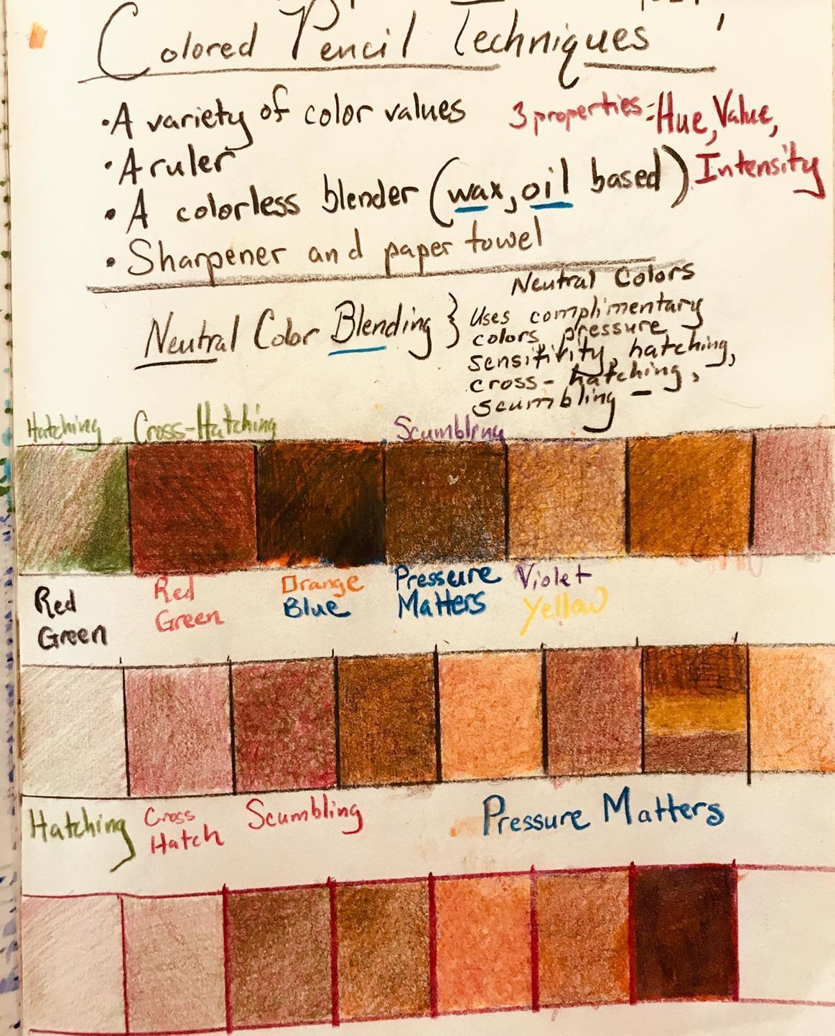Example: Dustin Hoon

Assessment and Evaluation:
This is an exercise intended to support more resolved and complex works of art in future. Formative assessment is implied. The tutor inserts themselves and scaffolds the student mindful of the tactile aptitude of the student, assessing hand-eye coordination and understanding of color application and blending of media.
Tutorials on Colored Pencil Application
https://youtu.be/P5VIfFETIe8

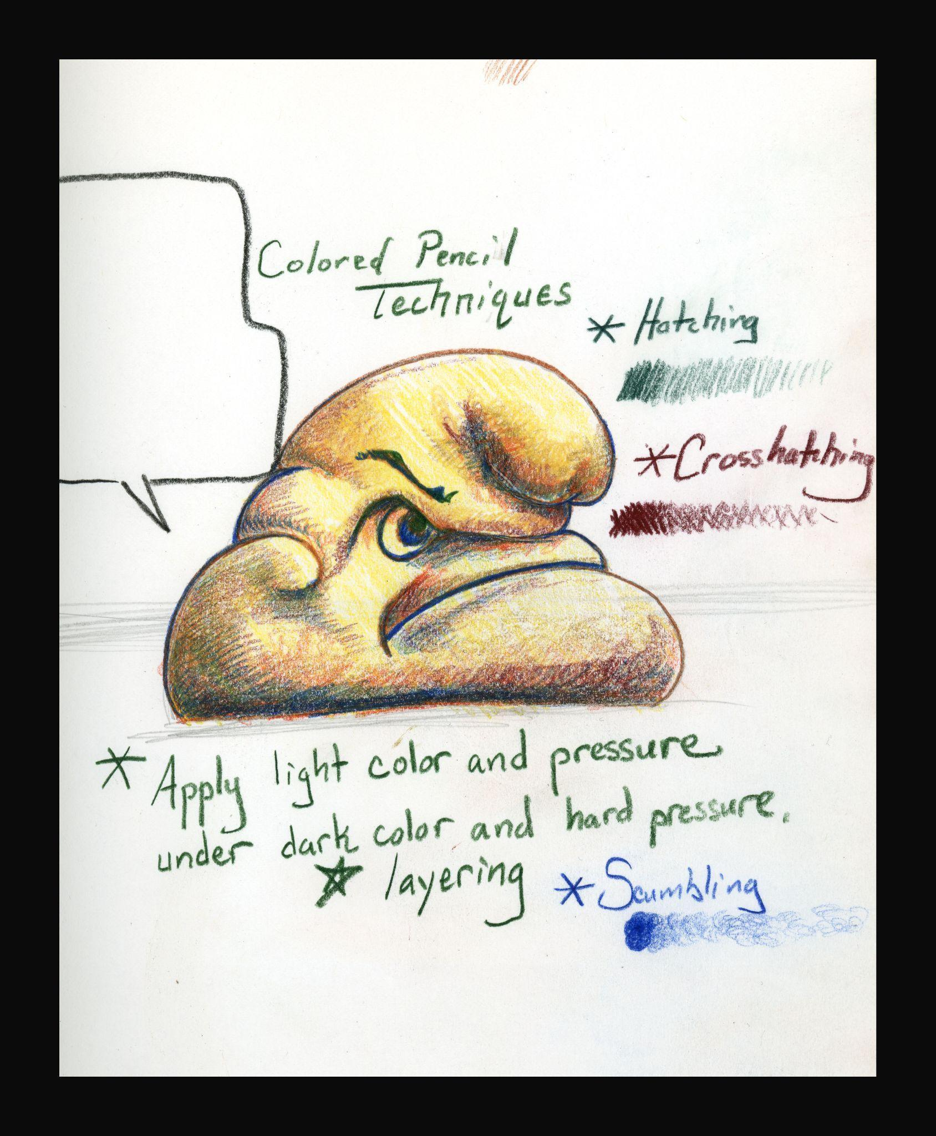

Creature Collage
Anchor Standard 3: Refine and complete artistic work.
• Enduring Understanding: Artists and designers develop excellence through practice and
constructive critique, reflecting on, revising, and refining work over - time.
Essential Question: What role does persistence play in revising, refining, and developing work? How do artists grow and become accomplished in art forms? How does collaboratively reflecting on a work help us experience it more completely?

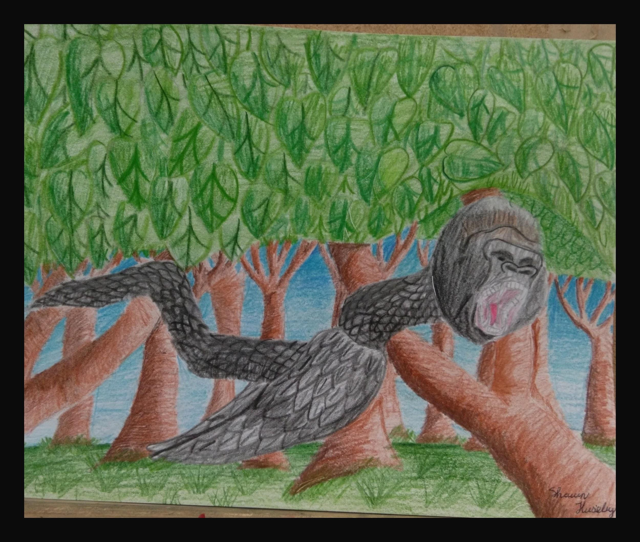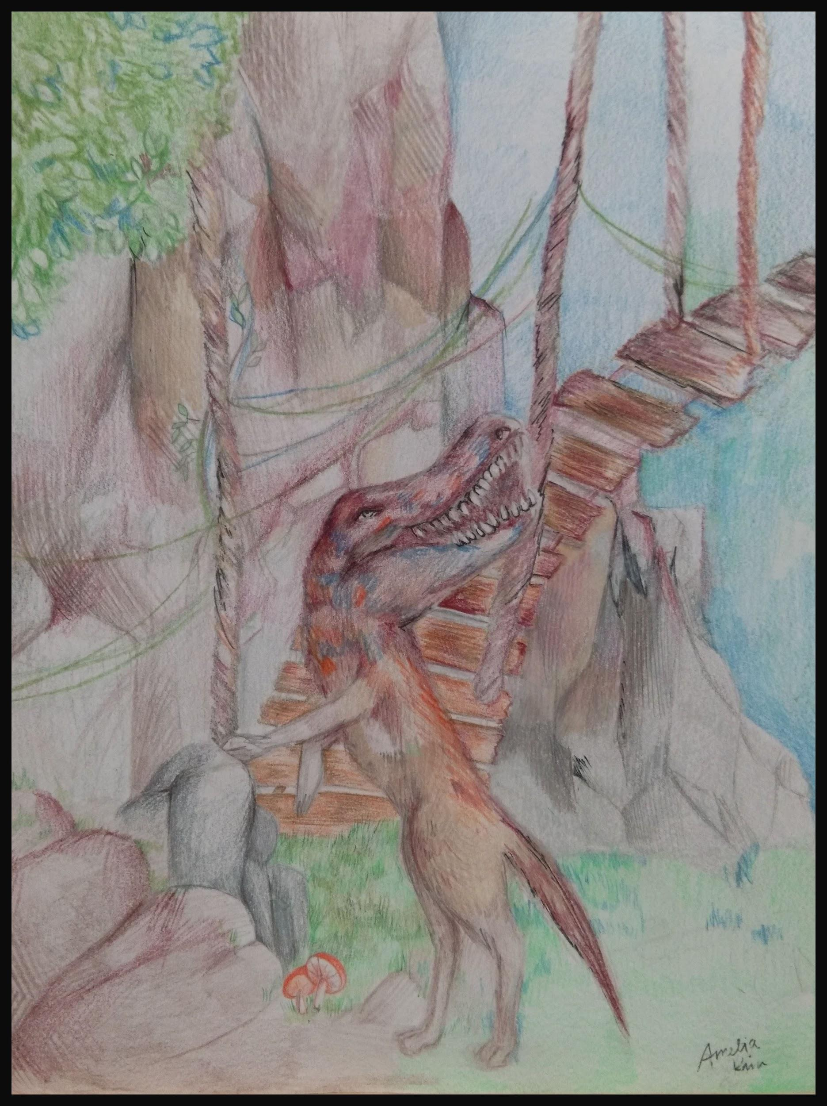Artist: Amelia Kim
Artist: Shawn Kieseley

Artist: Amelia Kim
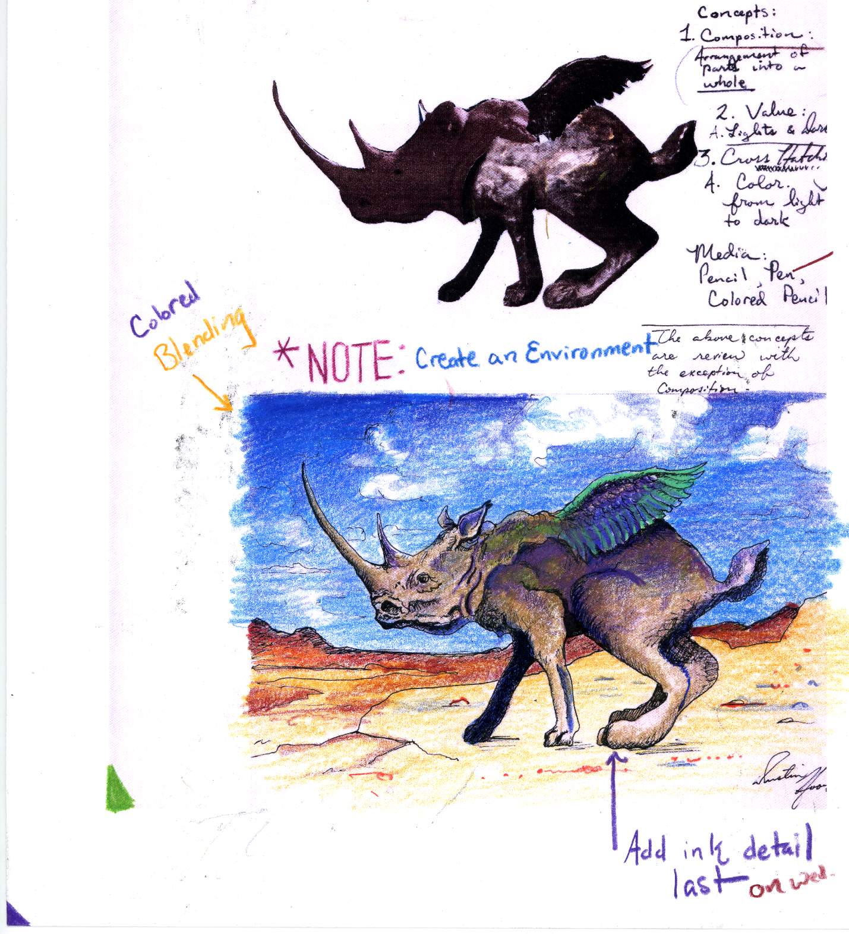

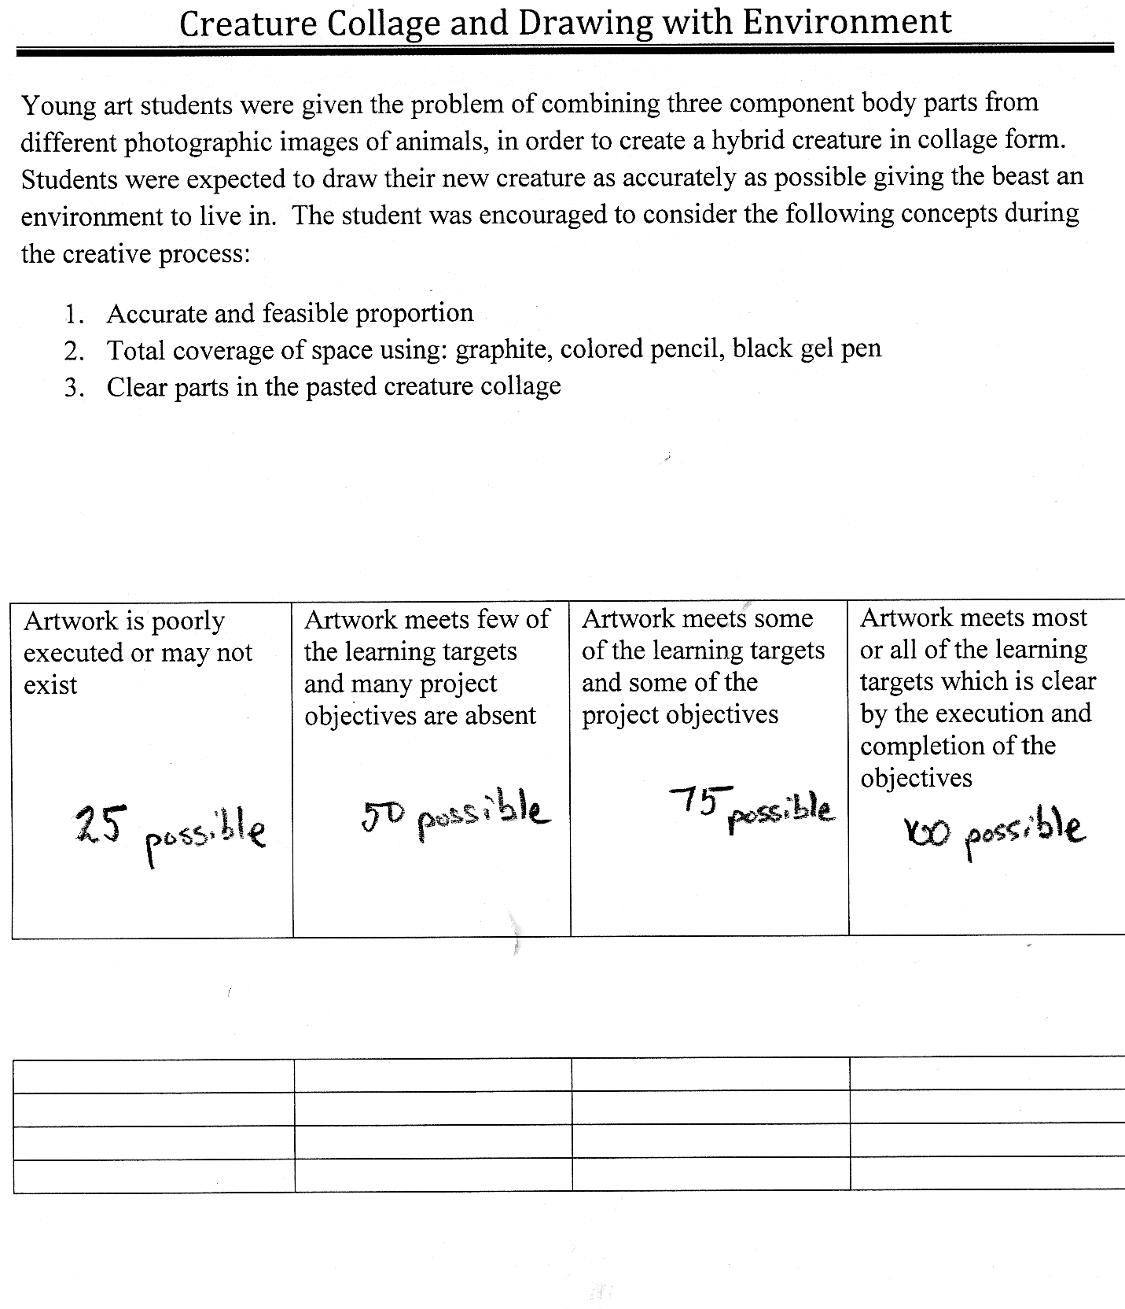

Stippling Formative Assessment
Anchor Standard 1: Generate and conceptualize artistic ideas and work.
Objective:
Students will dedicate full - fresh sketchbook pages to practicing the following technique examples.
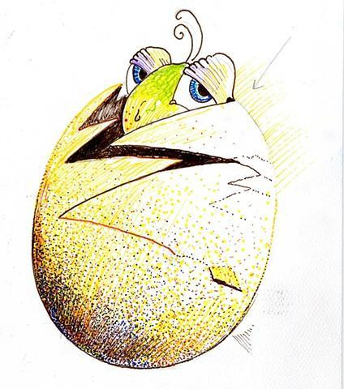 Artist: Dustin Hoon
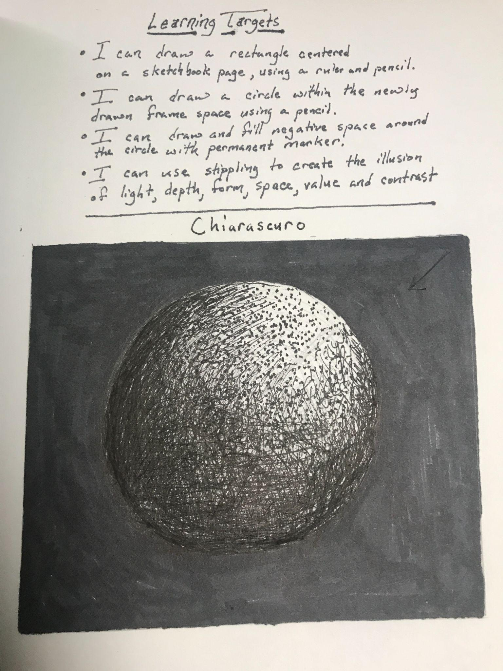
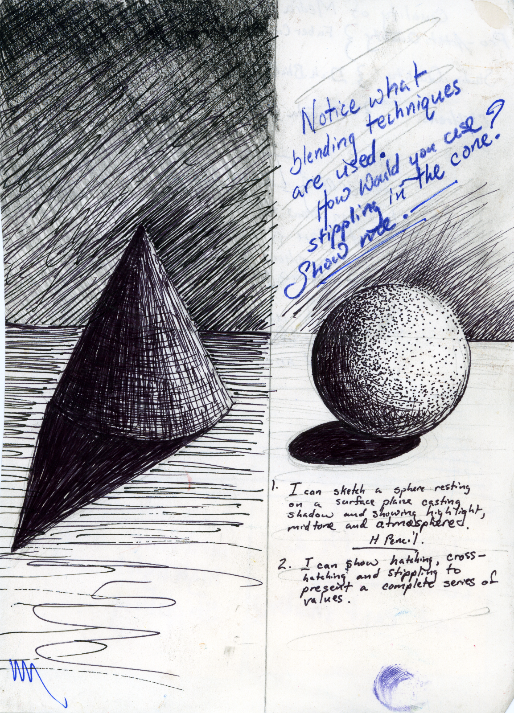
Consider Modifying for students with fine motor skill challenges by photocopying, shredding into pieces of picture, comparing the pieces to the original, and gluing into a new composition, so as to demonstrate understanding of value scale, gradation and shading.

Self Portraits: An Artistic Phenomenon

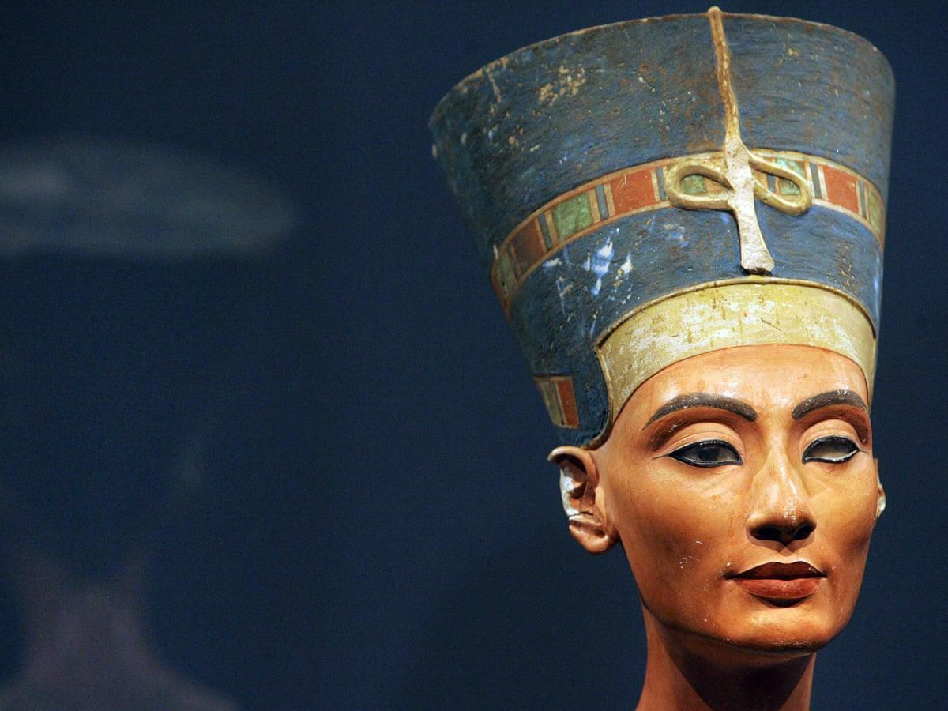
Queen Nefertiti Circa 14th Century BCE. Wife to Akhenaten Mother to Tuthenkamen

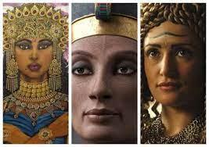

Assemblage of imagined African and Indian Queens:
accessed Google Images 9-3-21- FacetoFaceAfrica.com

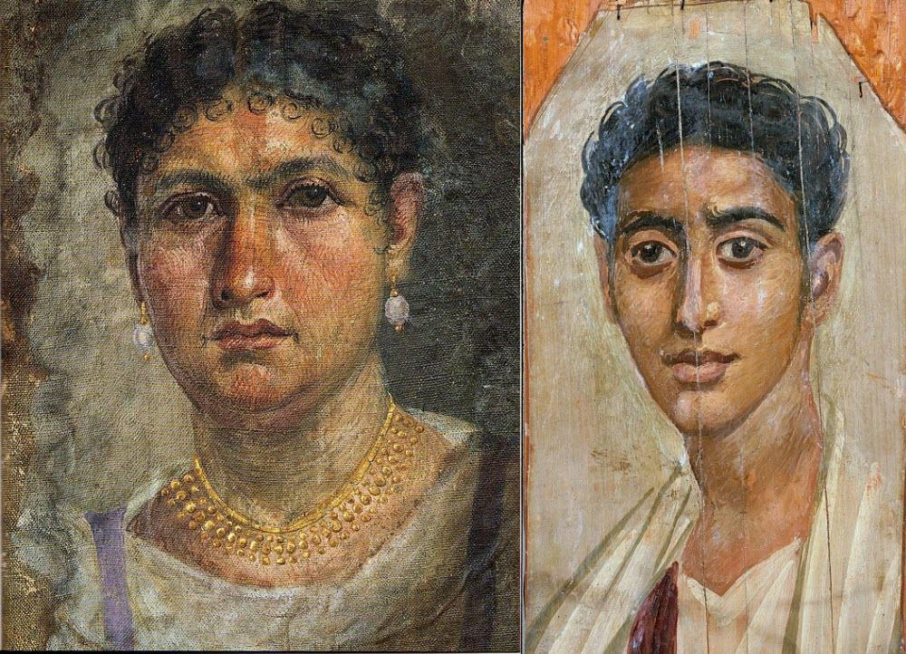
Egypt: Circa Greco-Roman Period BCE (Sarcophagus Portraits)
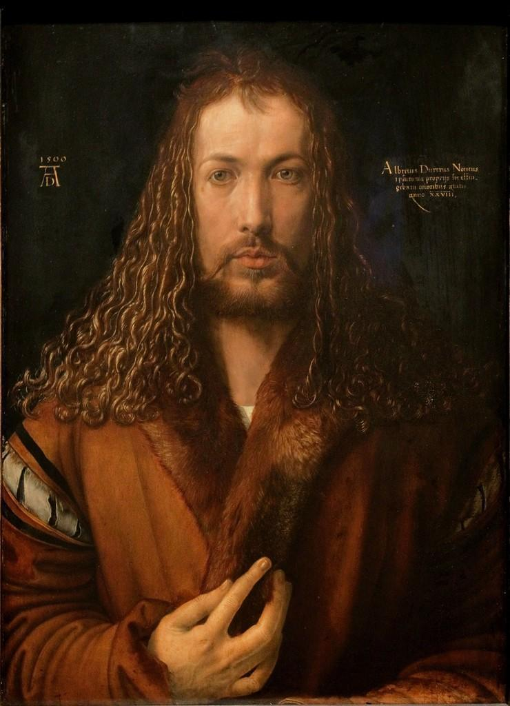
Albrecht Durer: 15th Century AD or the Common Era.
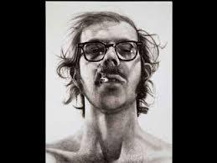

Chuck Close Mid to Late 20th Century AD
Symbolic Portrait
Mixed Media with Pen, Ink, Marker, Opaque & Transparent Paper (Dustin Hoon Instructor)
Intro to art
Objective: Students will observe the nature of transparency and opacity in mixed media art examples. Students will use what they have seen in order to compose a portrait that incorporates the following concepts: Transparency, opacity, emphasis, narrative, symbolism, pattern, symmetry, balance, composition, mixed media.

Methods:
- Examples will be reviewed by teacher and students i.e. instructor’s personal work, mixed media, symbolist & surrealist artwork, illuminated manuscripts.
- Students will collect a portrait (close up image of human face) from a magazine, cut precisely with a blade. The image must be of a person the artist has never seen before. This image will be placed centrally on a piece of quality piece of hot - pressed paper. The rectangular portrait will be outlined in the center of the paper, so that the image will always be registered in the same position in relation to the traced image.
- Students will lay a piece of quality transparent paper (or vellum) over the image that remains positioned in the center of the hot-pressed paper. Students will trace the contours of the face on the tracing paper using a gel pen or a quill pen.
- Students will create a pattern and design on the hot-pressed paper around the border for the portrait that uses symbols, and or, a narrative in order to create a story for the person’s image. Students will use black pen and ink, as well as colored pencil and fine-tipped markers to design the narrative border.
- Students will lay the finished tracing of the face over the hot-pressed paper border design to create a layered finished image. Students will attach the layers with transparent glue on the edges of the paper. Students will use extreme detail and stippling to add values.
Materials:
India ink, pen, colored pencil, fine-tipped marker, transparent paper (or vellum) hot pressed paper, glue sticks, portrait image.

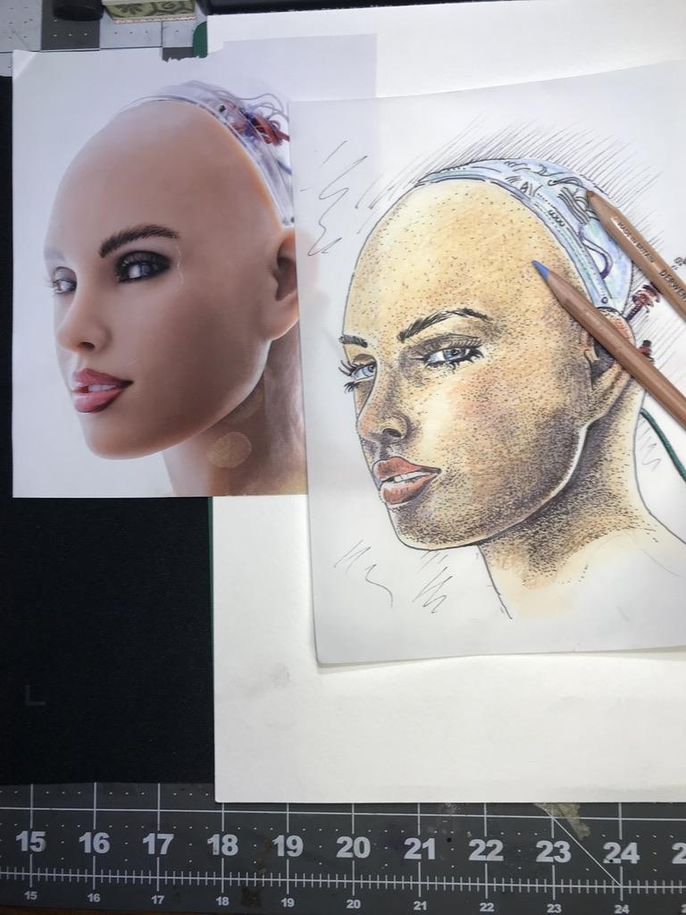
Artist: Dustin Hoon Tracing and Stippling Phase Two

Applying Colored Pencil Blending  - Blend with hatching, cross hatching and scumbling.  - Always start with light pressure.  - Consider using both sides of the tracing paper to soften the appearance of color value.  - Consider using complimentary colors to achieve flesh tone neutral values  - Consider how pressure matters when creating highlights, mid tones and core shadows.  - Save details for last.  - Consider using a fine-tipped black ink pen to create contour lines that separate the head and major shapes from the negative space.  DO NOT USE INK TO OUTLINE ISLANDS OF VALUE. CONFERENCE WITH YOUR INSTRUCTOR ABOUT APPROACHES. | To Achieve Neutral Flesh Tones on Tracing Paper.  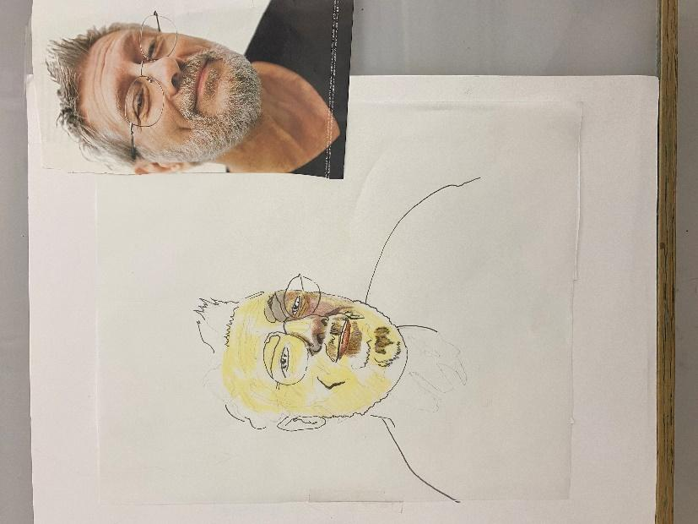  REPOSITION THE PORTRAIT TO SEE IT.  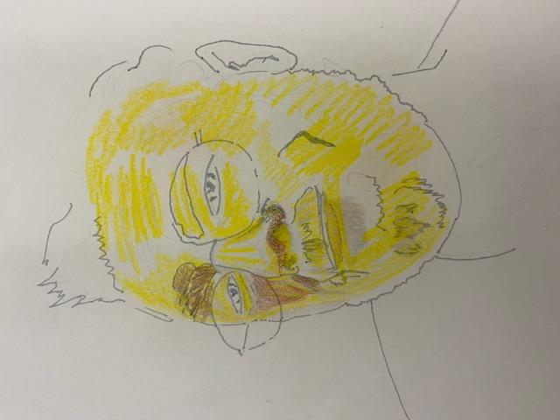  LOOKING FOR THE LIGHTEST COLOR VALUE IN THE PORTRAIT AND APPLYING UNDERNEITH THE TRACING PAPER. THE COLOR IS INTENSE UNDER AND LESS INTENSE WHEN FLIPPED BACK OVER AGAIN.

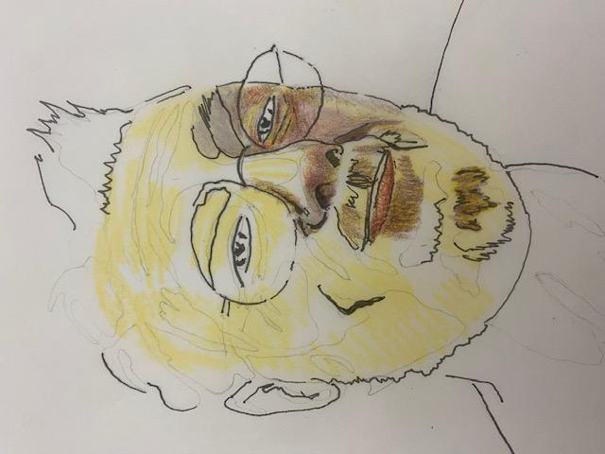 (FLIPPED BACK TO ORIGINAL SIDE) NOTICE HOW ALL THE PURE INTENSE COLORS ARE BLENDING TO CREATE NEUTRAL FLESH TONES. USING THIS KNOWLEDGE, YOU CAN CREATE A VAST RANGE OF FLESH TONES.
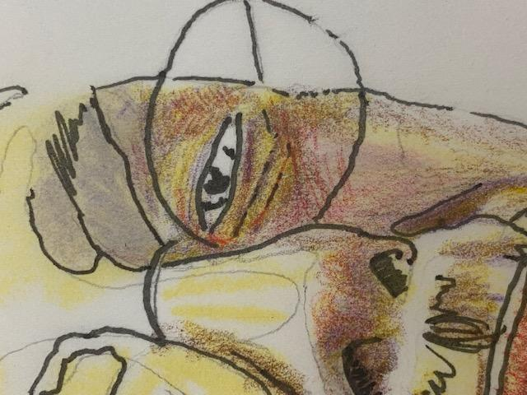See the color values blend to make neutral color values.

Evaluation:
Students will follow the steps listed above and a product will result from these methods and steps. A grading rubric can act as a checklist of method objectives. Note: Students will remove the cut out before gluing.
NOTE HOW THE BORDER IS FULL OF SYMBOLIC IMAGERY THAT TELLS A STORY ABOUT THE PORTRAIT IN THE MIDDLE. THAT’S THE IDEA! FILL ALL SPACE LEAVE LITTLE TO NO WHITE LEFT BEHIND. THE PORTRAIT IS TRACED FROM AN ORIGINAL WITH SHADED ‘VALUE’ TECHNIQUES WHILE THE BORDER IS FROM THE STUDENT’S IMAGINATION.
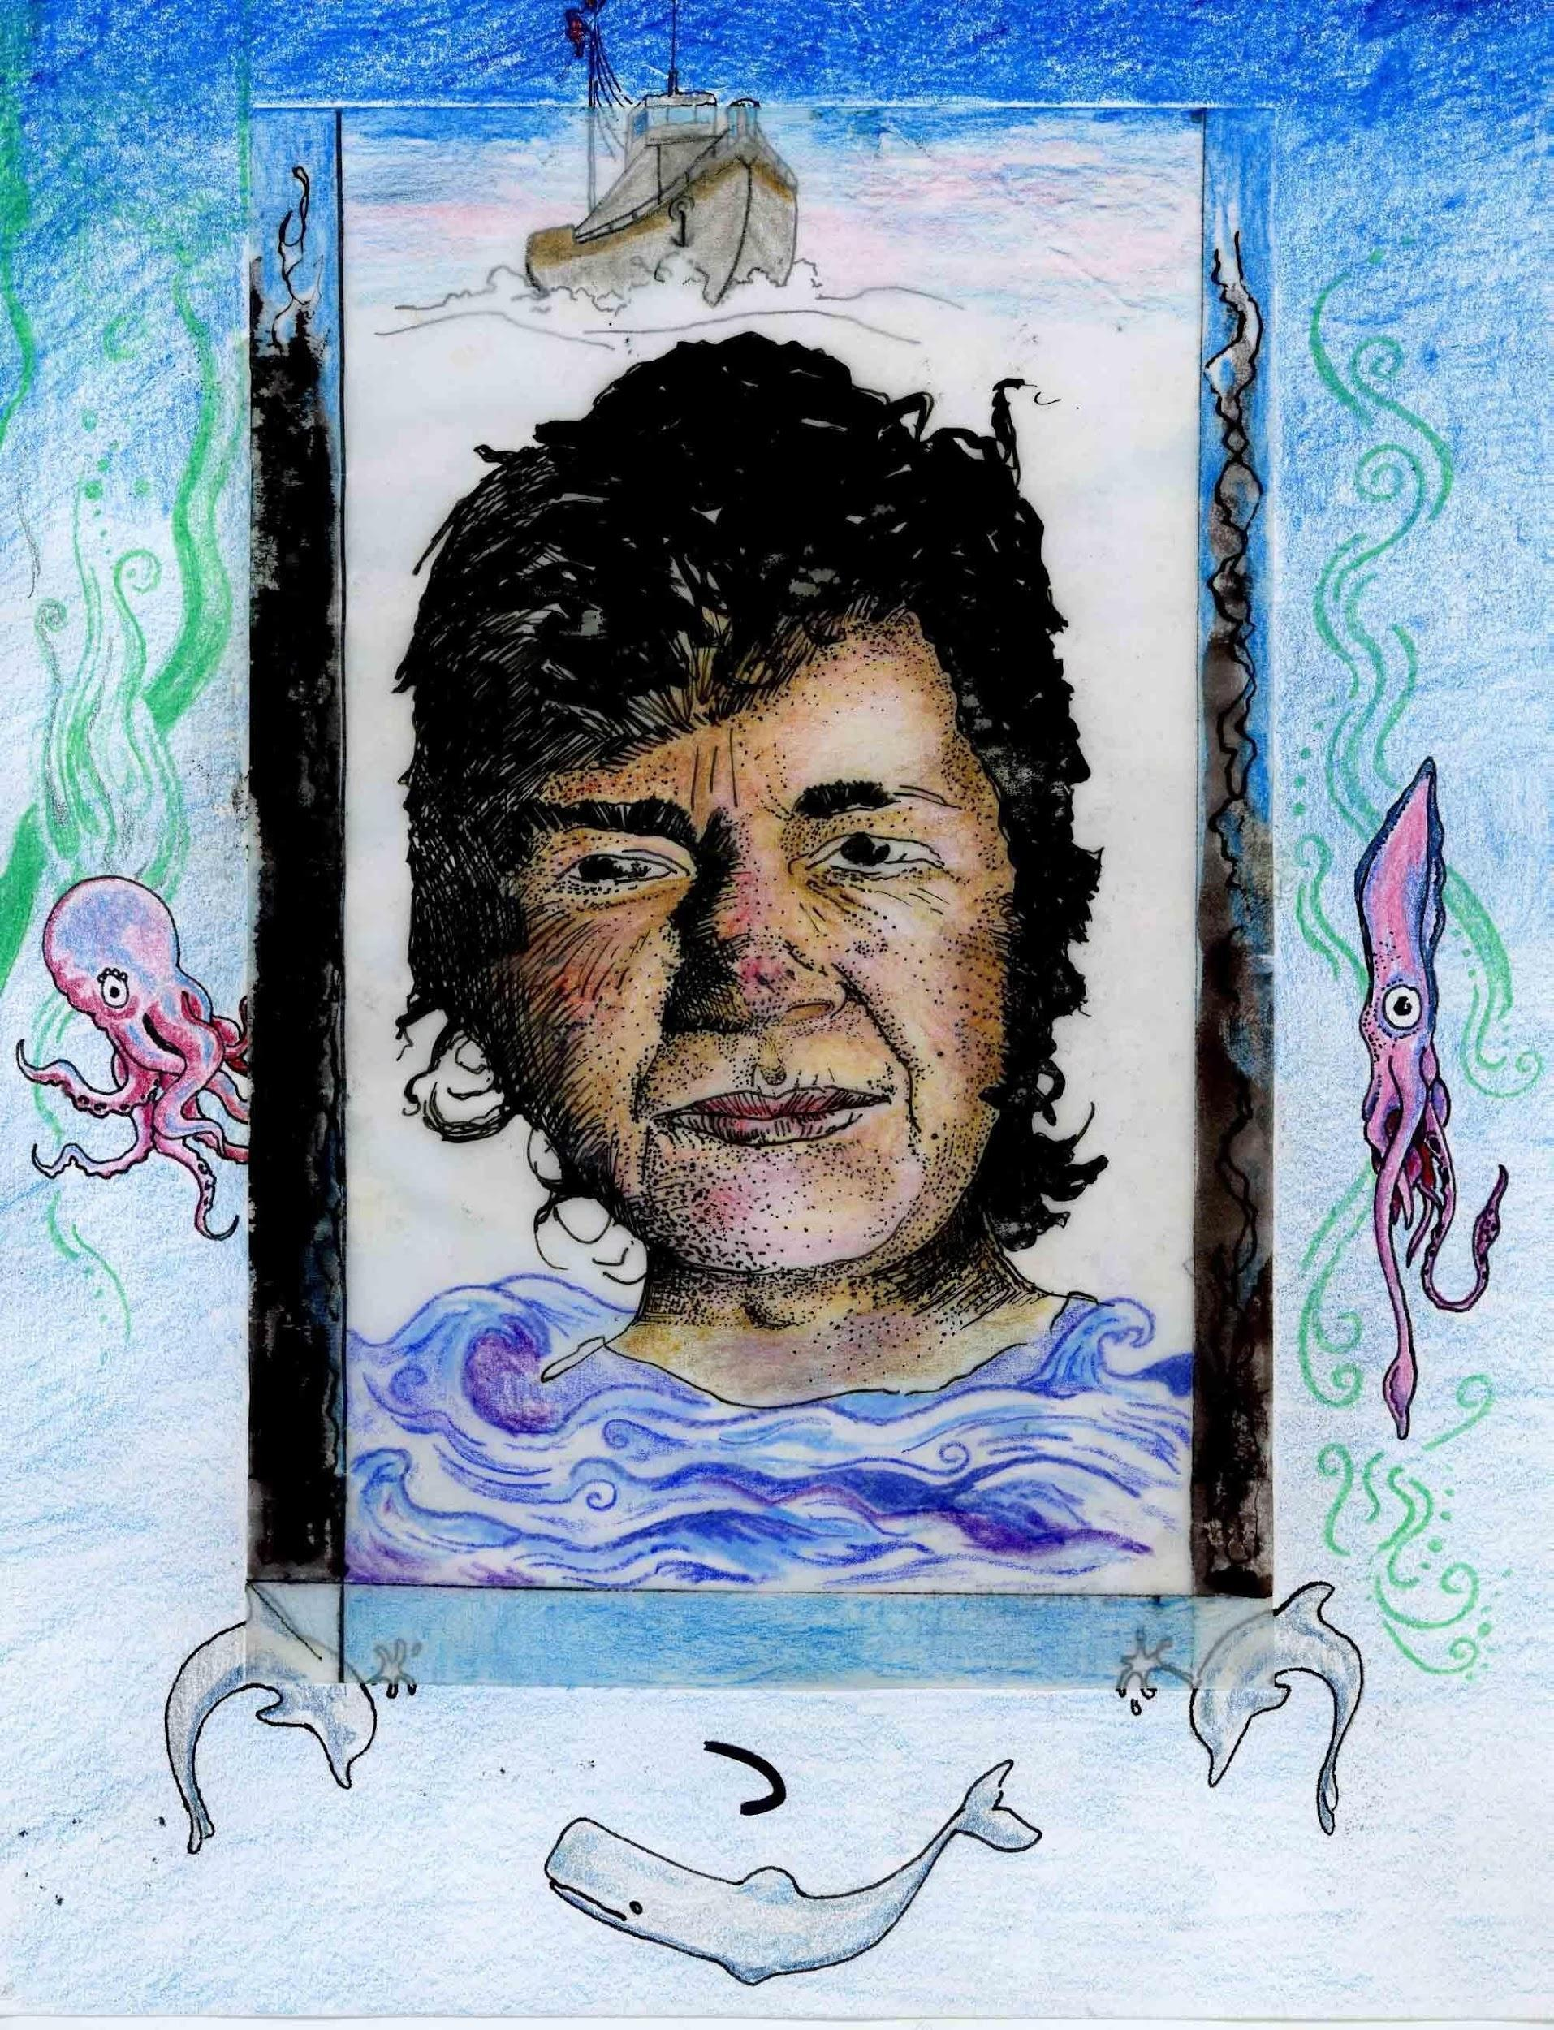Artist: Dustin Hoon

Mixed Media with Pen, Ink, Colored Pencil, Marker, Opaque & transparent Paper (Dustin Hoon Instructor). Extra Credit accompanies the written definition of all of the terms listed in the objective of the lesson.
- Image of portrait is cut and no larger than 4x6”  - Transparent paper lines up with hot pressed paper and traced contour is clear  - The ink contour is filled in completely with stippling to make different values clear  - A detailed pattern and narrative of symbols is present and clear, (this occupies the border around the portrait).  - Colored marker and colored pencil are incorporated in the border on the hot-pressed paper background  - Layered image is well crafted and lined up  - Students will define the following terms:  Stippling  Mixed Media  Composition  Pattern  Balance | Big ideas:  Tracing is a means to an end.  Narrative can inform a portrait and vice versa.  You can combine representational realism with imaginative, un-filtered drawing.  Revision, Coverage of an Entire Picture Surface and Mixed-Media is Fun and Interesting to Look at and Read.  Differentiated Instruction:  Consider the learning style and tactile aptitude of the student. Adjust expectations accordingly.  Consider replacing the tracing and portrait drawing with a collage of an actual photographic portrait surrounded with narrative drawing. Look for the elements of art that the student gravitates to and emphasize them while choosing a second or third element to scaffold a child/student to improve on.  Common Elements of Art: Line, Shape, Space, Form, Texture, Color: (Value, Hue, Intensity),

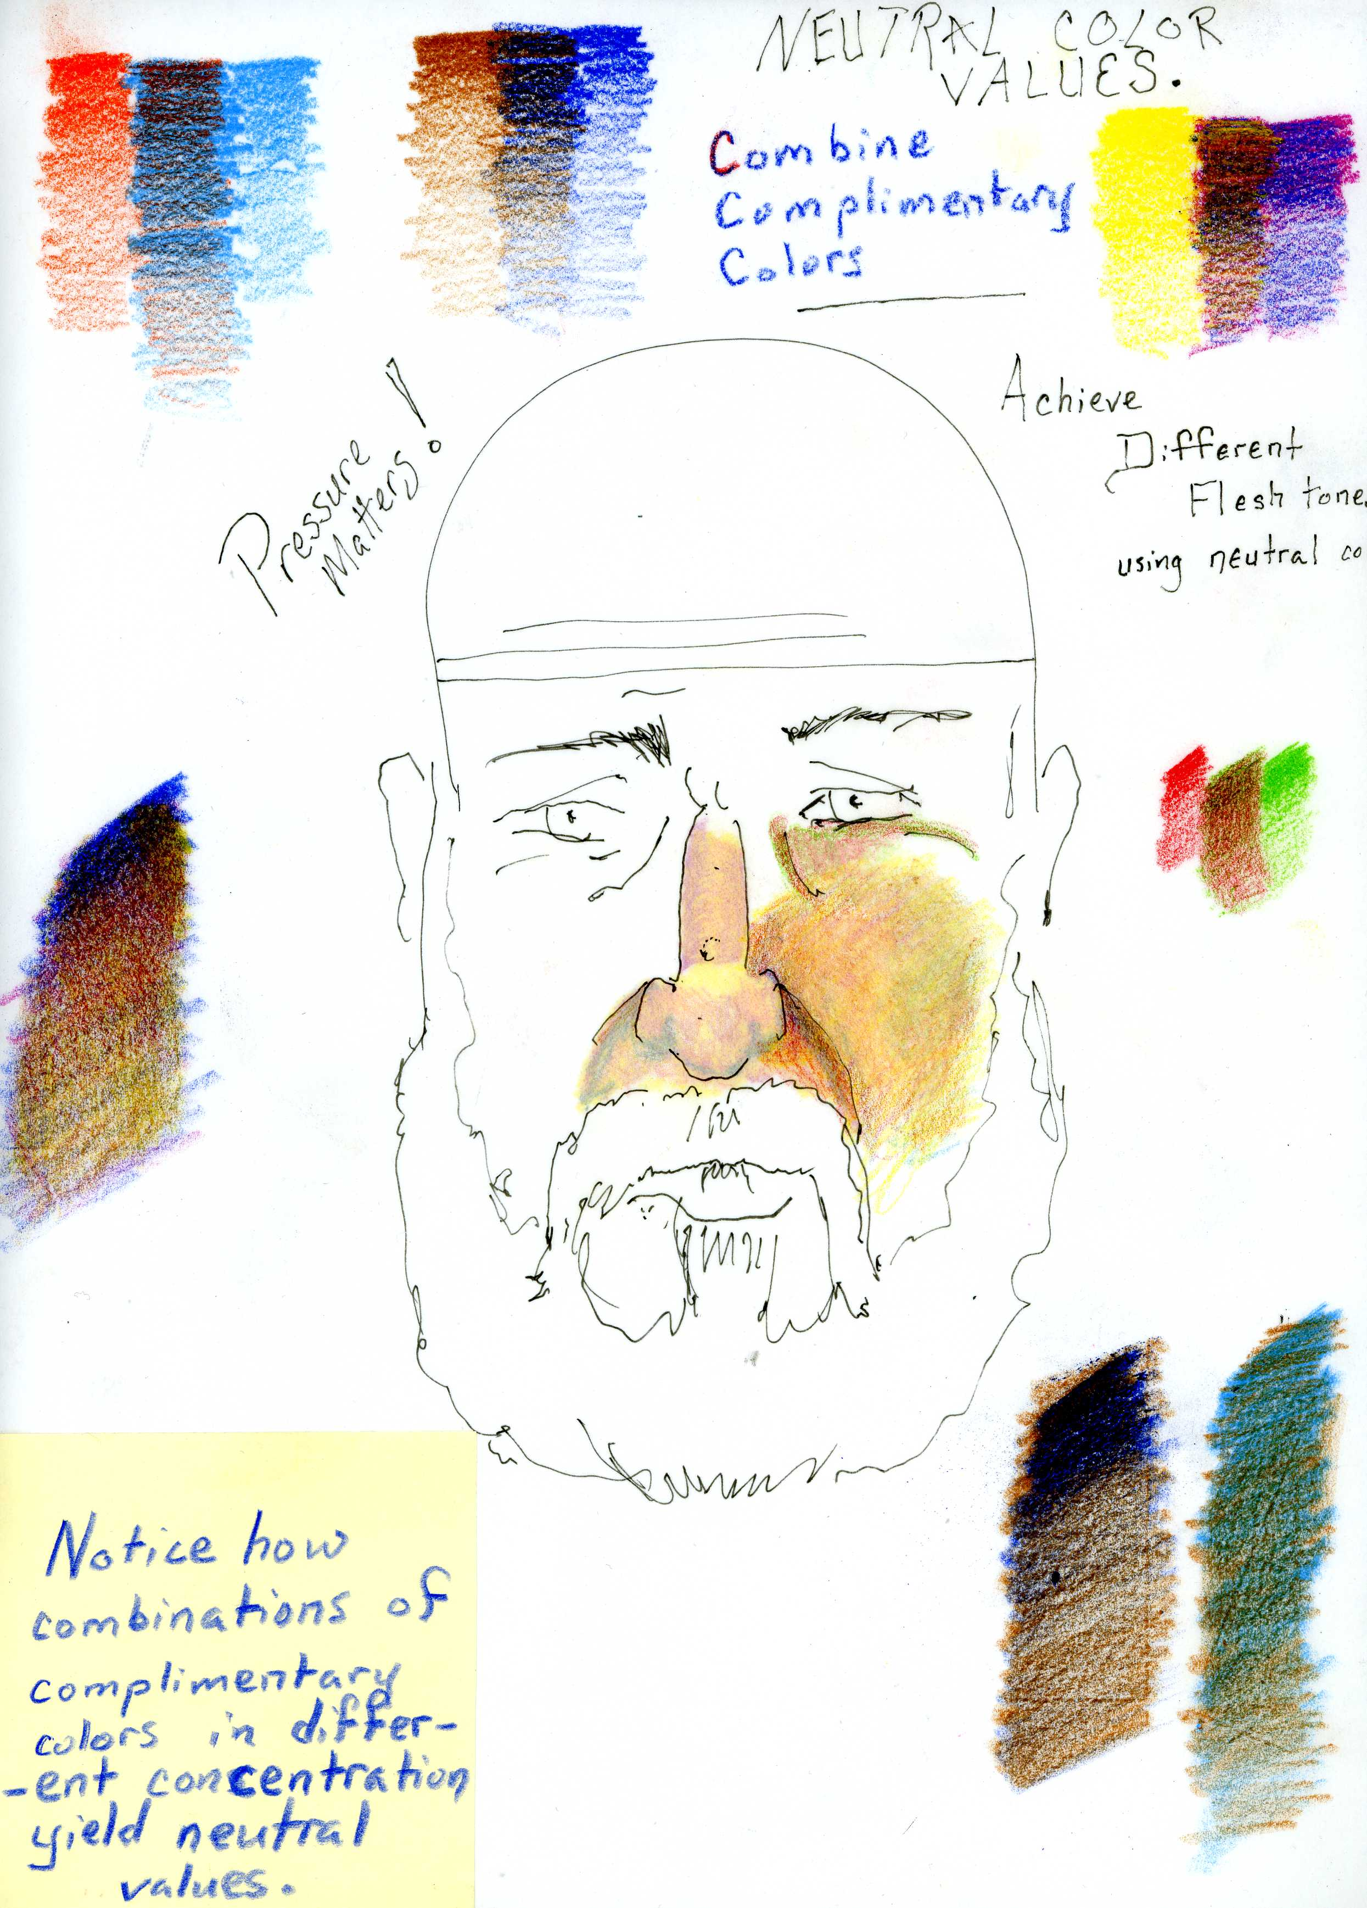
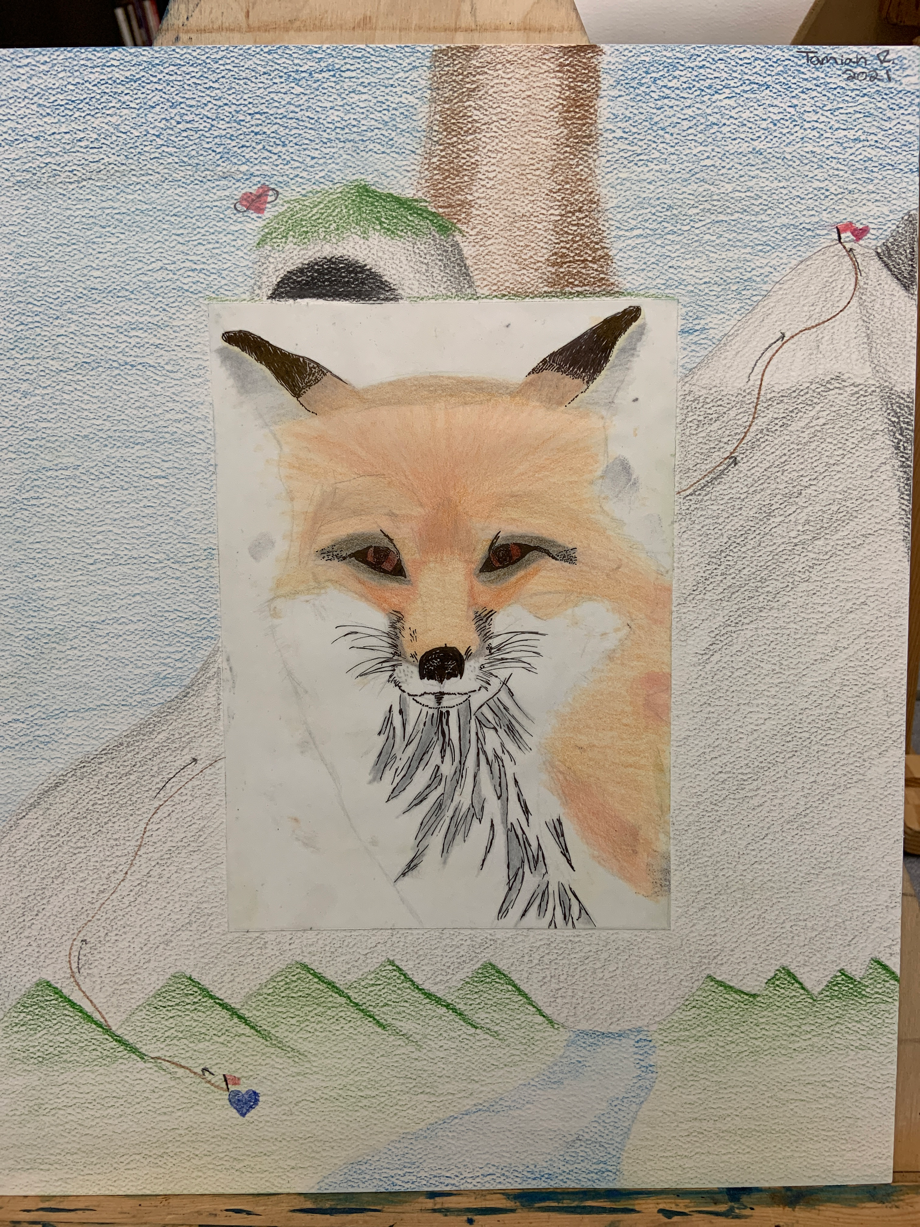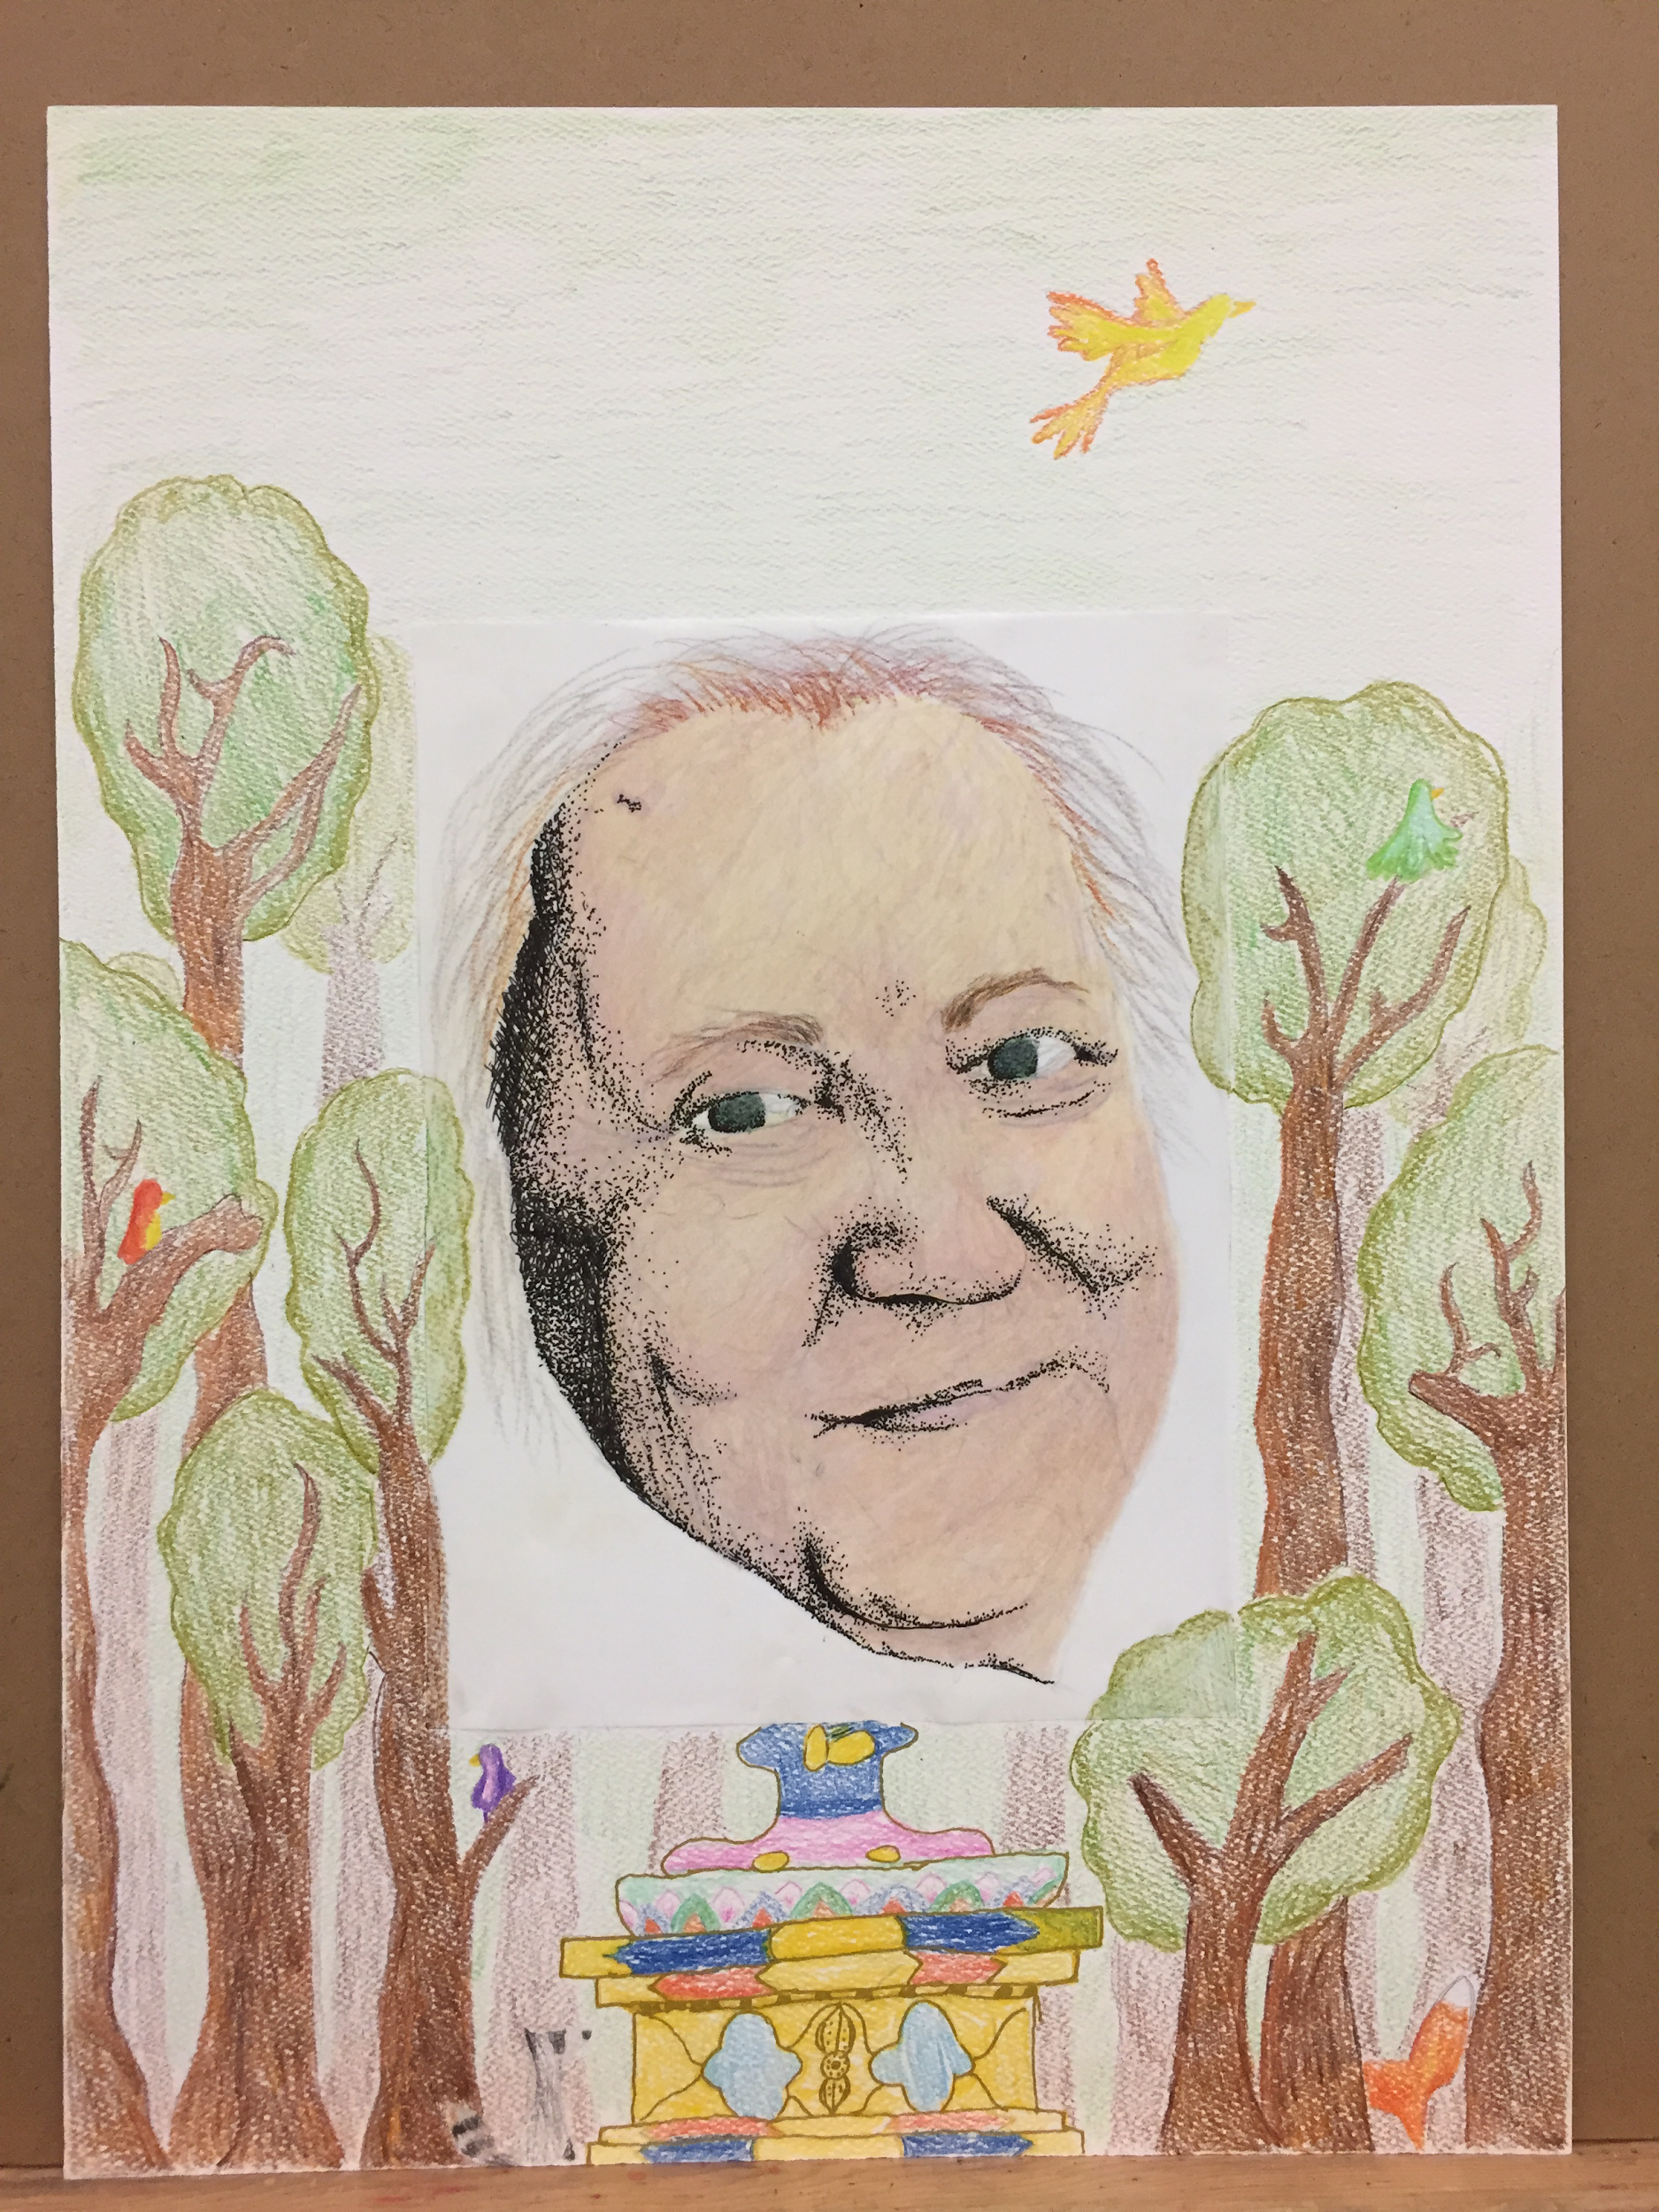
Artist 1. Timiah R.
Artist 2. Unknown Did they fill all of the ‘negative space’ border with detail, colored pencil blending, multiple values etc.? Did they fill the portrait with pen & ink stippled values and blended colored pencil; did they leave little or no white paper left behind? Discuss.

(Watercolor Application)
Watercolor Techniques,
Landscape, and Personal Image
Anchor Standard 5: Develop and refine artistic techniques and work for presentation.
• Enduring Understanding: Artists, curators and others consider a variety of factors and
methods including evolving technologies when preparing and refining artwork for display
and or when deciding if and how to preserve and protect it.
Relevance of Anchor Standard 5: considering the technical aspect of mounting watercolor paper, paper weight and stretching paper.
Objectives:
Students will:
Experience the medium of watercolor through technique and historical examples of watercolor painting.
Write down and discuss vocabulary related to watercolor, landscape, and depth.
Review and apply specific elements of art and principles of design.
Paint a landscape on watercolor paper.
Paint a personal painting using techniques learned.
Practicing Painting Techniques
Stretching Watercolor Paper
https://youtu.be/9c6OWKyYNKI
Landscape Wet-on-Dry
https://youtu.be/rADMJ82-ZoM
Watercolor Techniques
https://youtu.be/K-KYHJriivw 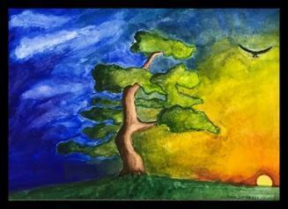Artist: Anna Schroeder

Terminology (All Terms will be written in sketchbook, definitions complete or incomplete): Support, watercolor, depth, foreground, middle ground, background, picture plane, gummed tape, stretched paper, transparent, opaque, wash, sizing, tooth, layering, wet on wet, wet – on - dry.
Assessment Grading:
Part I. Students will view instructional information, define vocabulary, identify an artist and their work, and answer the following questions in their sketchbook.
- Name three useful watercolor techniques?
- Which space should the painter begin painting: Background, Foreground Middle ground?
- What is the difference between transparent and opaque color?
Part II.
- Students will stretch two pieces of cold pressed paper in their sketchbooks using masking tape. These will be used for practicing watercolor techniques on one piece and painting a landscape on the second using practiced skills.
- Students will use gummed tape in order to stretch cold pressed paper on a board. This will serve as their support for an original watercolor painting of their own design. Look to the assessment rubric for learning objectives to consider.

Materials: Cold-pressed watercolor paper, gum tape, H pencils, watercolor palette and pan/tube colors, sponge, rag/towel, water containers, sketchbook, drawing board.

Watercolor Landscape Painting
Students Can Use This Checklist to Assess Their Own Process Throughout the Exercise.
Yes or No

The paper is stretched appropriately; and the paper is not seriously warped. | Y  N
The student painted all details clearly, saving detail work as the last step, and in the foreground. | Y  N
The student shows washes and practices techniques. | Y  N
All space is resolved: i.e. positive and negative spaces are painted. | Y  N
The painting shows successful wet on dry techniques. | Y  N
The painting shows a clear foreground | Y  N
The painting shows a clear middle ground | Y  N
The painting shows a clear background | Y  N
Washes are applied from lightest to darkest or (layered successfully) | Y  N
The student presented a finished work that has straight sides, is signed and attached to their rubric. | Y  N

Experimenting with Watercolor Painting
Students Can Use This Checklist to Assess Their Own Process Throughout the Exercise.

The paper is stretched appropriately; while the paper is not seriously warped. | Y  N
The student rendered all details clearly. | Y  N
The student experimented with making washes | Y  N
All space is resolved: i.e. positive and negative space. | Y  N
The painting shows successful wet-on-dry techniques. | Y  N

Painting One Big Sky-High School Dustin Hoon (Instructor)

Painting Material Use, Concept, Process, Production and Product
Anchor Standard 2: Organize and develop artistic ideas and work.
• Enduring Understanding: Artists and designers experiment with forms, structures, materials, concepts, media, and art-making approaches.
• Essential Question: How do artists work? How do artists and designers determine whether a particular direction in their work is effective? How do artists and designers learn from trial and error?

VA:Cr2.1.IIa Through experimentation, practice, and persistence, demonstrate acquisition of skills and knowledge in a chosen art form.
○ I can demonstrate the ability to conceive, plan and complete an artwork.
○ I can work within the traditions of painting in order to produce a body of work.

4 –Score exceeds proficiency representing  Excellence. | The painting meets and exceeds all learning targets issued by the instructor. The painting succeeds at demonstrating creative ingenuity and a unique approach.
3. Score indicates proficiency in technique, process and completion | The painting meets the safety, technical and effort requirements of the given painting challenge issued by the instructor. The painting leads by example and the artist can use it to communicate the techniques used and the properties of the medium. The painting shows undisputed:  - Effort required for completion.  - Even and consistent coverage of the surface.  - Consistency respecting the properties of the painting materials used.
2.5-Score indicates concept, technique & ongoing process lacking completion. | The painting covers much of the surface with clear effort; however, there are inconsistencies in one or all of the following:  - Commensurate effort required for completion.  - Uneven or inconsistent coverage of the surface.  - Haphazard, incomplete or ignored appreciations of the consistency and properties of the painting materials in use.  Note: MANY STUDENTS CHOOSE TO EXPLORE A MEDIUM, IDEA OR TECHNIQUE WITH INTEREST YET ARE CONTENT TO FINISH WHEN THEIR INTEREST WAINS & DIMINISHES, THUS THEIR PRODUCT LACKS AN APPEARANCE OF COMPLETION OR IGNORES CONSTRUCTIVE CRITICISM THAT COULD OFFER ASSISTANCE. This is typical. The instructor works with constructive criticism in order to inspire renewed student effort to reengage and complete their product.
2.-Score indicates an initial design with a concept or technique. | The painting is a work in progress. It may or may not relate to the assignment given, as there is too little evidence of work and effort present in the product; however, a significant portion of the picture plane or surface is painted.
 | The painting represents little evidence of process and may or may not even relate to the assignment issued by the instructor.

Differentiated Instruction:
Consider the learning style and tactile aptitude of the student. The demands of stretching watercolor paper will challenge tutor and student alike. Assessment and ultimately evaluation of this process should account for the collaboration between teacher and student. Assessment of the student’s aptitude will inform the instructor/facilitator as to how much to help.
. Look for the elements of art that the student gravitates to and emphasize them while choosing a second or third element to scaffold a child/student to improve on.
Look for the Principles of Design and determine the student’s understanding. Scaffold the student to improve on one or two additional principles at the facilitator’s discretion.
Common Elements of Art: Line, Space, Shape, Form, Texture, Color: (Value, Hue, Intensity)
Common Principles of Design: Emphasis, Movement, Pattern, Repetition, Rhythm, Proportion, Variety & Unity
https://www.getty.edu/education/teachers/building_lessons/principles_design.pdf

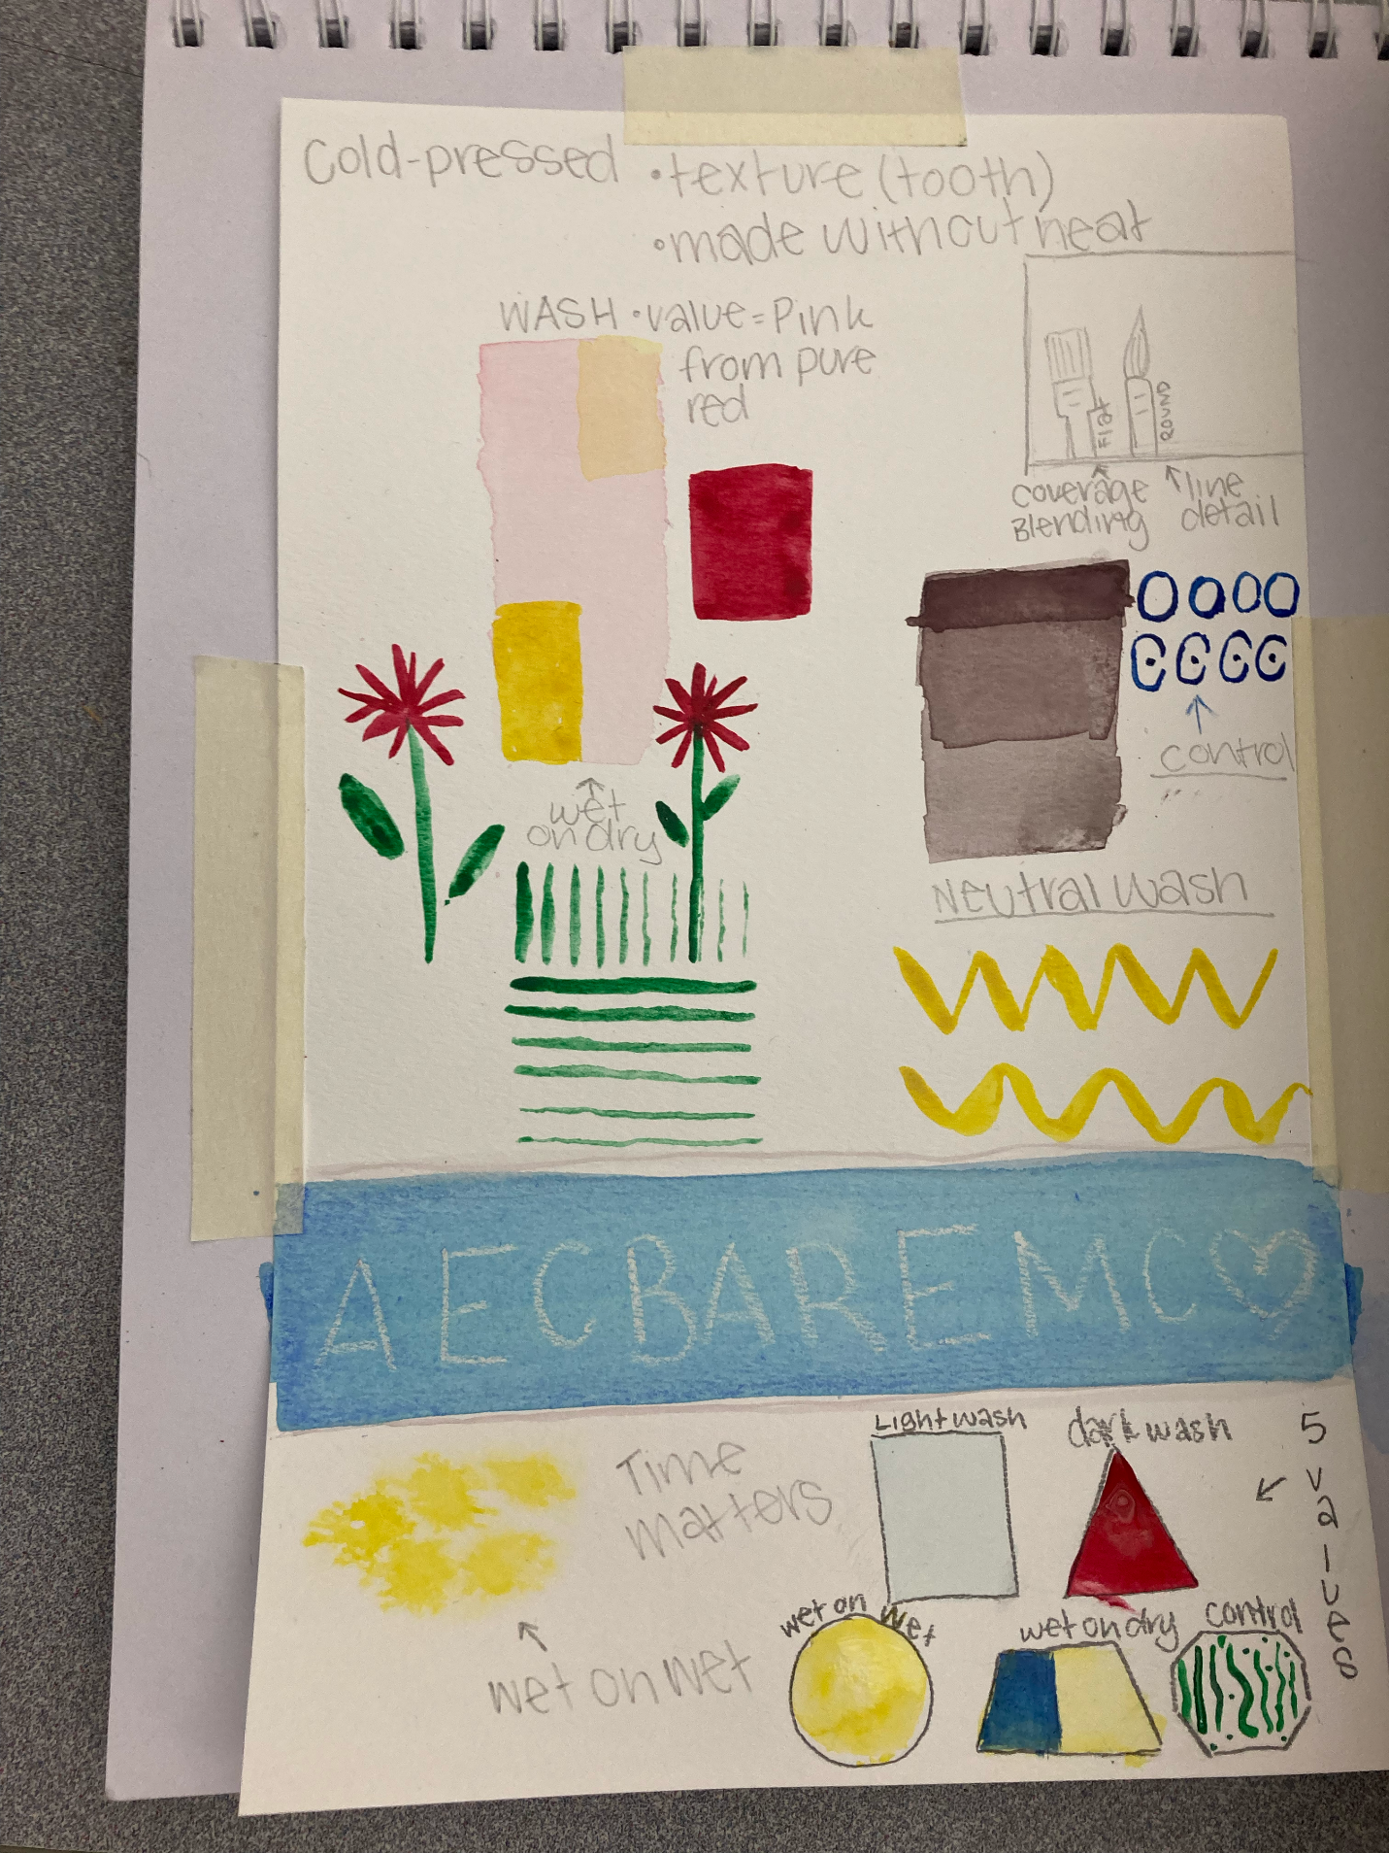
Student Technique Practice.
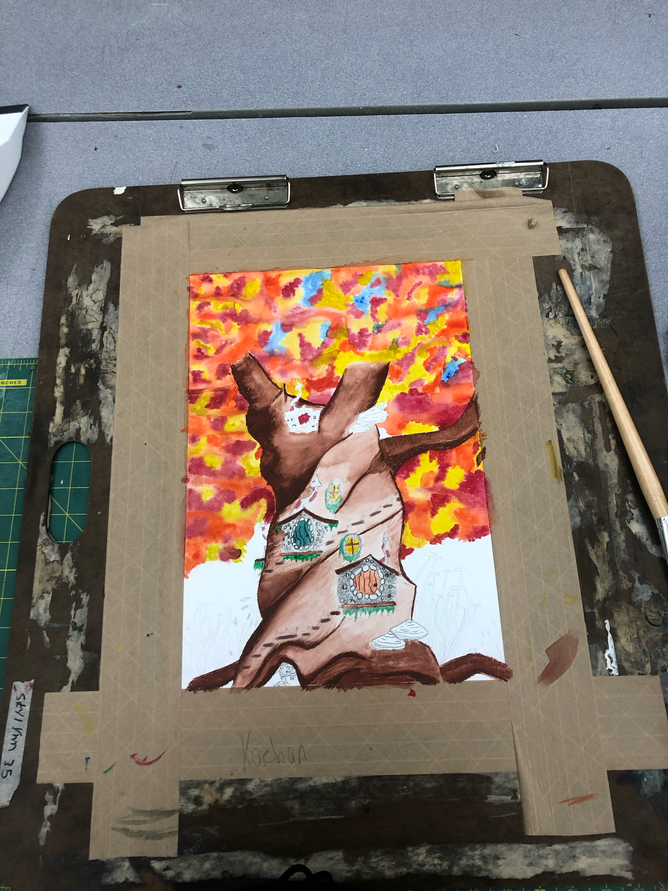
Koehen Swearingen: Personal Painting in Progress – Stretched with Gum Tape Wet on Wet Background
Symbolizing Government

Representative Democracy, Direct Democracy, & Autocracy
Indigenous and Eurocentric Models

Dustin Hoon
M.ED.

Big Sky High
School Art Department
Dept. Chair

August 19, 2019
Revised Nov. 10, 2022

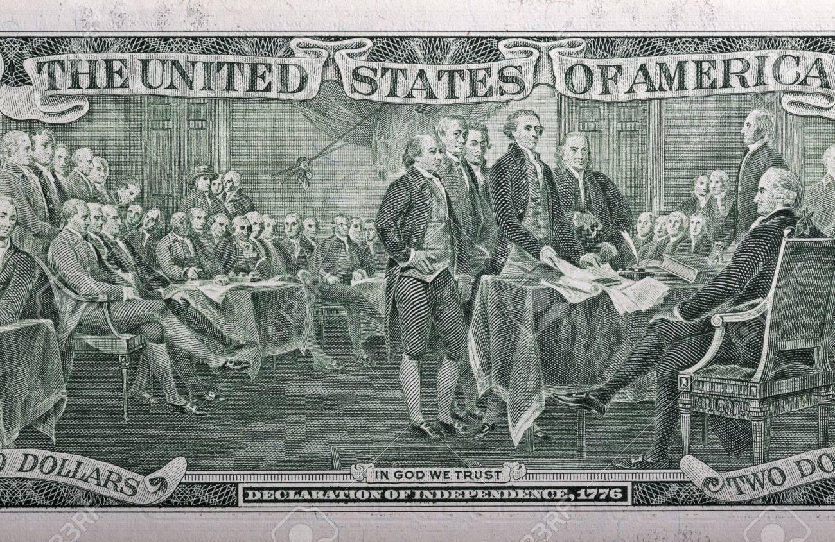
Image of the Back of the U.S. Two Dollar Bill
https://www.123rf.com/photo_61714579_declaration-of-independence-1776-on-the-back-of-a-two-dollar-bill-closeup.html
Lesson Summary:
Students are presented with several visual and auditory examples of government, highlighting representative and direct democracy as opposed to autocracy. Students are given examples of Eurocentric and indigenous models of government. Students collaborate in groups or operate individually to envision themselves as personifying a system of governance. Students participate in class wide dialogue with the instructor regarding similarities and differences of styles of governance. Students design, refine and create a highly rendered symbol, seal or sign that signifies their personified imaginary government. Students submit their work for summative evaluation and exhibition.
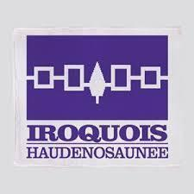
https://www.google.com/imgres?imgurl=https%3A%2F%2Fi3.cpcache.comhttps://www.cafepress.com/+iroquois-confederacy+blankets
https://www.cafepress.com/+iroquois-confederacy+blankets

Lesson Duration: This exercise unfolds over 3 instructional hours:
Unit Name: Symbolizing Government

Visual Art Standards Covered:
C-AS1 Refine and complete artistic work.
P-AS6 Convey meaning through the presentation of artistic work.
C-AS2 Organize and develop artistic ideas and work.
CN-AS11: Relate artistic ideas and works with societal, cultural, and historical context to deepen understanding
R-AS7: Perceive and analyze artistic work.

Learning Targets:
C-AS1 I can demonstrate the ability to conceive, plan and complete an artwork.
C-AS1 I can rework my design if requested or needed to increase visual impact.
P-AS6 I can explain how my art is constructed.
P-AS6 I can respond to questions about my piece using appropriate vocabulary.
C-AS2 I can use experimentation, practice, and persistence, and demonstrate acquisition of skills relevant to the overall creative process.
NOTE: THE INSTRUCTOR CHOOSES ONE OR MORE OF THE ART STANDARDS TO MEASURE FOR (GRADE) SUMMATIVELY AND FORMATIVELY.

Formative Assessments:
- Record related discussion and ideas
- Compose Elements (Line, Shape, Form, Color (value, hue, intensity), Texture, Space) into a personal visual symbolic logo
- Record and submit evidence of participation daily
- Cover the entire white space of the paper surface (unless intentionally discussed with the instructor)
- Exhibit and discuss/critique: Describe, Analyze, Context/Content,

Summative Assessments

INTRODUCTION TO ART
CREATING C-AS1
Generate and conceptualize artistic ideas and work.
Score 4.0 | In addition to score 3.0 performance, the student demonstrates in-depth inferences and applications that go beyond what was taught.
Score 3.0 | Generate and conceptualize artistic ideas and work.  Learning Target(s):  VA:Cr1.1.Ia Use multiple approaches to begin creative endeavors.  ○ I can demonstrate an understanding of the Elements of Art and the Principles of Design.  ○ I can brainstorm an idea for a project and either develop a plan to complete it or ask for help in developing a plan.  ○ I can make a visual product and justify its intention.  ○ I can collaborate with others in the creative process LEARNING TARGETS: I can make a visual product. (Meeting the teacher’s learning targets regarding the specific task or art challenge)  - I can cover an entire picture plane with line, shape, values, color, form, detail and elements or targets specific to the art challenge.  - I can leave little or no white behind with my drawing media.  - I can blend my drawing media with intention responding to constructive feedback from the instructor.
Score 2.0 | The student will recognize or recall specific vocabulary, such as:  The student will perform basic processes, such as:  MEDIUM SPECIFIC - Elements & Principles of Art: Line, Texture, Space, Form, Color (Hue, Value, Intensity), Balance, Rhythm, Emphasis, Unity, Movement, Pattern & Proportion
Score 1.0 | With help, partial success at score 2.0 content and score 3.0 content.
Score 0 | There is no evidence of learning through observation, interaction, and/or limited attendance.

INTRODUCTION TO ART
 |  | Creating C-AS3
Refine and Complete Artistic Work
Score 4.0 | In addition to score 3.0 performance, the student demonstrates in-depth inferences and applications that go beyond what was taught.  The work leads by example.
Score 3.0 | LEARNING TARGETS: I can make a visual product. (Meeting the teacher’s learning targets regarding the specific task or art challenge)  - I can cover an entire picture plane with line, shape, values, color, form, detail and elements or targets specific to the art challenge.  - I can leave little or no white behind with my drawing media.  - I can blend my drawing media with intention responding to constructive feedback from the instructor.
Score 2.0 | The student will recognize or recall specific vocabulary, such as:  MEDIUM/Lesson specific ex: vanishing point, depth, value  The student will perform basic processes, such as:  MEDIUM SPECIFIC - Elements & Principles of Art: Line, Texture, Space, Form, Color (Hue, Value, Intensity), Balance, Rhythm, Emphasis, Unity, Movement, Pattern & Proportion
Score 1.0 | With help, partial success at score 2.0 content and score 3.0 content.
Score 0 | There is no evidence of learning through observation, interaction, and/or limited attendance.

Summative Rubric:ReAssessment Process:
Complete all Formative assignments
Apply feedback given by the teacher to rework Summative assignment.

Hour One: Information, Knowledge, Analysis, Application
Hour Two: Work individually or in Groups of 3, Division of and Recognition of Different Branches of Government & Roles, Brainstorm Imagery, Creation & Collaboration
Hour Three: Creation, Collaboration & Clean Up
Lesson Overview & Objectives:
- Students will experience examples of European Representative Democracy i.e. U.S. Federal Government.
- Students will experience examples of Indigenous Representative Governments – past and present: i.e. The Iroquois Confederacy.
- Students will take notes on the following concepts:
    - Governments come in many forms
    - Forms of government are related to time, place, culture and people.
    - O.P.I. Indian Education for All Essential Understanding 1 states: There is great diversity among the twelve tribal nations of Montana in their languages, cultures, histories and governments. Each Nation has a distinct and unique cultural heritage that contributes to modern Montana.
This understanding is addressed through content knowledge, comprehension, analysis, application, synthesis and evaluation.
- Students will participate in a classroom discussion facilitated by the instructor:
Six Discussion Questions:
- Do you see similarities among the various examples of government spanning societies and cultures?
- Can you define or explain the difference between representative democracy and direct democracy, and what can you infer from that?
- As a group or individually, can you imagine being a governing body?
- Would your body be a representative democracy, a direct democracy or some form of autocracy i.e. monarchy, tyranny etc.?
- What role would you, as a person, play in this body politic?
- Can you envision a visual symbol, standard, logo or sign that represents your form of government?
- Students will sketch a draft or layout of their symbolic image in their sketchbook using graphite pencil 4H to HB.
- Students will review their draft with the instructor and their peers through formative assessment.
- Students will transfer their idea to a final surface i.e. Bristol Board or Sulfate Drawing Paper after the explicit approval of the instructor.
- Students will refine their design through formative assessment, persistence, effort and ingenuity using colored pencil as their principal medium.
- Students will submit their signed final image to the teacher for summative assessment.

Knowledge terms for comprehension:
Direct Democracy, Representative Democracy, Autocracy, Sign, Symbol, Council Government, Indigenous, Eurocentric

Teacher Resources for Comprehension:
The Great Seal

American Eagle Holding Thirteen Arrows Parallel Thirteen Original Colonies and Multicultural Symbolism
Use this internet link to inspire dialogue:
http://greatseal.com/symbols/arrows.html
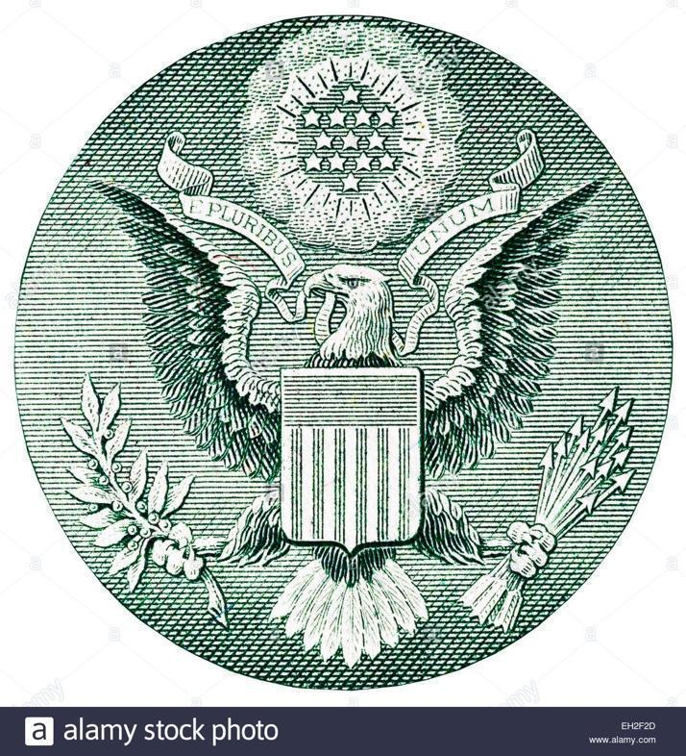

Examples of the 13 Tribal Flags of Montana

Use this Internet Hyperlink to Facilitate Dialogue:

https://hs.umt.edu/nas/documents/29151 NAC Story of Flags brochure.pdf

Similarities Between U.S. Representative Government and Iroquois League Government
Teacher Guidance Note: The idea that the Iroquois inspired the U.S. constitution is controversial. Consider addressing similarities, not claiming an absolute and sole influence on the U.S. constitution. It may appear like left-wing propaganda based on slim evidence as a cause and effect example. The evidence supports similarity only. Students can infer what they will.
View this Documentary to Build Background Knowledge:

Native America Episode II: Nature to Nations, PBS 2018, Streaming Video Amazon Prime Video
https://www.amazon.com/New-World-Rising/dp/B07MTWZL8M/ref=sr_1_1?crid=1V9FA56SHX1TC&keywords=native+america&qid=1566243359&s=instant-video&sprefix=Native+Am,prime-instant-video,219&sr=1-1

(Visual Arts)
Anchor Standard 11: Relate artistic ideas and works with societal, cultural, and historical context to deepen understanding.
Enduring Understanding: People develop ideas and understandings of society, culture, and history through their interactions with and analysis of art.
Essential Question: How does art help us understand the lives of people of different
times, places, and cultures? How is art used to impact the views of a society? How does art preserve aspects of life?

Core 4.0 | The work leads by example, inspires interest and inquiry. The piece shows a highly resolved surface with clear understanding of the Elements of Art, Color Theory & the Principles of Design. When pressed, the artist would have no trouble relating to their work and communicating its meaning, construction, completion and desired outcome.
Score 3.0 | VA:Cr3.1.Iia Engage in constructive critique with peers, then reflect on, re engage, revise, and refine works of art and design in response to personal artistic vision. ○ I can use aesthetics to describe process and product. ○ I can demonstrate the ability to conceive, plan and complete an artwork. ○ I can compare and contrast visual components between arts. I have contributed to the whole resulting in a visual product that uses Elements that I can describe visually and verbally. I have created a piece that indicates completion of the entire surface area of the picture-plane and can describe this visually and verbally or through critique.
Score 2.0 | Application shows thought and effort in most cases throughout the picture plane. Areas of the work exhibit application appropriate for the desired result-even if abstract and expressive. If abstract and expressive, a thoughtful distribution of line, shape, color, value, form, texture and space is evident; however, the piece shows differences in effort through inconsistent application of paint, some areas highly resolved, others not so.
Score 1.5 |  | Bottom Line: (The work exists, yet lacks time, significant thought for composition and effort). Some successes may present themselves, but overall the work is clearly incomplete and not consistent with the learning targets of the assignment.
Score 1.  And below | Materials and marks may exist, but a complete painting or work in progress is not clear in any recognizable way. There is no intention on the part of the artist to explain the example given.

Linear Perspective Landscapes of the Mind
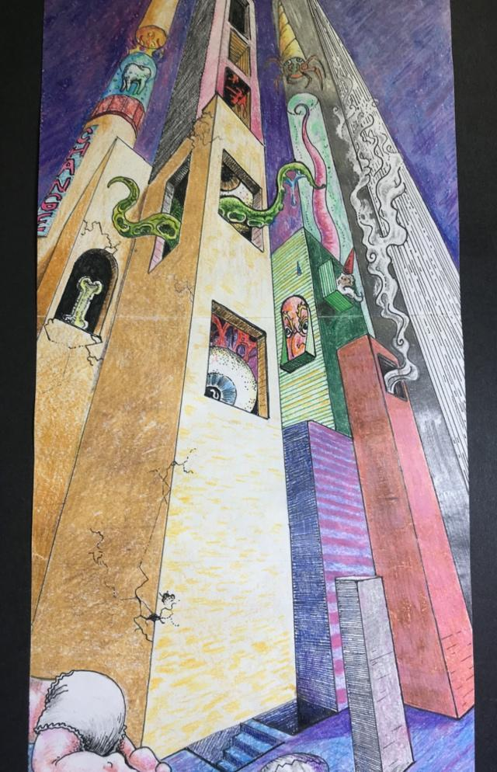
Artist: Dustin Hoon Landscape in 3-point Perspective
Objectives:
- Students will follow weblinks and instruction, review written material (Optional), explore one and two - point linear perspective techniques for review. The student will view the video on linear perspective in European art and answer the following question in written form, or if a student wishes to modify the assignment by recording their spoken answer, they may with the guidance of the tutor/instructor. Take is slow and steady. Remember linear perspective is like any scientific or mathematical process, it starts with fundamentals and advances into more complex applications. Students will review one and two-point perspective and conclude their experience with three-point perspective and surrealism.
- Students will create an environment with the four basic forms on a plane or surface in accurate linear perspective. Students may use YouTube posts, the following references and their own ingenuity to meet the challenge.

Question for Consideration:

Describe how the European Renaissance is associated with linear perspective. Historically how did this understanding come to be? Use the internet sources below for information, background knowledge and the process of informing class discussion.
https://www.youtube.com/watch?time_continue=3&v=WQUi5Ue_fLY&feature=emb_title
Practicing One & Two-Point Linear Perspective
https://youtu.be/mAXK7PF1XFg
https://youtu.be/uDswvLl7HBA
https://youtu.be/n45b-oF71QE
Practicing Three – Point Perspective
https://youtu.be/UPNUZzfsri0
https://youtu.be/Umv4PjC8fjo
https://youtu.be/EPBaHkj753I
https://youtu.be/braEb5a3IuA

What is Surrealism
https://www.youtube.com/watch?v=fH1uXlm9qoQ

3 Point Perspective Landscape of the Mind – Surrealism in Color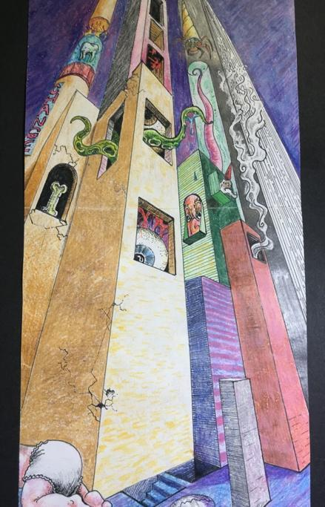Artist: Dustin Hoon
Objective:
The student uses linear perspective and drawing techniques to create a landscape with rectangular solid buildings in three-point perspective. The student will begin with light sketching in light H graphite pencils and conclude by adding values, details, color, cast-shadows and symbolism using well-blended color pencil application. The student is strongly encouraged to revisit, revise and modify their artwork until all white of the paper is covered, unless left uncovered intentionally.
Students Can Use This Scale as a Check List to Assess Their Own Process Throughout the Exercise.
The student used the properly assigned media: Graphite, colored pencil, black pen | 5)relevance virtually absent objectives not met  10) some relevance-objectives lacking  15) objectives and relevance present  20) objectives are clear, and work is relevant  25)objectives are clear and support work that shows time, deliberation, and effort
The student filled the entire page and used positive and negative space. Values are present in the various spaces. | 5  10  15  20  25
The image has surrealistic components and or symbolic components. | 5  10  15  20  25
Details: i.e. cylinder form, rectangular solids, forms, shading or adding values, color, tones, and various structures are present. | 5  10  15  20  25
The drawing’s components and visual illusions obey the rules of linear perspective. | 5  10  15  20  25
The environment created on the picture plane is an illusion of the third dimension. It is a space that has the Illusion of depth. | 5  10  15  20  25

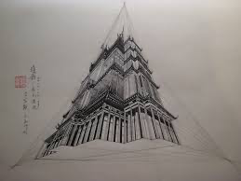Worm’s Eye View
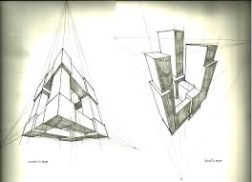
Worm’ Eye and Bird’s Eye Views

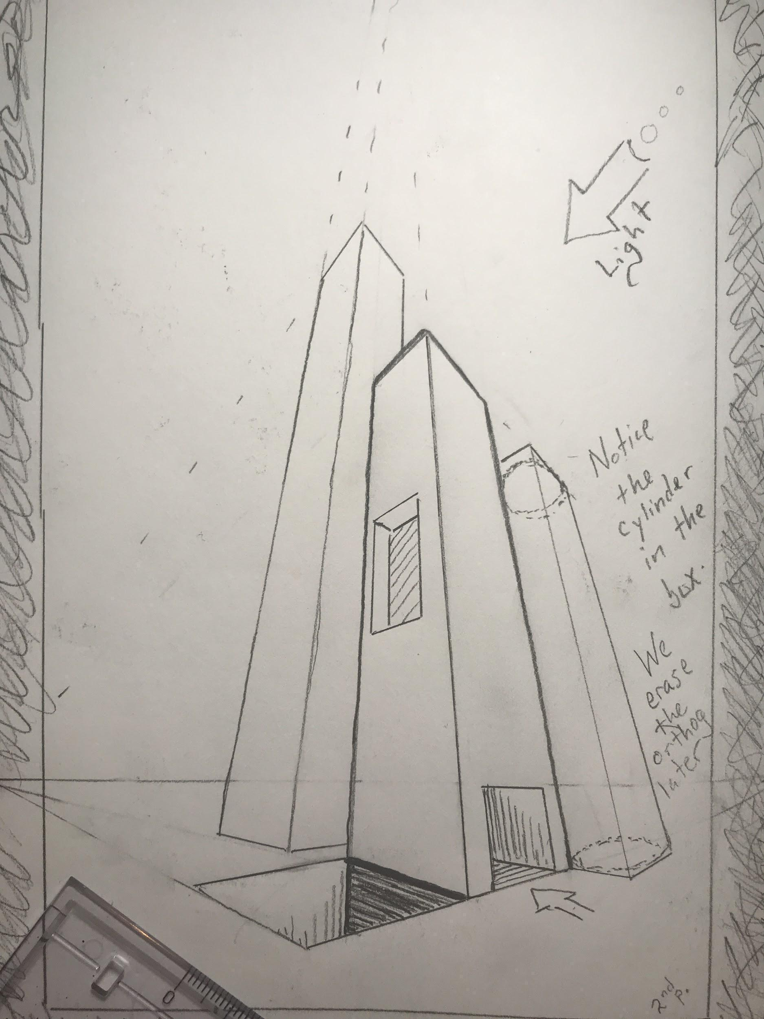
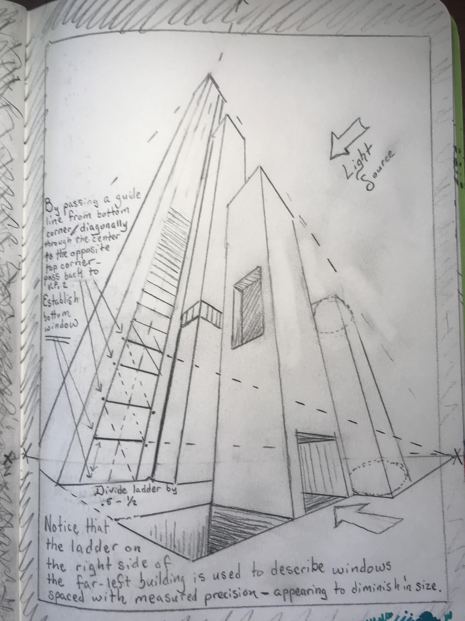
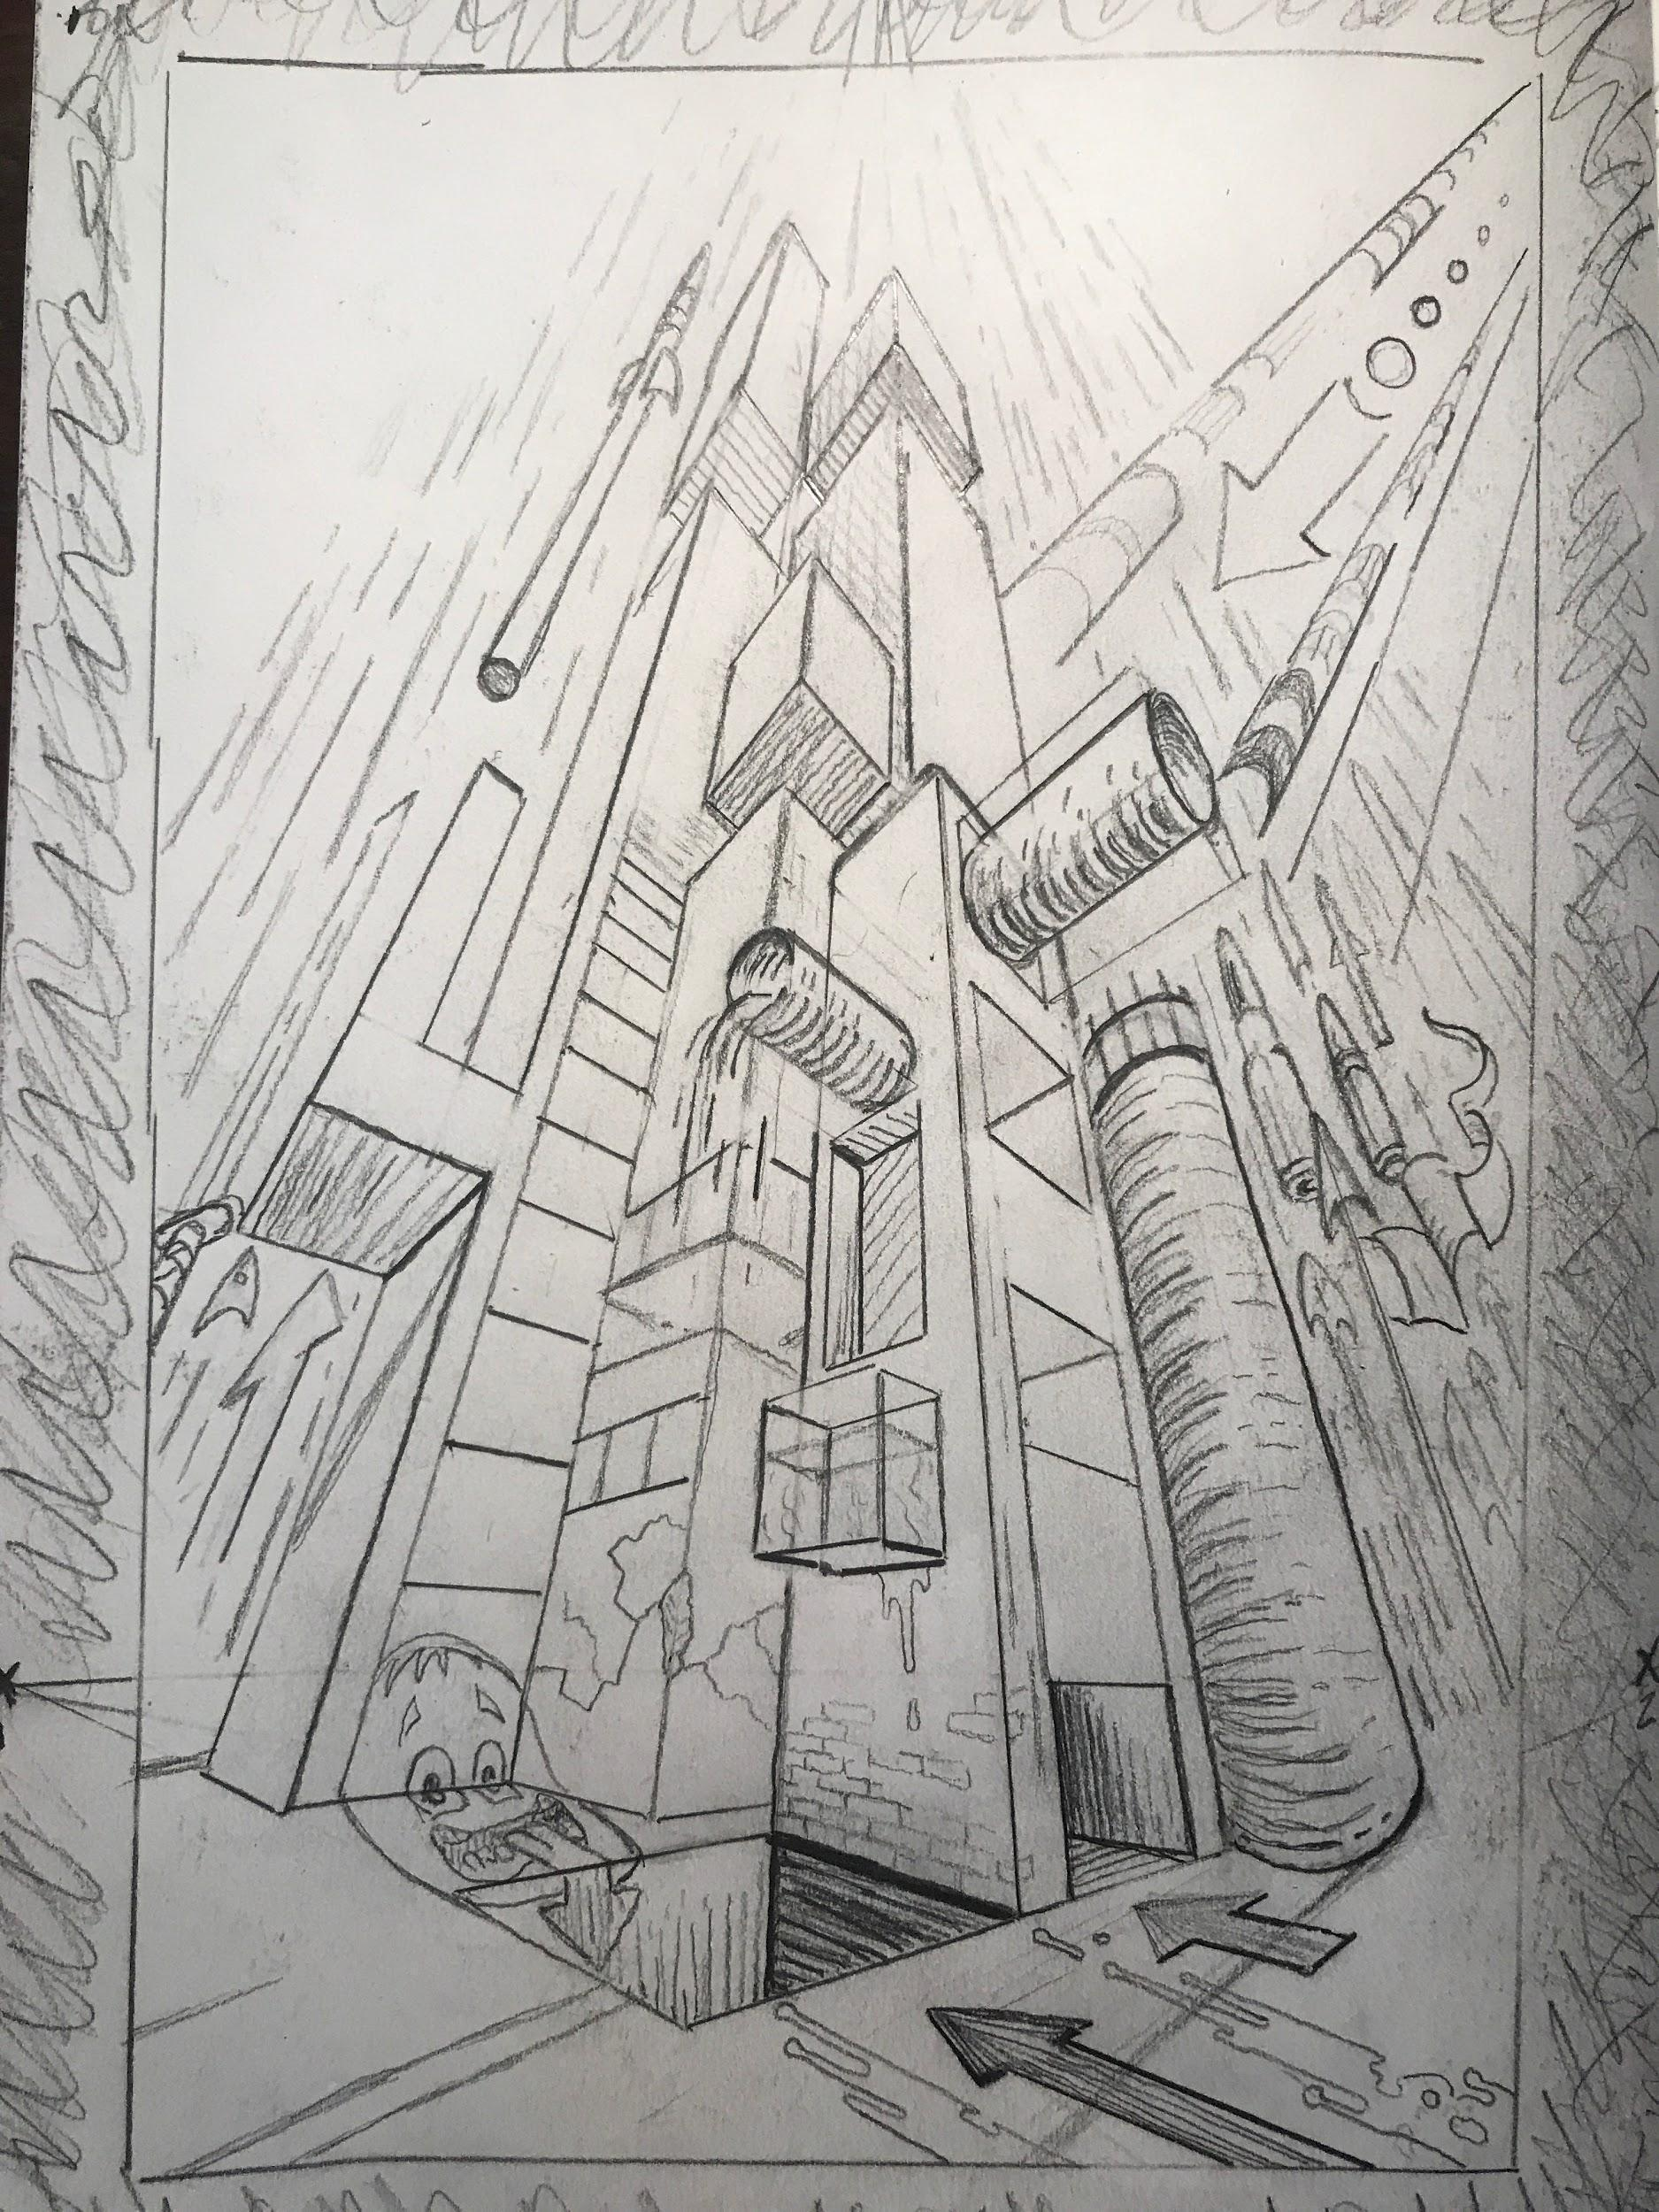
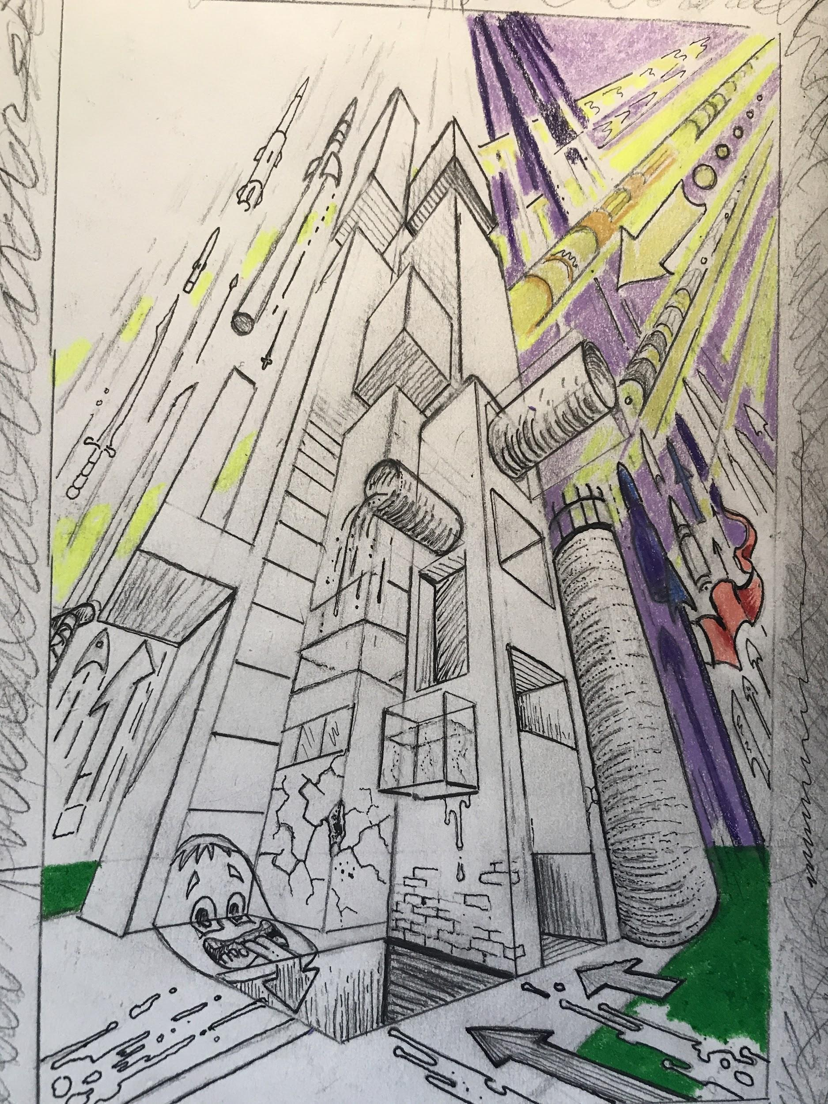
Making a Collage Portrait in a Range of Values
Anchor Standard 3: Refine and complete artistic work.
• Enduring Understanding: Artists and designers develop excellence through practice and
constructive critique, reflecting on, revising, and refining work overtime.
• Essential Question: What role does persistence play in revising, refining, and developing
work? How do artists grow and become accomplished in art forms? How does
collaboratively reflecting on a work help us experience it more completely.
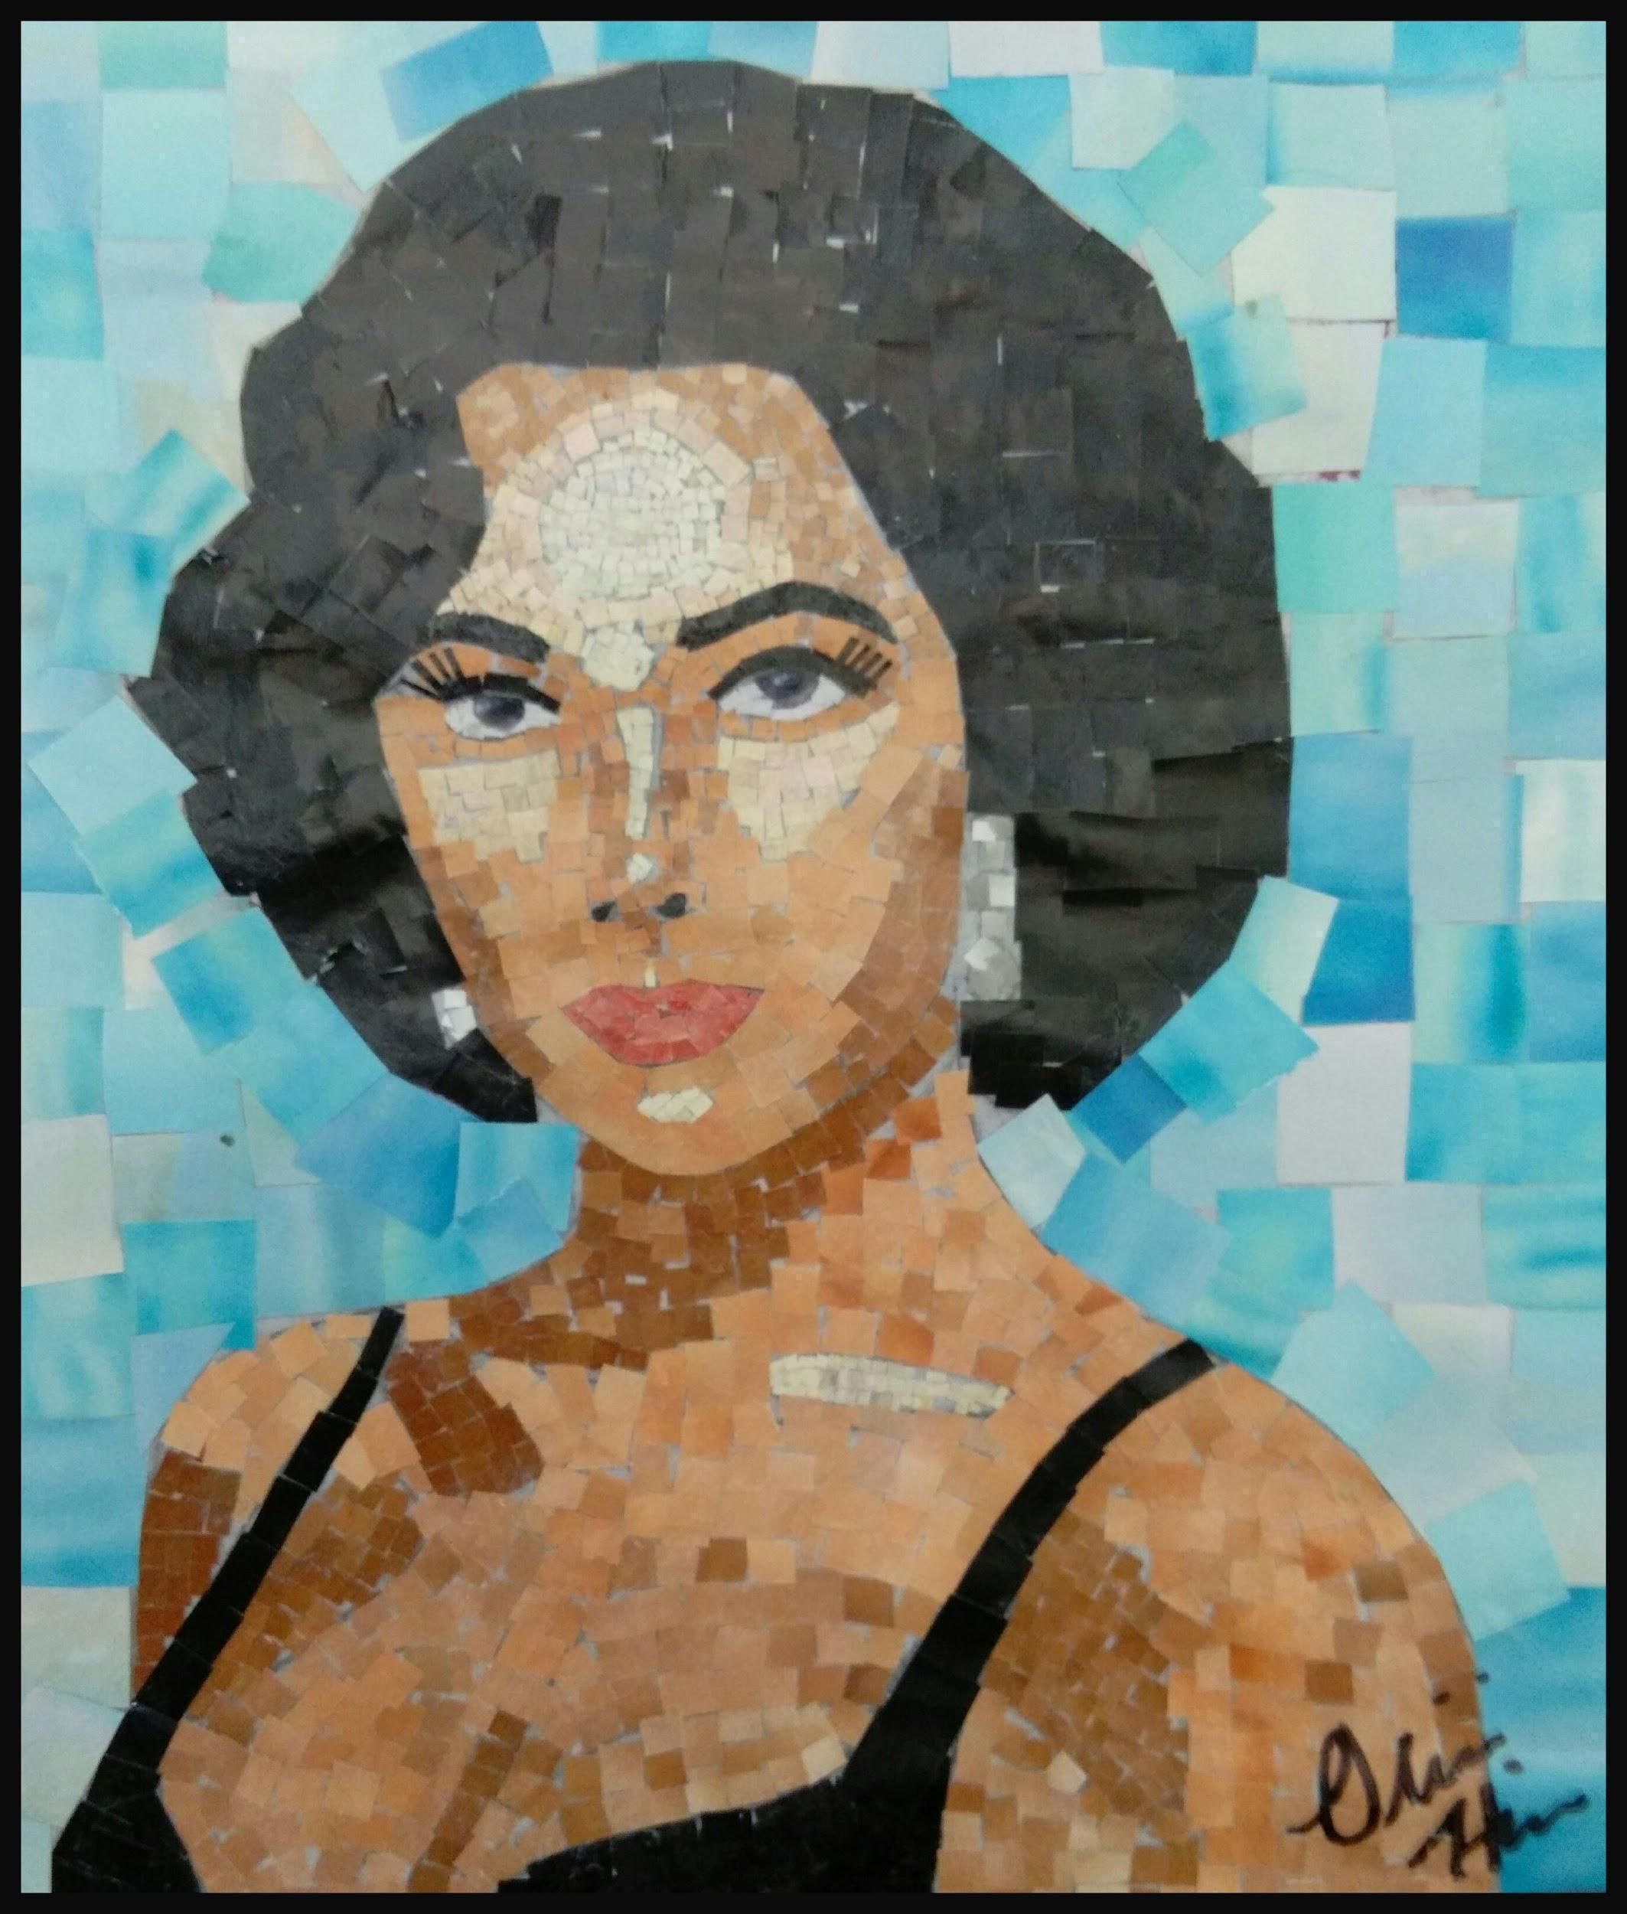Artist: Oliva H.

Objective:
Students will select a portrait that will not exceed 8x10 “but be no smaller than 4x4 in size.” They will gather one from the classroom or bring one from home. Students will carefully tear paper out of magazines in an effort to organize different values and color-temperatures. Students will use a glue stick or a brush and glue to construct a replication of the portrait that they selected. Students will use the instructional handout in addition to class notes to meet the following goals.

As a student I can meet the following assessment goals:

Note Each Goal is worth 20 possible points
Assessment Goals | Satisfactory | Unsatisfactory
I have drawn a contour drawing of the portrait, using a grid with the (diagonal scale method).

I have torn pieces of magazine that don’t exceed 1 in. square in size. I have organized my scraps of value into envelopes of value which I have kept in my portfolio.
I have carefully matched the values of the original portrait into my collage portrait resulting in a collage with different values and a textured appearance.
In some areas, not all areas, I have “augmented” the values in the collage with another form of drawing media that best suits the color temperature or value scheme of the image.

i.e. oil pastel, graphite, conte crayon etc.
I can describe value, grid, scale, collage
Making a Design with Attention to Color, Shape, Space & Detail
Using and Making Scratchboards.
Anchor Standard 1: Generate and conceptualize artistic ideas and work.
• Essential Question(s): What conditions, attitudes, and behaviors support creativity and
innovative thinking? What factors prevent or encourage people to take creative risks?
How does collaboration expand the creative process?
• Enduring Understanding: Creativity and innovative thinking are essential life skills that
can be developed.
Materials: Magazine, knife or scissors, soft b type pencil, colored pencils, dark-colored or black oil pastel, scratch tool
Objective:
Through the use of black scratchboard and the creation of their own scratchboard, the student will explore and appreciate positive and negative space, color theory, and the complexity of detail, relief and graving techniques.
- The student will use a black scratchboard and a scratch tool in order to enhance the silhouette of an object gleaned from a magazine.
- The student will choose an image that is clear in its contour. In other words, the object must be easily recognizable as a black silhouette.
- The student will place the magazine cut out over a piece of black scratchboard and using a soft b type pencil trace the contour of the object. In doing so, the pencil makes an impression on the soft scratchboard beneath. This impression is visible to the naked eye but faint.
- The student will attempt to scratch pattern and line in tight detailed formation up to the contour of the object taking care not to simply scratch along the contour, rather up to it. The effect is an implied contour line with extreme detail surrounding it. This effect is visible in the artwork example provided by student artist Leonie Pfalzgraf.
- This exercise primes the student’s brain for thinking about the positive space within and the negative space without the object.
- Students and teachers critique the results and prepare the final assignment by creating a colored version using colored pencil under oil pastel on paper.
- The student chooses a color scheme and creates a design on paper. The application of the colored pencil must be thick in order for the process to work properly.
- The student covers the majority of the surface with a dark-colored or black oil pastel. The student may choose to use a solvent like mineral spirits to soften and blend the covering oil pastel to a nice buff surface.
- Using a scratch tool, the student practices the process of scratching tightly spaced patterns and lines revealing the design underneath.

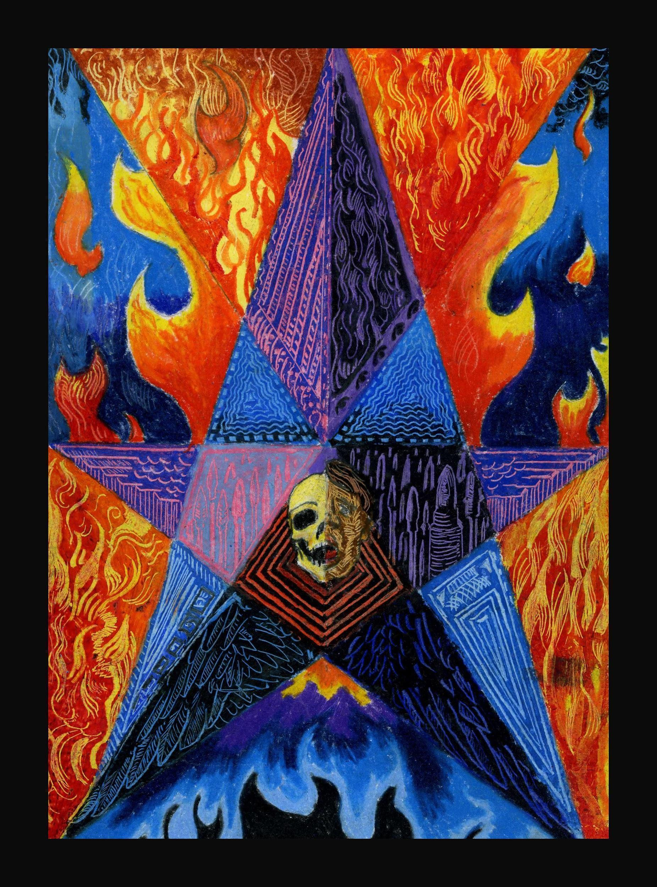Artist: Dustin Hoon

Artist: Dustin Hoon
Scratchboard Formative Assessment
Name____________________________________ Date___________________________
I can apply scratch technique in order to create a design.
I have affected the entire page leaving very little black board behind.
I can show my understanding of the concept of relief carving through the process of scratchboard.
I have practiced my techniques and shown relief on one board taped into my sketchbook.

I have created a product that clearly appears finished and complete, ready for hanging.
I have shown extreme detail and tight patterns using a scratch tool.
I can keep a project safe from damage and wrinkling.
I have worked through each period of art class using time wisely.
I can talk about the elements that make up my work.
OBJECTIVES:
1. Experiment with creating an image that respect the concept of ‘relief carving’ on scratchboard
2. Show that I understand that a ‘complete piece of art’ possesses scratch work throughout the whole board
3. Create a design that uses the black of the board as shadow, and the white of the line as light
4. Use the scratch tool at differing angles yielding different thicknesses of line.
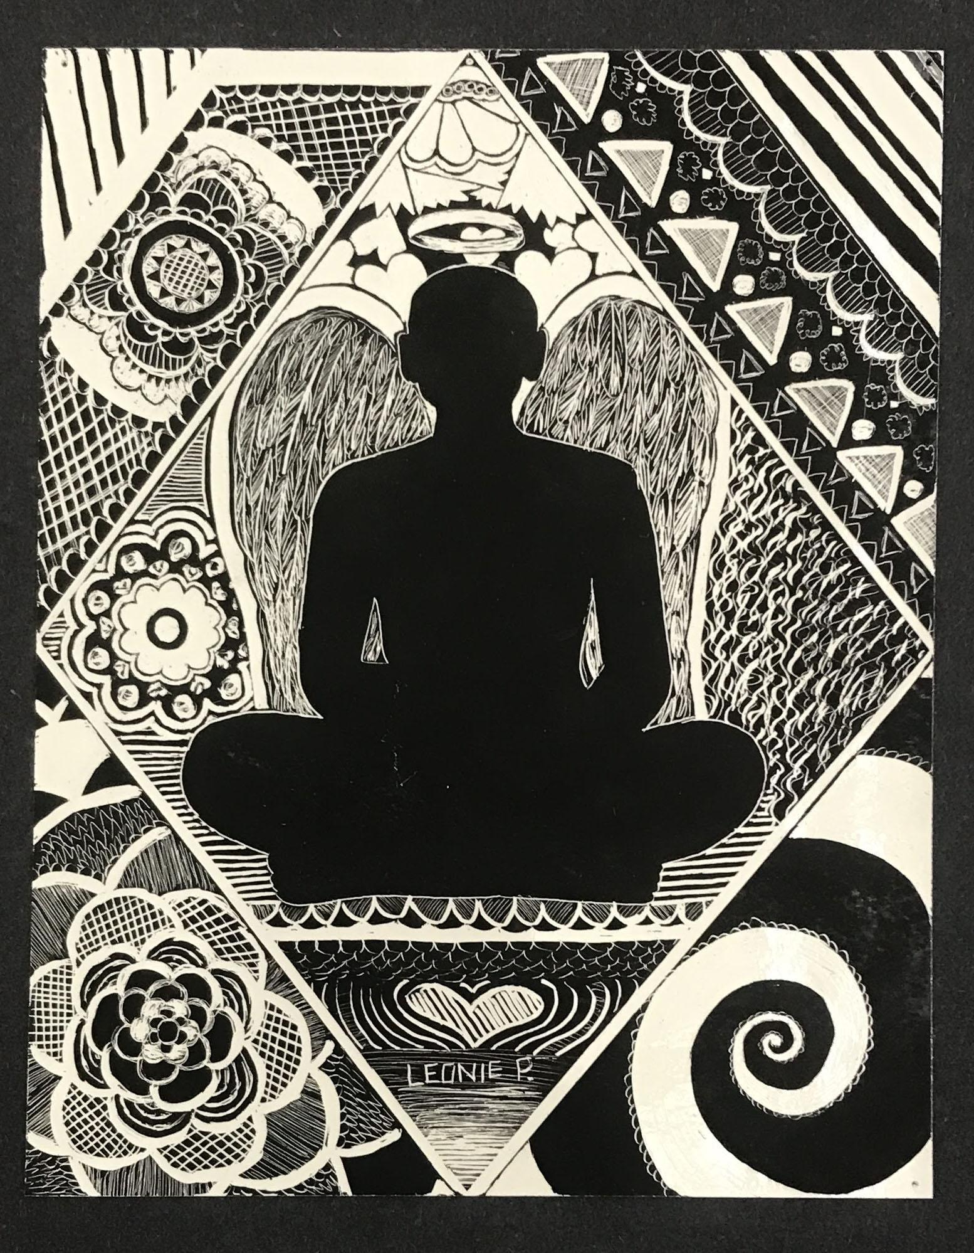
Artist: Leonie Pfalzgraf

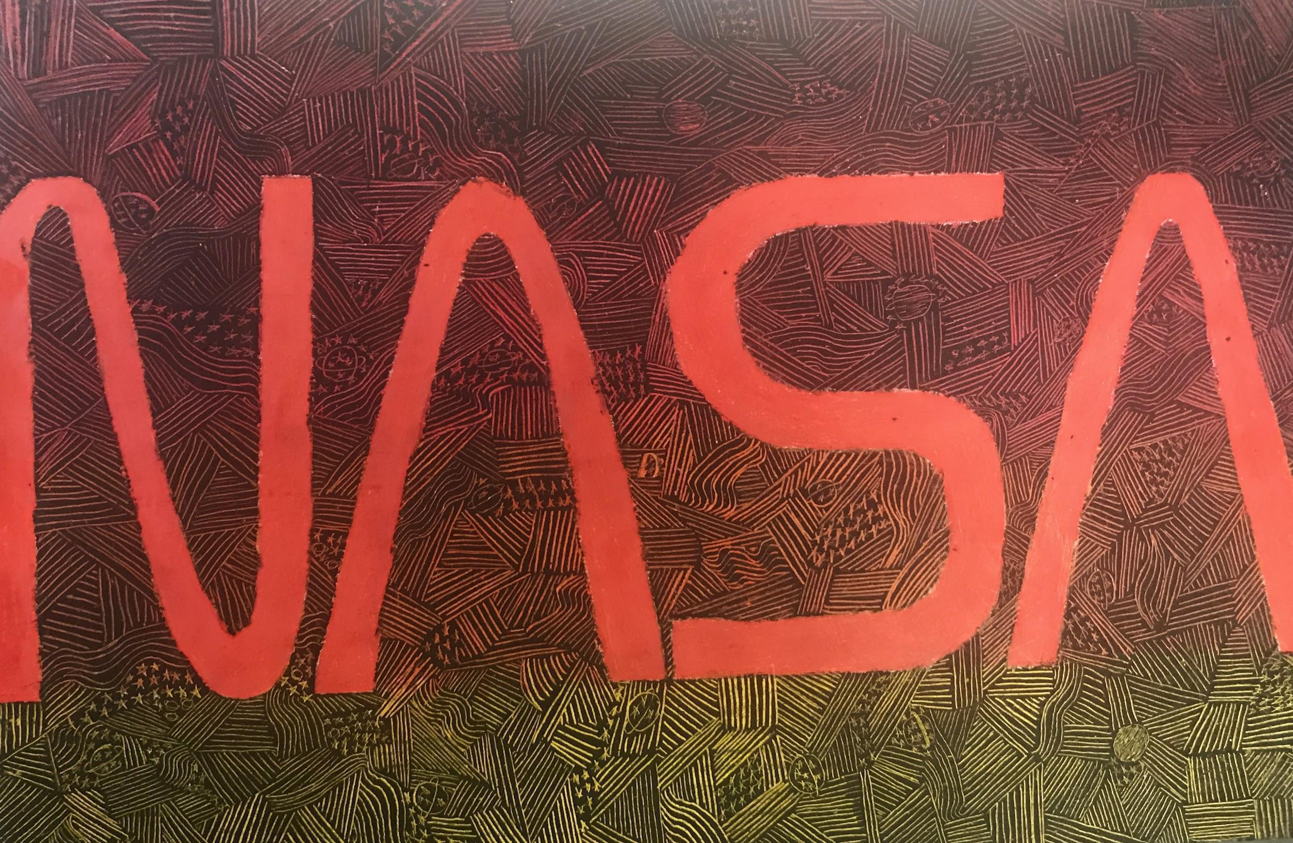

Self - Assessment Oil Pastel Over Colored Pencil Design
Name____________________________________ Date___________________________
I can show a color scheme in my design.
I have covered the entire page with line, color & design
I have used all of the media that I am familiar with in this piece.
I came to class prepared.
I have written the color scheme of my piece on the reverse side of it.
I have shown extreme detail and tight patterns using a scratch tool.
I can keep a project safe from damage and wrinkling.
I have worked through each period of art class using time wisely.
I can talk about the elements that make up my work.
OBJECTIVES:
1. The student considered how to organize line, shape and color into a color scheme/harmony.
2. The students have two class periods to create a complete piece of 2D art that respects and represents a physical product of their understanding of color theory
3. The student created a design with colored pencil, oil pastel and a tack or scratch tool.
4. The student revealed colored pencils under pastel in extreme detail with a tack in at least one area of the piece.
5. The student studied the color wheel in order to correctly identify a scheme/harmony to be used in their piece.

Comics, Sequential Art and Narrative
Anchor Standard 2: Organize and develop artistic ideas and work.
• Enduring Understanding: Artists and designers experiment with forms, structures,
materials, concepts, media, and art-making approaches.
• Essential Question: How do artists work? How do artists and designers determine
whether a particular direction in their work is effective? How do artists and designers
learn from trial and error?
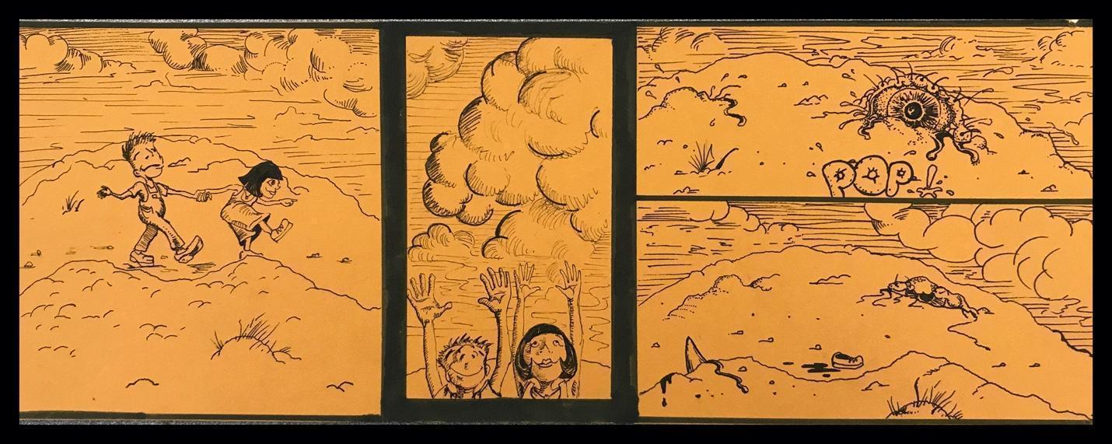
Artist: Dustin Hoon

Anchor Standard 5: Develop and refine artistic techniques and work for presentation.

Comics, Sequential Art and Narrative
WHAT’S THE POINT?
Developing comic strips and cartoon characters is more than just fun; it is an interesting and graphic way to tell a story. Students will exercise drawing and writing skills, and techniques, in order to develop storyboards or comic strips.
The instructor will introduce the following techniques:
1. Drawing characters and figures the third dimension
2. Contour lines and shading with values relative to a light source.
3. Reinstating lines with pen and ink.
4. Adding the written word and speech balloons.
5. Developing frames and sequences.
Read, research and discuss the following terms in the ‘context’ of sequential art or comic strips/books.

Relative Vocabulary that must be written down for reference and understanding:
Narrative_______________________________
Sequence_____________________________________________________________
Values_____________________________________________________________
Contour Line____________________________________________________________
Frame/Panel_______________________________________________________________
Cartoon________________________________________________________________
Line____________________________________________________________________
Overlapping______________________________________________________________
Completely Resolved artwork meets the following Skill Objective criteria:
A CHARACTER, REINSTATED INK LINES, SPEECH BUBBLES, NARRATIVE, THE ILLUSION OF THE THIRD DIMENSION, SHADED VALUES RELATIVE TO A LIGHT SOURCE, FRAMES, FACIAL EXPRESSIONS, A HORIZON LINE, IMPLIED MOVEMENT
Students are encouraged to ask themselves when considering their work:
“Am I filling all space, developing a narrative, and carefully “framing” my scenes?”
Assignments:
1. The student will: develop a character that appears to occupy the third dimension, include expressions, imply movements in the character, show speech bubbles, and sequence in their Sketchbook. Students will show thick, thoughtful and even frames/panels for a sequence of events. (One to Four Panels). Formative Grade Given One full page with H type Pencil and B pencils for shaded values.
2. The students will: Develop a framed sequence on one full sketchbook page (or quality Bristol Board). The final comic strip will meet the Skill objective criteria listed above. The artwork will be completely resolved. (One to Four Panels Minimum). Summative Grade Given One full page with H type Pencil under drawing, Colored Pencil Values, and Fine Black Pen Contour and Detail.

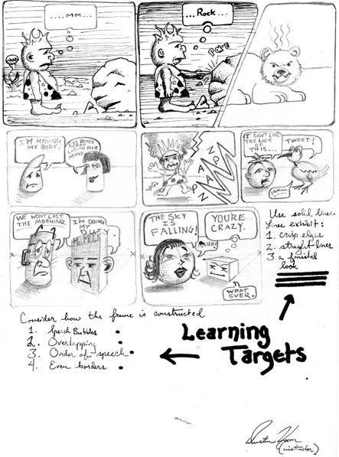This is a practice page -
Notice how the panels advance the story from left to right – top to bottom.
Why might that be?
Notice that the top left two panels seem more resolved and complete.
Why might that be?
Notice how the text bubbles overlap and have clearly defined text. Why is that?
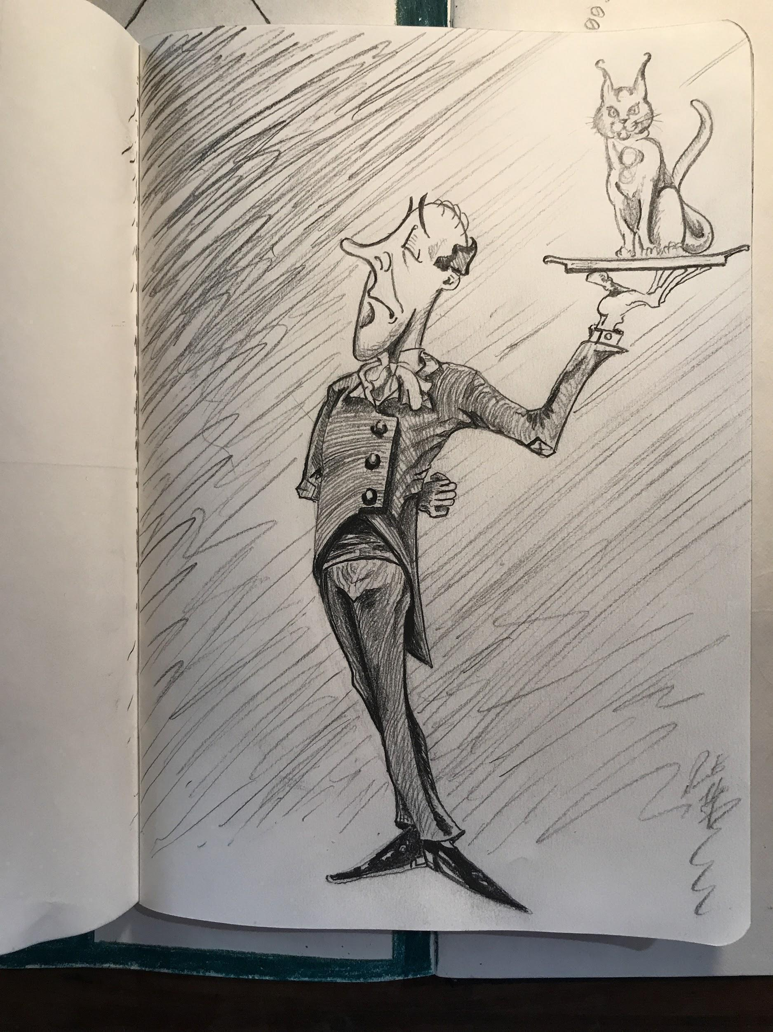Character Study without panels
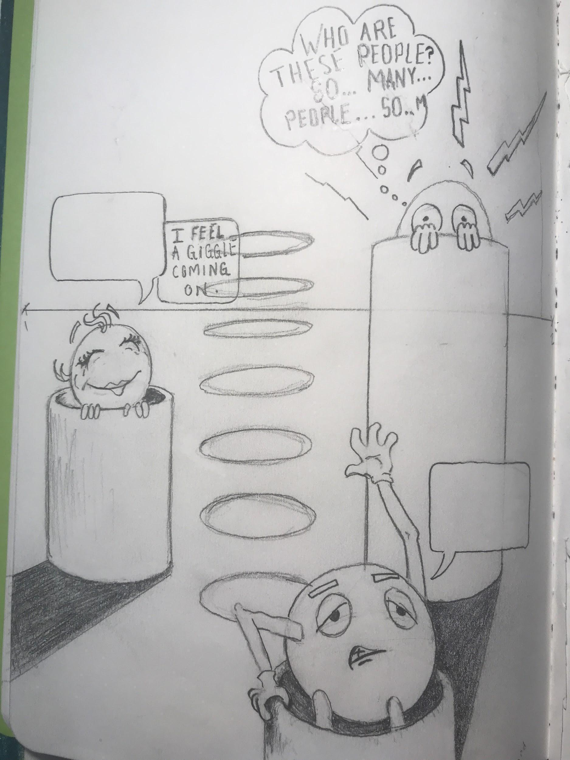
Character study scene with overlapping sequence of speech but no panels.
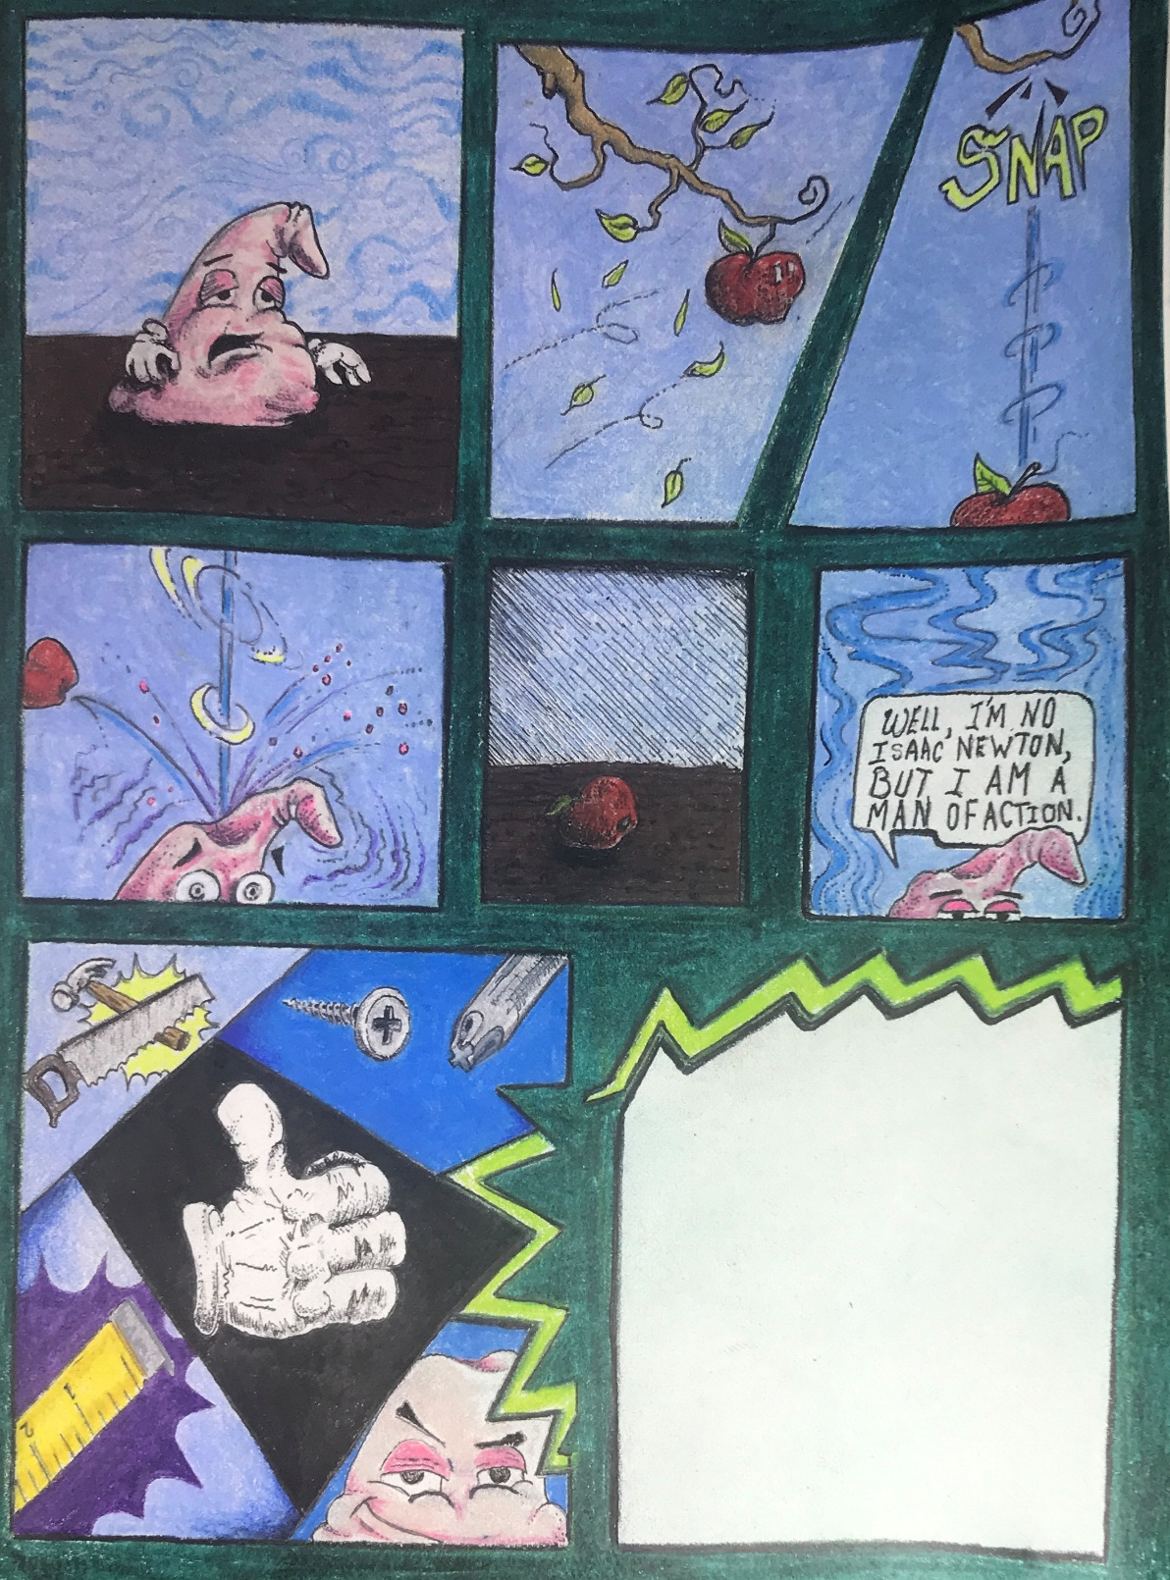Dustin Hoon (Artist). This example is a final piece. Can you imagine how this comic might conclude or end? Notice how the frame is used to show drama or action.

Puppetry
Anchor Standard 4: Select, analyze, and interpret artistic work for presentation.
• Enduring Understanding: Artists and other presenters consider various techniques,
methods, venues, and criteria when analyzing, selecting, and curating objects, artifacts,
and artworks for preservation and presentation.
• Essential Question: How are artworks cared for and by whom? What criteria, methods,
and processes are used to select work for preservation or presentation? Why do people
value objects, artifacts, and artworks, and select them for presentation?
Anchor Standard 5: Develop and refine artistic techniques and work for presentation.
Anchor Standard 6: Convey meaning through the presentation of artistic work.

Objective:
Students will create a shadow puppet, consider and develop a 30 second to one-minute performance-and for extra credit-perform shadow puppetry for the camera. Students will explore cultural and historical background on the origin and function of shadow puppetry. After the instructor has introduced the students to the history and components of shadow puppetry, students will conceive of a character, create a puppet of that character and design write and potentially perform a skit based on a narrative created by the student.

A.) Students will write a script and consider the following responsibilities in the creation and preparation of the production:  1. Environment & philosophical or natural question or problem  2. Animal/animals and names  3. Protagonist/hero and name  4. Villain/antagonist & name  5. Solution or answer to problem/question |  | D.) Students will perform dialogue, and manipulate puppets.  The dialogue must:  1. Be available to group members  2. Students will analyze and synthesize the construction and meaning of the monolog’s plot while writing this meaning in their sketchbook.
B.) Students will create their own assigned puppet or scene. |  | E.) Students will create a commercial break with the following:  1. As many characters or props as group members  2. Detailed art  3. A product or idea to sell  This commercial will require the group or individual to create a 3D puppet and a script that the students create.
C.) The shadow puppet or scene must have at least one moving part, fine detail with pen & ink, colored pencil, and fine holes for the purposes of translucence. The puppet must have |  | F.) Students will perform for the camera and possibly an audience.  Concepts of commercial may be for an adolescent teen audience i.e. PG 13, but the general play must be for a general audience or have a G rating.
G.) Puppet or scene must meet proper size specifications: Between approximately 6-12” |  | I.) Students will clean up their workspaces and the classroom without complaint and until thoroughly clean.
H.) Artwork must be in silhouette with great detail i.e. pen and ink, colored pencil carved or punched out detail for transparency, color, moving parts etc.  Students will work at tasks, building and arranging the set. |  | J.) *The students may have the ability to work on their performance in the computer lab using movie editing software.
Concepts, Vocabulary, Learning Targets/Skill Objectives:
1. Chinese, Indonesian, Turkish, and European Shadow Puppetry
2. Script, Performance, Three-dimensional art, Collaboration, Enunciation, Digital video
3. Manipulating paint, colored pencil, exacto-knives, adhesives, pen & ink, papier mâché, wire, safety goggles, lamps, computer software, digital video, fabric, scissors, plaster, lighting, audio equipment,
Relative Elements of Art: Line, Form, Texture, Color, Shape, Space, Value
Relative Principles of Design: Movement, Composition, Balance, Emphasis

 | The student has contributed above and beyond; therefore, the following extra credit points have been awarded:
Puppet Performance Assessment
Dustin Hoon (Instructor)
Name Date_______________________
The following criteria are measured by being complete or incomplete. Each criterion category will be checked either complete or incomplete. The student will sign and date the rubric. The instructor and art student will determine the relative completion.
Each Category Worth 10 Possible Points for a total of 100 possible points | Complete | Incomplete
THE STORY:
Is written in the form of a script with clear indications of which character is doing or saying what.
The writing is well-spaced and, in each student’s, best penmanship (Black Pen)
…script is written by every student in their own sketchbook in order to promote memory.
…is rated PG for so that younger students may see the production
THE STUDENT DOES THE FOLLOWING: | PERFORMANCE | PERFORMANCE
The student enunciates their lines with clarity and proper emotion and enthusiasm
Prepares with practice of lines in order to memorize lines
The student manipulates the puppet so that the puppet moves with hand gestures and other movements
Keeps the script to approximately 5 minutes at the most
Listens to the direction of the instructor during the taping of the final performance
Is respectful to others while students are performing

Shadow Puppet Assessment
Dustin Hoon (Instructor)
Name Date_______________________
The following criteria measured by being complete or incomplete. Each criterion category to be checked either complete or incomplete. The student will sign and date the rubric and the instructor will determine the relative completion.
Each Category Worth 10 Possible Points for a total of 100 possible points | Complete | Incomplete
The puppet:
Has pen & colored pencil details using blending, colored paper, exacto-knives and patterns.
Is between 6 and 12” tall
Is decorated on both sides with equal detail,
Has at least one moving part
Moving parts are connected at the end with thread and knots
Wire is twisted tight and remains separate from the puppet.
Wire is approximately 18” in length
Has cut-out details in its form
Has strong connective knots that are tied tightly
Is firm

Marionette Assessment
Dustin Hoon (Instructor)
Name Date_______________________
The following criteria are measured by being complete or incomplete. Each criterion category will be checked either complete or incomplete. The student will sign and date the rubric. The instructor and student/artist will determine the relative completion.
Objective: the student will construct a marionette puppet for the purposes of a 30 second to one-minute skit, in the form of a commercial, or a public service announcement. The puppet will have a control and strings. A separate rubric will be presented for the creation of a script.
Each Category Worth 10 Possible Points for a total of 100 possible points  The puppet will exhibit the following qualities: | Complete | Incomplete
The puppet has painted facial expression
The student has constructed a marionette
It is between 12 and 15” tall
It is decorated on all sides with equal detail
It has at least two moving parts
Moving parts are connected at the end with thread and knots to a control stick
Joints are connected with wire and thread
Strings are set at appropriate lengths
It is constructed with appropriate materials
It is a character that represents a narrative
It is well constructed: firm, detailed, complete, refined, imaginative
Making a Marionette
https://youtu.be/eLa2-zOr-Fg
Making a Shadow Puppet
https://youtu.be/KKeL6A9AAok
Shadow Puppet Tradition
https://youtu.be/8-mzqxZNp2g

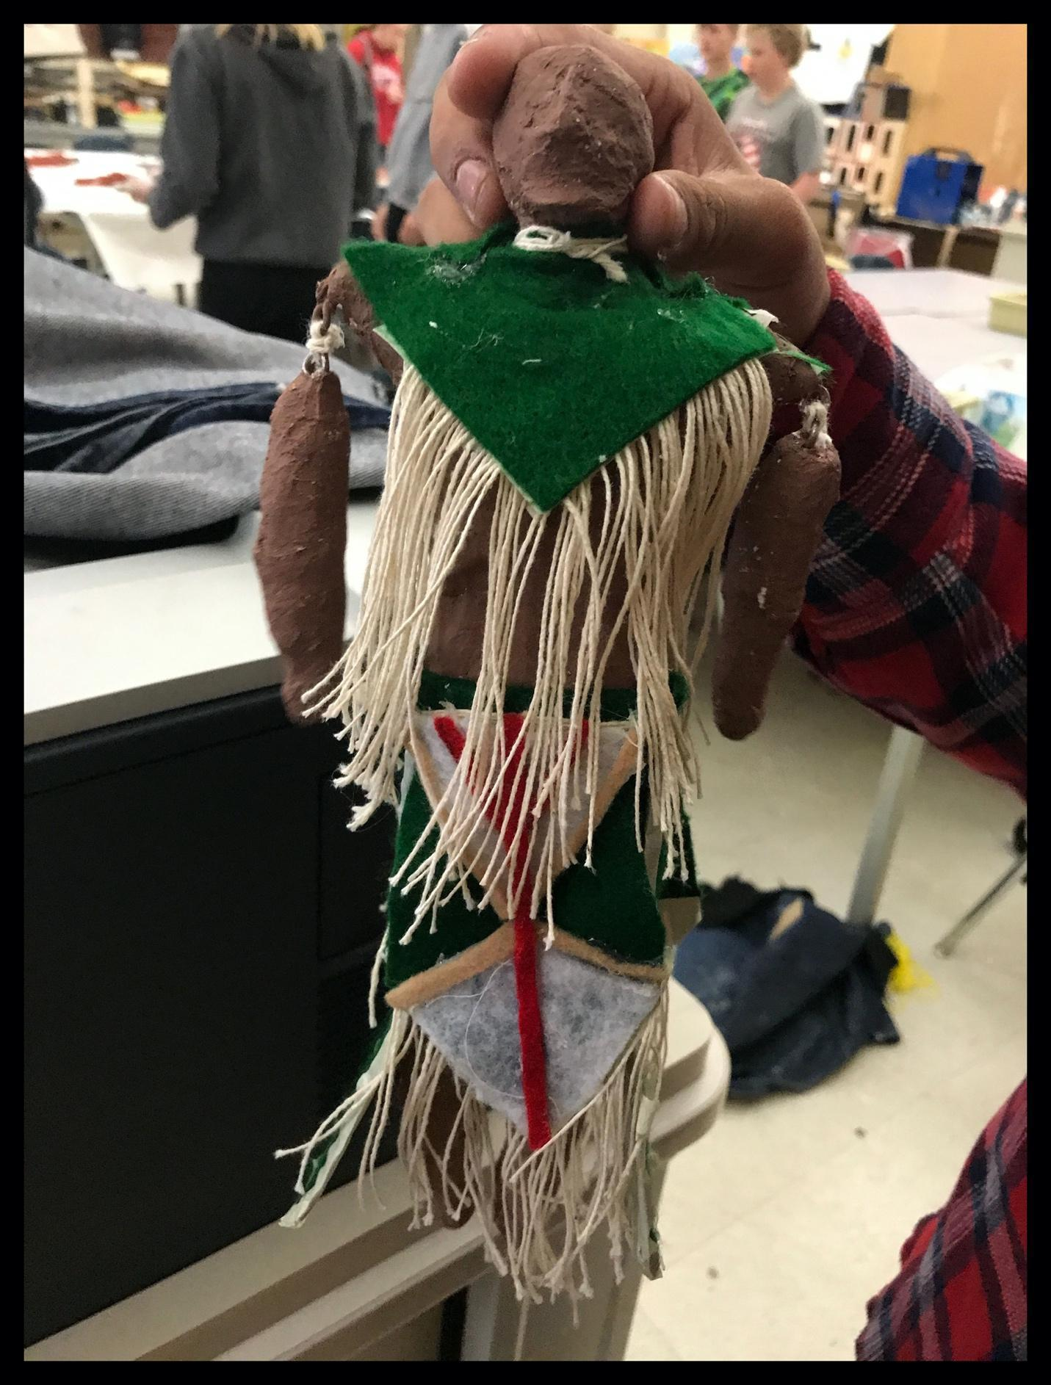
Student Critique with Marionette
Bibliography

Clairmont, C; Earling, D. M; Taafee, R. & Glueckert, S. (n.d.). Native perspectives on the trail: A contemporary American Indian art portfolio. Missoula, MT: Missoula Art Museum.
ISBN: 0974613711

Gair, A. (Ed.). (1995). Artist’s manual: A completed guide to painting and drawing materials and techniques. San Francisco: Chronicle Books.
ISBN: 0811813770

Kemp, M. (Ed.). (2000). The Oxford history of western art. Oxford: Oxford University Press.
ISBN: 0198600127

Lucie-Smith, E. (1984). Dictionary of art terms. London: Thames and Hudson.
ISBN: 0500202222

Read, H. (Ed.). (1994). Dictionary of art and artists. London: Thames and Hudson.
ISBN: 0500202745

References & Hyperlinks
National Art Standards.
https://www.nationalartsstandards.org/sites/default/files/Visual%20Arts%20at%20a%20Glance%20-%20new%20copyright%20info.pdf

Missoula County Public Schools Curriculum for the Visual Arts
https://www.mcpsmt.org/cms/lib/MT01001940/Centricity/Domain/959/Visual%20Arts%20Curriculum%202017.pdf

Elements of Art & Principles of Design
https://www.getty.edu/education/teachers/building_lessons/elements_art.pdf
https://www.getty.edu/education/teachers/building_lessons/principles_design.pdf
Illuminated Manuscripts and Calligraphy
https://youtu.be/HVM9qvUohO0

http://www.bl.uk/catalogues/illuminatedmanuscripts/ILLUMIN.ASP?Size=mid&IllID=22878
Calligraphy Technique

https://youtu.be/sBoVGqiSzr4
https://youtu.be/Rql8Qq3DMlk

Colored Pencil Techniques
https://youtu.be/P5VIfFETIe8

References for symbolizing government
http://greatseal.com/symbols/arrows.html

Practicing Painting Techniques
Stretching Watercolor Paper
https://youtu.be/9c6OWKyYNKI
Landscape Wet-on-Dry
https://youtu.be/rADMJ82-ZoM
Watercolor Techniques
https://youtu.be/K-KYHJriivw

Symbolizing Government
https://www.123rf.com/photo_61714579_declaration-of-independence-1776-on-the-back-of-a-two-dollar-bill-closeup.html
https://hs.umt.edu/nas/documents/29151 NAC Story of Flags brochure.pdf
https://www.amazon.com/New-World-Rising/dp/B07MTWZL8M/ref=sr_1_1?crid=1V9FA56SHX1TC&keywords=native+america&qid=1566243359&s=instant-video&sprefix=Native+Am,prime-instant-video,219&sr=1-1
The history of linear perspective
https://www.youtube.com/watch?time_continue=3&v=WQUi5Ue_fLY&feature=emb_title
Mr. Hoon Instructs in one and two-point perspective
https://youtu.be/mAXK7PF1XFg
https://youtu.be/uDswvLl7HBA
https://youtu.be/n45b-oF71QE
Exploring and learning three-point perspective techniques
https://youtu.be/UPNUZzfsri0
https://youtu.be/Umv4PjC8fjo
https://youtu.be/EPBaHkj753I
https://youtu.be/braEb5a3IuA

Considering dream-like surrealism & surrealism in art history

Making a Marionette
https://youtu.be/eLa2-zOr-Fg
Making a Shadow Puppet
https://youtu.be/KKeL6A9AAok
Shadow Puppet Tradition
https://youtu.be/8-mzqxZNp2g

